Physics 262, Exam 1, Feb 25, 2005, Dr. Baden

Please do all problems, and show your work clearly. Credit will not be given for answers with no work shown. Partial credit will be given.

Problem 1 (30 points). A mass of 0.50kg moves along the x-direction under the influence of a spring with spring constant k=2.0 N/m. The origin of the x-axis is taken to be the equilibrium point of the mass, meaning the point at which the spring force is zero. At t=0 sec, the mass is at the origin and moving with a speed of 0.5m/s in the +x direction.
- Calculate the angular frequency and period T.
- Calculate the maximum extension (amplitude).
- At what time t₁ does the mass arrive at its first maximum extension?
- What is the total kinetic and potential energy at t=0 sec?
- What is the total energy at t=t₁ sec?

- Given m=0.5kg and k=2N/m, then the angular frequency ω=2π/T=$\sqrt{km}$=2 rad/sec. Solve for the period T gives T = 2π/ω = π sec.
- The maximum velocity for a spring is always when the spring is at the equilibrium point, and then we have v_{max}=A⋅ω and v_{max}=.5m/s here. Solve for A=v_{max}/ω=.5/2=¼m
- The mass would take that many seconds to go from zero to the Amplitude, then back to zero, then to –Amplitude and back to zero, so the time to get to the maximum extension from zero is ¼ of the full cycle, or T/4= π /4 sec.
- At t=0, the origin, PE=0 (no extension, therefore no spring force) and KE=1/2 mv²=.5*.5*.5²=1/16 Joules
- Total energy is constant, so total energy at any time is the same, must be 1/16 joules

Problem 2 (20 points). A source of sound waves is operating in midair, far from any reflecting surfaces. If, 1m from the sources, the level of the sound is 60dB, then calculate
- The total power output of the source.
- The intensity and decibel level 100m from the source,

- Total intensity 1 meter away is given by $\text{60}\text{dB}=\text{10}\text{log}I_{1}I_{0}$where I₀=10⁻¹² W/m. Solve for I₁ gives I₁=10⁻⁶ W/m². Intensity is power/area, or I=P/A where A is the area of the sphere centered at the source with radius at the measurement point – the sound is spread out over the surface of this sphere as it radiates radially away from the source (uniformly in all directions), especially an isolate source like this which is far from any reflecting surface. At 1m radius the area of a sphere is 4πr²=4πm² which means the total power is P=I₁⋅4π=4π x10⁻⁶ W.
- The radius of the sphere at 100m is 4πx(100m)². The intensity at 100m is the power radiated per area of the sphere centered at the source, which gives I₁₀₀=4πx10⁻⁶W/(4πx100²m²)=10⁻¹⁰ W/m². The sound level in decibels is 10log(I₁₀₀/I₀) =10log(10⁻¹⁰/10⁻¹²)=10log(10²)= 20dB.

Problem 3 (20 points). A uniform wire has a mass of 1.2kg and a length of 8.3m. The cord is attached to a wall on one end, and passes over a pulley which is 7.6m from the wall, and supports a 4.2kg object hanging off the end (which is 8.3m away from the wall). A sine wave of 440Hz and amplitude 15cm is introduced at the wall end of the wire.
- Calculate the velocity of the sound wave.
- How long does it take for the sine wave to get from the wall to the pulley?
- When the pulse hits the pulley, will it be reflected? If so, will it be inverted or non-inverted? Why?

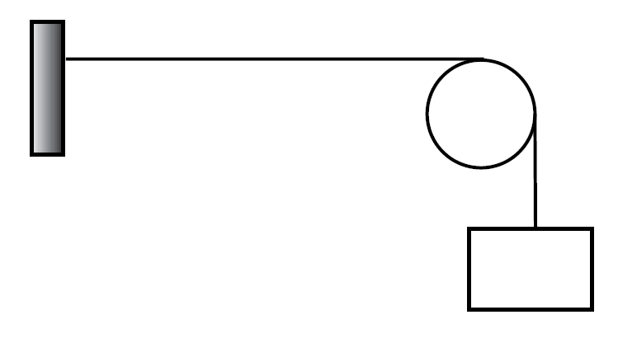
4.2kg
7.6m

- The velocity of waves on a wire or rope is given by $v=\sqrt{Tμ}$where T is the tension and μ is the mass per length. The tension is from holding up the 4.2kg mass, is due to gravity and is then given by T=mg=4.2kgx9.8m/s²=41.2N. The mass per length is for the entire rope (or any section if you like), so m=1.2kg/8.3m=0.14kg/m. This gives the velocity $v=\sqrt{Tμ}=\sqrt{\text{41}\text{.}2N0\text{.}\text{14}{\text{kg}}/m}$=16.9m/s
- The wave travels 7.6m with a velocity of 16.9m/s so it takes T=7.6/16.9=0.45s.
- The wave hits the pulley, it will be reflected, and since the wire is constrained to the surface of the pulley, it will be inverted.

Problem 4 (30 points). A rectangular tub made of a thin shell of poured cement has length L=1m, width W=80cm, and depth D=60cm and mass M=200kg. 3 people of mass 80kg each are standing in the tub. How far below the surface of the water will the bottom of tub reach?

Below is the picture. 3 people, mass 80kg each. The buoyant force needed to hold the tub up is equal to the total mass, which is 240kg for the people + 200 kg for the tub, or 440kg. So B=440⋅g in Newtons. This buoyant force is equal to the weight of the water displaced, and since water is incompressible, the volume of the water displaced is equal to the volume of the tub that is below water. This volume is given by the area A=L⋅W=.8m² times the amount it is below water, “h”. So we use the buoyant formula B=ρ_{water}gV_{displaced} or 440⋅g=ρ_{water}gV_{displaced}=1000kg/m³⋅g⋅0.8m²⋅h. Solve for h=440/(1000⋅.8)=.44/.8=.55m. This height is less than the total depth of the tub, D=60cm so it does stay afloat.
water
h
water

