IX: Angular Correlation of Gamma Rays

References
Brady, E. L. and Deutsch, M., “Angular Correlation of Successive Gamma- Rays,” Physical Review 78, no. 5 (1950), pp. 558-566.

Frauenfelder, H. and Steffen, R. M., “Angular Distribution of Nuclear Radiation,” in Alpha-Beta-Gamma Ray Spectroscopy, Kai Siegbahn, ed., pp. 997- 1039.

A. C. Melissinos and J. Napolitano, Experiments in Modern Physics 2nd edition (New York: Academic Press, 2003).

John Lilly, Principles and Applications of Nuclear Physics (John Wiley & Sons, 2001), pp. 65-70.

Preparatory Questions
(must be answered in lab book before experiment is started and signed by instructor or TA)
- How can one measure the coincidence resolving time for this experiment?
- What is the angular correlation function for the 511 keV γ-rays from ²²Na? What does one learn from the measured width of this correlation?
It is highly recommended that you carry out experiment VII before doing this experiment. Experiment VII will introduce you to the detectors and electronics used in this measurement. See the writeup for VII for additional reference material.

Introduction and Purpose
The purpose of the lab is to introduce you to coincidence and angular correlation techniques. Just as in the case of the atom, electromagnetic radiation is emitted when a nucleon is in an excited orbital and makes a transition to a lower energy orbital. However, in this case the energy of the transition is higher and a γ-ray with energy in the MeV range is emitted rather than a visible photon with energy in the eV range. Often when two gamma rays are emitted in rapid succession from a nucleus, the directions of the emission of the two rays are correlated. Assuming the first ray is emitted in the z-direction, the probability of detecting the second gamma is dependent on the angle θ (with respect to the z-axis). If two detectors are used in coincidence, and the coincidence counting rate C(θ) is observed as a function of the angle θ between the detectors, the angular correlation function C(θ) often depends upon the angular momentum of the final states. These measurements can give information about the angular momentum of the nuclear states.

Sodium-22 Correlation
Sodium-22 decays by beta-plus decay (90%) (one of the protons in the nucleus decays by p → n + e⁺ + ν) and electron capture (10%) (one of the atomic electrons captures on a proton by p + e⁻ → n + ν) into an excited state of neon, which then decays to its ground state by emitting a 1277 keV gamma ray. The angular correlation of sodium-22 arises from the following process:
The positron produced will be slowed down in the material surrounding the source (by electromagnetic interactions) and is captured by an electron, forming positronium. The positronium at rest then decays through pair annihilation to form two gamma rays of energy 511 keV each, the rest mass of an electron.

Figure IX-1
To conserve momentum, the gamma rays must propagate in opposite directions. The angular correlation between the two 511 keV γ-rays from ²²Na is therefore theoretically given by δ(π − θ). However, there is a finite width of the angular correlation due to the finite angular resolution of the detectors used in the experiment. Because of the sharp correlation of ²²Na, it is often used for calibration purposes.

Cobalt-60 Correlation
Cobalt-60 decays, by emitting a beta minus (n → e⁻ + p +ν ), into an excited state of nickel. The ⁶⁰Ni nucleus then decays to its ground state by the emission of two cascaded γ rays (see Fig. IX-2), each giving off two units of angular momentum: they are thus quadrupole radiation. The lifetime of the intermediate state is 8 x 10⁻¹³ seconds. We can then consider the two photons as being emitted in coincidence. The gammas have energies of 1.333 and 1.172 MeV.

Figure IX-2
The angular correlation of the emitted radiation is more complicated than that of sodium-22. The correlation of the gammas can be understood by the following argument: The first gamma will have an angular distribution with respect to the spin axis of the nucleus; thus, its observation at a fixed angle θ =0 conveys information about the probability of finding the spin at some ψ with respect to the direction θ =0. Now the second gamma ray also has some angular distribution about the spin axis which is now known to be at ψ. Thus, the probability that the second gamma ray will be emitted at an angle θ can be found. This is called the angular correlation function C(θ). The time coincidence signal assures us that the two gammas have indeed come from the same nucleus and, therefore, are the two gammas of interest.
It can be shown from theoretical considerations that the correlation function takes the form
$A\left(θ\right)=C{\left(θ\right)}/C\left(\text{90}\right)=1+a{\text{cos}}^{2}θ+b{\text{cos}}^{4}θ$ . IX-1
The constants a and b are given by
$\begin{aligned}a=0\text{.}\text{125}=1/8 \\ b=0\text{.}\text{042}=1/{\text{24}}\end{aligned}$
Alternatively we could write this function in terms of Legendre's polynomials which describe the shape and an overall normalization determined by α (which should be a variable parameter in your fit to the data and is ~ 1.04):
$$\begin{aligned}A\left(θ\right)=\left[1+A_{\text{22}}P_{2}\left(\text{cos}θ\right)+A_{\text{44}}P_{4}\left(\text{cos}θ\right)\right]×α \\ A_{\text{22}}=0\text{.}\text{1020} \\ A_{\text{44}}=0\text{.}\text{0091}\end{aligned}$$

Experimental Setup
The setup for the experiment (figure below) consists of the two NaI detectors set at a fixed distance (about 10 inches from the source is recommended) from a radioactive source. One detector stays fixed and the other will be rotated. The signals from the detectors are fed to a coincidence circuit that enables us to get a coincidence counting rate at each angle. The distances and angles are clearly marked on the table in inches and degrees. The radiation sources are located in the cabinet and care should be taken in their handling. The two of interest to us are ²²Na and ⁶⁰Co.

Figure IX-3
The circuit for this experiment (see Fig. IX-4) consists of a series of modules that are arranged to analyze the incoming pulses from each detector, decide if the pulses are in coincidence and if so send one of the NaI pulses to a multichannel analyzer for pulse height analysis. It is recommended that the high voltage supply (HV) be turned on prior to the experiment and let warm up for 1/2 to 1 hour. This is to reduce the possibility of a shift in the gain during data-taking. All thresholds and widths associated with the output pulses have been preset and it is suggested that they not be changed. However, it is necessary to check the pulses from each unit to insure proper behavior. A brief description of the equipment follows.

Sodium Iodide (Th) Scintillation Counters
The two detectors for this experiment are NaI counters doped with thallium. These detectors are described in detail in Experiment VII and it is suggested that the part pertaining to their operation be read. When a gamma ray interacts with the NaI crystal visible light is produced, the number of photons being proportional to the energy lost by the γ-ray. This light falls upon the photocathode of a photomultiplier tube that produces an output, again proportional to the energy loss of the gamma ray. This output can be seen by sending the output of the photomultiplier directly to the oscilloscope (see scope usage). See also Experiment VII.

Fan-Out
The signal from each photomultiplier tube is sent to the input of a linear fan-out, which splits the signal, providing four separate identical outputs. These can then be fed to several different circuits.

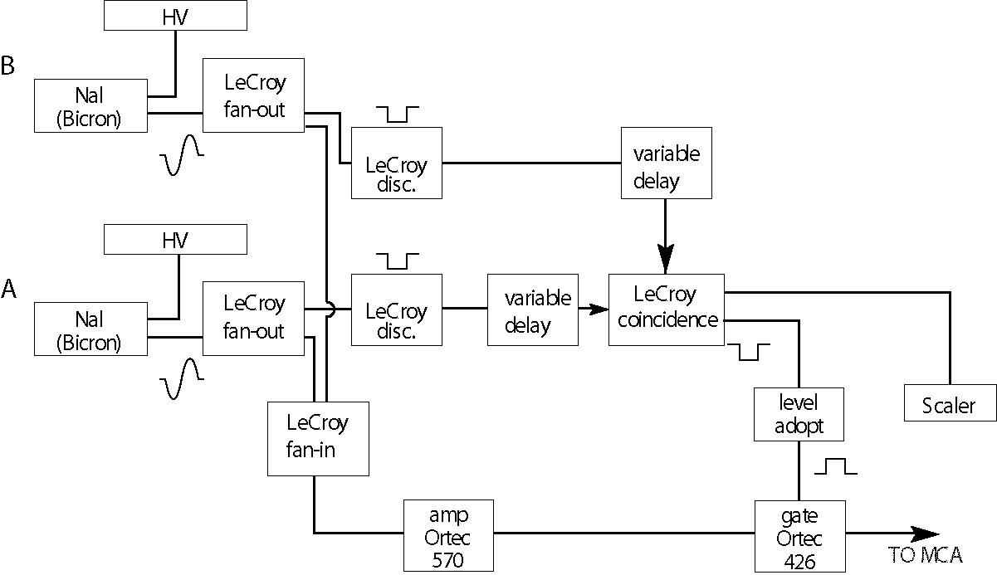

Figure IX-4

Fan-In
The signals from both photomultiplier tubes are sent to the inputs of a linear fan-in which sums the two input signals before sending the summed signal to the ORTEC amplifier. The pulse height of this sum should be less than 1.4 V maximum.

Discriminators
The discriminator takes an input signal and outputs a standard logic pulse for every signal above a preset threshold. The logic pulse is −0.7 volts and the width is adjustable to the needs of the experiment. (These are preset and should only need to be checked.) (See Fig. IX-5.) These standard pulses are needed as input for the coincidence circuit. Note that the threshold level relative to the NaI analog pulse can be examined by sending the NaI fan-out output to the oscilloscope and triggering the oscilloscope with the discriminator output. You must make sure that the threshold is safely below the 511 keV line for ²²Na.

Figure IX-5

Delay
The logic pulses from the discriminators pass through a variable delay box so that the two pulses arrive at the coincidence circuit simultaneously. We can adjust the delay in steps of 0.5 nsec up to a total of 63.5 nsec. To examine the relative timing between these two pulses use a ²²Na source and send the output from each delay unit of the two scope inputs. Then trigger the scope with one of the discriminator outputs. You should see two pulses, one narrow and one broad, which overlap in time.

Coincidence Circuit
The outputs from the discriminators are fed through variable delays to a four-fold coincidence circuit which generates an output pulse whenever there is an overlap of logic input pulses from all input channels that are set to IN.

Amplifier
The amplifier takes the linear pulse from the NaI fan-out, shapes and amplifies it, and provides an output suitable for analysis by the multichannel analyzer. The gain of the amplifier should be set so that the maximum energy pulse is less than about 7 volts.

Gate
The gate controls the input to the MCA. Whenever a logic signal from the coincidence circuit is sent to the gate input, the gate is opened for a preset time. This enables the amplified pulse from one of the photomultiplier tubes to be sent to the MCA. This pulse is the same one that was split at the fan-out and used for coincidence requirement.

Level Adapter
The level adapter takes an input pulse and converts it to the type of pulse needed by the linear gate (NIM to TTL).

Counter/Timer
The counter/timer (labeled “scaler” in the drawing) records the coincidence rate. Therefore, it records the rate at which pulses are sent into the MCA; for gate selection pulse inhibit it measures the individual detector counting rates, for normal it reads the coincidence counting rate. This is primarily used as a check of the experiment.

Use of the Oscilloscope
We can use the oscilloscope in this lab to check the outputs of the discriminators and the photomultiplier. See either experiment XI or the scope manuals for further information.
The two input channels (1 or 2) can be used to display the NaI pulses. Connect the signals to the appropriate channel and choose the display via the buttons in the section labeled MODE. The vertical gain can be adjusted independently for each channel.
Set the trigger select to channel 1.or 2 (depending on which input you’ve chosen) and the coupling to DC. Choose the trigger slope to be positive or negative depending on the type of signal you’re looking at, and adjust the trigger level until a trace appears; the TRIG'D indicator will light whenever a pulse has triggered the display. The signal height and width can be measured using the MEASUREMENTS buttons and the TIME/POSITION cursors.
The pictures in Fig. IX-6 are similar to what you should expect to see with the ²²Na source present.

Figure IX-6

Procedure
- Turn the high voltage switch to standby and let the supply warm up for a few minutes. Adjust the voltage to approximately 1300 volts. Note that it may be necessary to lower this to 1200 V in order not to exceed the 1.4 V output limit of the linear fan-out when looking at the ⁶⁰Co source. DO NOT EXCEED 1500 V. Turn the switch to on. Make sure the power supply has been on for at least 1/2 hour before taking any data for the correlation measurements. This is to reduce the possibility of a gain shift while data are being taken.
- Turn on the power to the instruments in the NIM bin (switch located on the right of the bin).
- Turn on the computer and start up the MCA program. The current MCA uses software called MAESTRO; you should browse through the manual in the lab before using it.
- Turn on the scope and adjust it to look at the discriminator or photomultiplier outputs.
- Take the ²²Na source from the cabinet and place it at the center of the apparatus between the two detectors. The Geiger counter must be placed near the source and turned on so as to remind you there is radiation present. FEDERAL REGULATION.
The two detectors should be at an angle of 180°. The source should be located at the same height as the center of the detector. Also adjust the position of the source in the plane of the two detectors so that the coincidence counting rate is at a maximum. This is important due to the sharp distribution of the emitted coincidence photons that are being detected. The source needs to be placed with the best accuracy on the line joining the center of the detectors. To get good angular resolution, the source should be about 10 inches from each detector.
- Switch the gate to pulse inhibit (this allows only non-coincident events).
- With only one input at a time to the Fan-In unit (see electronic block diagram (Fig. IX-4), acquire the non-coincidence spectrum of ²²Na to make sure the system is working. You should see peaks at 511 and 1279 KeV and some background. Adjust the amplifier gain (or HV) for the first input signal so that the 511 KeV peak falls at about channel 400 on a gain setting of 2048. You can also perform a two-point energy calibration using the MCA if you wish to be more accurate. For the second input signal, the gain can be adjusted by turning a pot (labeled G) at the back of the photomultiplier tube base. After the gain is matched, put both inputs back to the Fan-In unit.
- Switch GATE to normal.
The finite resolving time of the coincidence circuit gives rise to accidental coincidences. The smaller the resolving time, the smaller the accidental counting rate will be. We can measure the resolving time of the circuit as follows. Delay the input of one of the input channels to the coincidence circuit using the delay box. Measure the number of coincidences for a fixed time interval as a function of the relative delay between the two input pulses to the coincidence unit. A plot of coincidence counting rate vs. variable delay will give a trapezoidal shaped curve. The full width at half maximum is defined to be twice the resolving time. A method of generating the delay curve is to:
- Set the delay in channel B to zero.
- Acquire the coincidence spectrum for ²²Na for increasing delay times in channel A in steps of 4 ns to a total delay of 60 ns or until the coincidence counting rate is small (∼10 cts/sec).
- Repeat steps (1) and (2) with the delay in channel A set to zero and increment delay in channel B. In step (4), when plotting the delay curve, the delays for this step are to be treated as negative delays.
- Plot counts/sec vs. delay time.
- Make a delay curve for the ²²Na in coincidence. When completed, set the delay time in the center of the flat part of the delay curve. Keep the delay settings the same for the rest of the experiment.
The counting rates are recorded in two ways. First, record the total number of coincidence counts. This can be done either by reading the scaler that records coincidence counts or by summing over the spectrum in the MCA. Second, record the number of coincidence counts in the peaks that form on the MCA. This can be done by setting a ROI (see MCA section) to the desired channels and getting the integral readout (or use either Mathematica or the program ANALYSIS). Is there any noticeable difference between these two methods?
- Make the angular correlation measurements for the ²²Na source. Run- times of a few minutes are long enough since the counting rate for coincidences from ²²Na is fairly high at distances of about 10 inches and an angle of 180°. Use steps of about 5°. You should verify that the correlation curve is peaked at 180° and find the resolution of the system. Is this resolution consistent with the dimensions of the NaI detectors?
- Replace the ²²Na source by ⁶⁰Co. Make the angular correlation measurements in steps of 15°. Run times of 1/2 to 1 hour are recommended as the counting rate is fairly slow and it takes time for the peaks at 1.1 and 1.3 MeV to form. Make measurements between 180° and 90° in steps of 15°. First change the angle in 30° steps in one direction, then fill in the intermediate angles moving in the other direction. This will help you notice any temporal drifts. Record coincidence counts and singles counts from each detector. Recording the singles counts should only take a few minutes for each angle setting.
Make a least squares fit to the ⁶⁰Co angular correlation data using the Legendre polynomial form, properly accounting for the errors in the data points. To take into account the finite solid angles of the detectors and their efficiencies, there is a Mathematica notebook available that computes factors that should be applied to the two Legendre coefficients. Alternately, there is a DOS-based Monte Carlo simulation program, MC.EXE, which generates pseudodata to which you can compare your own data that also takes these acceptance factors into account. The computer programs are available in the lab, or ask the instructor.

