VI: The Charge to Mass (e/m) Ratio of Electrons

References
J. Classen, Physik Z. 9, 762 (1908).

J.J. Thomson, Philosophical Magazine 44, 293 (1897).

Shamos, M.H., ed., Great Experiments in Physics, Holt, Rinehart and Winston, 1959, Chap. 16 - Thomson’s paper on cathode rays.

Preparatory Questions
(must be answered in lab book before experiment is started and signed by instructor or TA)
- Is it important to locate the filament at a position normal to the line joining the two slits? If so, why?
- What percentage error in e/m would result if the electrons passing through the first slit were travelling in a direction 5 degrees from the normal?

Overview
This measurement, performed in 1897 by J. J. Thomson, was fundamental in establishing the existence of electrons. Before that experiment it was the almost unanimous opinion of German physicists that cathode rays were due to some then unknown etheric wave phenomenon. Thomson’s experiments showed that “...cathode rays carry a charge of negative electricity, are deflected by an electrostatic force as if they were negatively electrified, and are acted on by a magnetic force in just the way in which this force would act on a negatively electrified body moving along the path of these rays...” The value of e/m was found to be independent of the nature of the gas in the cathode tube and much larger than for the previously known maximum value, that for hydrogen atoms in electrolysis. Combining these facts with evidence of the long mean-free-path of cathode rays in air, Thomson suggested that the “carriers of the charges in the cathode rays are small compared to ordinary molecules...”
In this experiment, the ratio e/m, which enters directly into calculations of the orbits of charged particles in electric and magnetic fields, will be measured by Classen’s method.

Figure VI-1

Theory
Classen’s method involves measuring the radius of curvature of electrons in a magnetic field. The apparatus is shown in Fig. VI-1, with a pair of Helmholtz coils providing the uniform magnetic field parallel to the slits. Electrons emitted by the tungsten filament are accelerated toward the filament slit by a potential between the filament and the slit plate. With the filament aligned properly the electrons will pass through the slit perpendicular to the slit plate. The electrons will then experience a force,
$F=−ev×B$ , VI-1
which will give them a circular trajectory. This force corresponds to a centripetal acceleration
$F=\text{evB}={{\text{mv}}^{2}}/r$ , VI-2
where m is the electron mass and r the orbital radius. The velocity of the electrons is found from the kinetic energy they acquired from the accelerating electric field,
$\text{eV}={{\text{mv}}^{2}}/2$ , VI-3
where V is the potential. From these two equations the value of e/m can be calculated
$e/m=2V/(\text{rB})^{2}$ mks units . VI-4
In this apparatus, the orbital radius, r, is fixed by the position of a second slit, with a Faraday cup to collect the electrons which enter.

Procedure Outline
With the apparatus set up and evacuated, the filament is carefully heated to promote electron emission. The accelerating voltage is then set to some value. The magnetic field in the Helmholtz coils is then varied and a plot of collector current versus magnetic field is made. A large peak will occur where the field corresponds to the trajectory that enters the second slit. A series of these plots are made at different accelerating voltages. The ratio e/m is determined from the dependence of the peak positions on the accelerating potential.

Procedure Detail
The enclosed system mounts on an arm fixed to a cover plate bolted to the vacuum chamber flange, as shown in Fig. VI-2. Open the vacuum chamber, remove and examine the electrode structure. Note that the edges of the slits are beveled so that the slit widths are independent of the approach angle. Check that there are no breaks or shorts in the filament or collector circuits. The filament is a 7 mil diameter tungsten wire clamped between two arms mounted on ceramic insulators. A much-used filament is very fragile. If a new filament is mounted, the wire must not be bent sharply and should be under sufficient, but not excessive tension, to prevent it from sagging while hot. The slit plate position can only be varied slightly so the filament must be carefully positioned to be under and parallel to the slit. The two slit openings should be set to approximately 0.1-0.5 mm, and can be measured with automobile feeler gauges. Record the slit widths and the distance between the slits. With the slit plate remounted, the filament should be visibly aligned under the slit (shining a light from the direction of the cover plate may aid in checking this). Check that the filament is electrically continuous and is not touching the slit plate with a multimeter. Replace the electrode assembly in the vacuum chamber. The wing nuts need not be extremely tight.

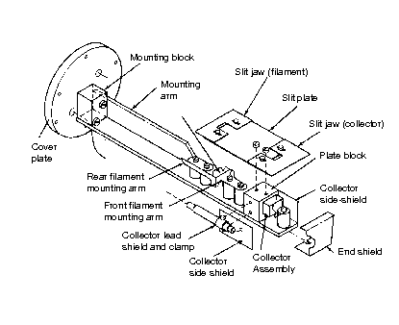
Figure VI-2

The vacuum chamber is evacuated by a standard two-stage mechanical and diffusion pump system. Instructions for operating the vacuum system are given in Appendix A of this manual. The lab technician will check your familiarity with the vacuum system before you start, and will obtain the liquid nitrogen for the cold trap. Begin to pump down the chamber.
With the master power switch off, connect the circuit as shown in Fig. VI-1, following the steps outlined below. The accelerating potential between the filament and the slit plate is provided by a D.C. high voltage power supply. Measurements on a precision voltage divider and with the Lab Pro are used to determine the potential difference between the vacuum chamber and the filament leads. The collector current is measured with a picoammeter. Some of the currents in this experiment are quite small and the picoammeter is sensitive and delicate. Always keep the meter on scale. When not in use it should be kept on the least sensitive scale. Minimize all motion when making a measurement as any movements of body or cables can cause large capacitive fluctuations in the current reading. The picoammeter cannot respond instantaneously to changes in input and when making a plot the magnet current must be swept slowly and smoothly. Turn on the picoammeter and record the residual current with all power supplies off.
Turn on the magnet power supply and adjust it initially to give about 0.5 A – you will eventually be ramping this value to the maximum the supply can deliver. Check the direction of the magnetic field with a compass to make sure that the electrons will circle in the proper direction. A calibration for the Helmholtz coils is posted near the experiment. Consider how any systematic error caused by the magnetic field of the earth can be canceled.
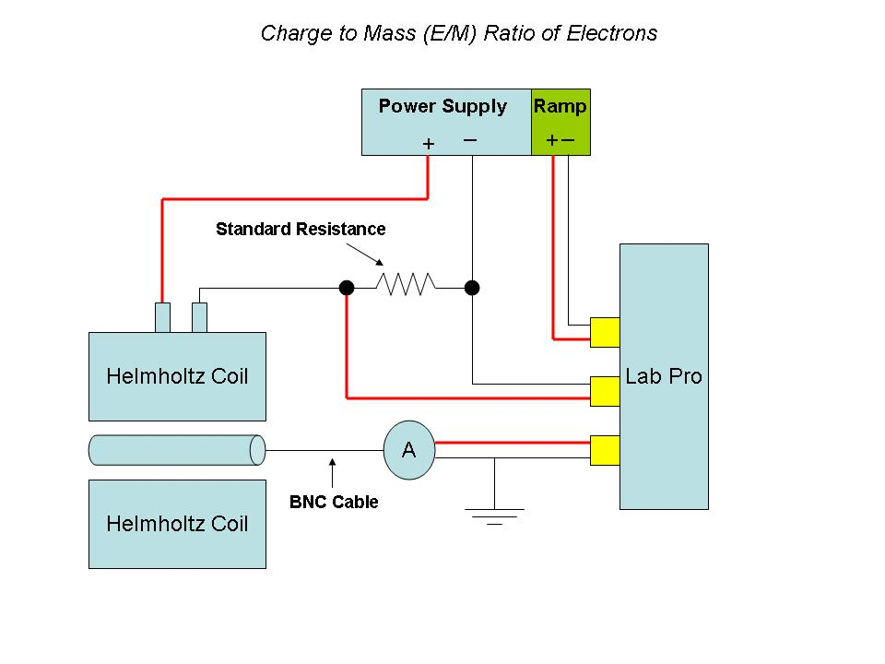
Figure VI-3
With the HIGH VOLTAGE switch OFF, turn on the high voltage power supply. After some delay the panel meter will indicate a voltage. Turn the HIGH VOLTAGE switch to NEG and observe the picoammeter readings at various settings of the HV power supply COARSE switch. On the auxiliary HV controller, you should connect a multimeter to the High Voltage Divider output – this will give you a more accurate monitor of the HV setting when you are collecting data.
When sufficient vacuum (~5 x 10⁻⁶ mm Hg) has been established, set the VARIAC to zero and turn on the filament transformer. The filament current is measured on the AC ammeter while the emission current is read from the DC microammeter. The filament current should be set to give a measurable collector current greater than the background measured above (2.7 amps or slighly greater), without burning out the filament. One method of doing this is to turn on the negative high voltage, select the lowest picoammeter range on which fluctuations are no longer measurable, and then turn up the filament current until a steady collector current background is seen. Typically, the filament will burn out at about 2.9A.

Connections to record the e/m data:
The following connections will permit you to record the pico-ammeter output and current applied to the electromagnet as a function of time. You will also collect a voltage reading from the voltage divider that will allow you to calculate the accelerating potential provided by a D.C. high voltage power supply. The connections are made from the e/m apparatus to the Pico-ammeter and to the Lab Pro as shown in Fig. VI-3, as follows:
- Connect the BNC connector on the vacuum flange to the Pico-ammeter using a BNC cable.
- Connect the analog output of the Pico-ammeter (at rear of the instrument) to the CH 1 signal terminals of the Lab Pro.
- Connect the ramp power supply positive terminal to the positive terminal of the magnet coil. Connect the negative coil terminal to the Standard resistor and then from the resistor to the negative terminal of the ramping power supply.
- Connect the CH 2 signal terminals of the Lab Pro to read the voltage drop across the standard resistor.
- Connect the CH 3 signal terminals of the Lab Pro to the trigger output of the ramp power supply.
- DO NOT connect the voltage divider circuit to CH 4. Instead, read the voltage divider with the multimeter on top of the filament current power supply.

Preliminaries:
Put the ramp/reset switch on the ramp power supply in the reset position. In this position, the voltage output is zero.
Be sure the High Vacuum valve is open and you have proper vacuum in the chamber.
Turn on the High Voltage Power Supply and wait for the voltmeter to register voltage. Adjust to desired voltage and then turn High Voltage switch to Negative.
Turn on power to Filament Source Control Panel. Adjust filament current to approximately 2.7 AC amps.

Computer acquisition of the collector signal:
You are now ready to run the computer program “Logger Pro” which will permit you to record the output of the picoammeter and voltage drop across resistor as the current is increased on the electromagnet.
- Select the folder on the computer desktop labeled Lab_Pro_Templates. This folder contains Logger Pro templates designed for the Phys 405 lab experiments. Selecting one of these templates starts the program Logger Pro and loads the setup information for the experiment selected.
- The range settings of the Pico-ammeter must be selected as appropriate for their input readings. Special attention should be noted to these ranges as they can have an effect on the values of the analog output signals in which these current and voltage readings are used in your analysis.
- If needed, select the Zero button from the tool bar and zero all sensors.
- Select the Collect button on tool bar. The screen will then display a message “Waiting for trigger”.
- Set the reset/ramp switch on the ramp power supply to the ramp position. This will initiate the ramping of the voltage of the power supply and the taking of the data by the computer. (It is a good idea to put the reset/ramp switch to the reset position as soon as the data sampling is completed to insure a proper zero start for the next data sampling.)
The apparatus can be changed to attempt to remove systematics and improve resolution. Be certain that the HV power is off before touching the apparatus.
The entire electrode structure can be installed upside down and the magnetic field reversed. The filament current, slit widths, and filament- slit alignment can be varied to maximize resolution and signal-to-noise ratio. The system can be brought up to atmospheric pressure to make these changes and quickly re-evacuated by following instructions contained in Appendix A of this manual.
In order to accurately determine the accelerating potential difference between the filament and the slit plate, a precision voltage divider and the Lab Pro are used to determine the voltage provided by the D.C. high voltage power supply. You must measure the values of the total resistance of the divider and the output resistor used in this voltage divider in order to find the correct conversion factor and its uncertainty to use with the data from the Lab Pro. The Keithley 177 meter is used to make this measurement. A special adapter has been made to allow a banana plug to connect to the center pin of the High Voltage input connector of the Filament Source Control Panel. Measure the resistance between this pin and the positive banana terminal of the voltage divider. You must also measure the resistance between the two banana terminals of the voltage divider.
NOTE: 1) Be sure to turn OFF the High Voltage BEFORE disconnecting the high voltage cable. NOTE 2) Never attempt to measure the resistances of the voltage divider with the High Voltage Connected to the Filament Source Control Panel.
NOTE 3) Never attempt to directly measure the high voltage with any meter in this laboratory as special equipment, training and precautions must be taken.

The following information is stored in the Logger Pro template.
- The Lab Pro will collect data from 3 analog channels.
- Channel 1 is set to collect data from the Pico Ammeter and display this data in the table and on the graph.
- Channel 2 is set to collect data from the power supply and display this data in the table and on the graph.
- Channel 3 is set to trigger the data collection. The trigger that initiates the taking of data will be provided by the ramp power supply as the reset/ramp switch is set to the ramp position. The trigger data is not displayed.
- The Data Collection sampling rate is set to 50 samples (measurements) per second.
- The Data Collection Length has been set to 20 seconds. This may require changes the time of voltage ramp is changed.

Discussion Questions (to be answered in lab report)
Explain any changes in the plots taken with different filament currents and slit widths. Can you simultaneously maximize signal-to-noise ratio and resolution?
What measured parameter contributes most to the statistical error of the final calculated result? How much would it need to be improved to make another parameter more important?
How does a charged particle move in crossed uniform electric and magnetic fields?
Why is the measurement made in vacuum?
The direction and magnitude of the electric field between the filament and the slit plate are not constant, and the emission current itself will affect the fields. How will the electron trajectories be affected in the region where both electric and magnetic fields are present?

