V Hyperfine Structure of Rubidium

References
Griffiths, Introduction to Quantum Mechanics, (Prentice-Hall, 1995) pp. 235-252

C. Weiman and L. Hollberg, “Using Diode Lasers for Atomic Physics”, Review of Scientific Instruments 62 (1991) 1-20.

G.N. Rao, M.N. Reddy, and E. Hecht, “Atomic hyperfine structure studies using temperature/current tuning of diode lasers: An undergraduate experiment”, American Journal of Physics, 66 (1998) 702-712.

J. Moore, C. Davis and M. Coplan “Building Scientific Apparatus”, (Addison Wesley, 1989), pp 519-521.

More information about diode lasers and Doppler-Free Spectroscopy can be found in two Advanced Optics Lab manuals from the University of Colorado:
http://optics.colorado.edu/~kelvin/classes/opticslab/Laserdiode.doc.pdf
http://optics.colorado.edu/~kelvin/classes/opticslab/LaserSpectroscpy6.doc.pdf

Alkaline D-line spectroscopy data, compiled by D. Steck at the University of Oregon: http://steck.us/alkalidata/. Good original references can also be found here.

Preparatory Questions
(must be answered in lab book before experiment is started and signed by instructor or TA)
- Suppose the diode laser wavelength in this experiment varies by some small amount Δλ about a central value λ = 780 nm. Derive the relationship between this small relative wavelength and the small corresponding relative frequency change.
- Show that the hyperfine splitting of the ground state of ⁸⁵Rb is 3000 MHz, and calculate the corresponding expected wavelength.
- Briefly explain what Doppler broadening of a line-width is, and the meaning of “blue-shifted” and “red-shifted” light.
- For atoms at room temperature (T=300K) estimate the FWHM of one of the ⁸⁷Rb absorption lines, in MHz, using equation V-8.

Overview
This laboratory is an introduction to the use of diode lasers in atomic spectroscopy, and to the effect of nuclear spins on atomic states, referred to as hyperfine splitting. A simple infrared diode laser will be used to measure the hyperfine splitting of the ground states of two most common isotopes of rubidium, ⁸⁵Rb and ⁸⁷Rb. As the laser light is swept over frequencies corresponding to atomic transitions from the 5S_{1/2} ground states to the 5P_{3/2} excited states of the two isotopes, laser light is absorbed.

Theory

Two basic postulates of Bohr’s quantum theory of the atom were the existence of discrete energy levels and the proposition that atoms can only absorb or emit energy by amounts corresponding to the difference between two such energy levels. Bohr’s theory was based on the regular characteristics of atomic line spectra (as are observed in Experiment 2), but additional evidence was needed that the discrete energy levels were intrinsic to the atomic systems.

The quantization of energy levels in an atom was first postulated by Bohr in 1913, at which time it was possible to correctly predict the observed energy levels in hydrogen. In the years that followed, the theory of quantum mechanics was developed and it became clear that Bohr’s relatively simple model of the hydrogen atom could not describe the fine details of atomic spectroscopy. As experiments became more precise, more energy levels were found, requiring the concept of electron spin and the coupling between the spin and angular momentum of the electrons and the nucleus to describe the observed states. With the development of lasers, precision atomic spectroscopy became a valuable tool to study chemical properties of atoms and the basic quantum properties of nuclei. Diode laser technology has made it economically feasible for lasers to be used for many everyday applications.

In Bohr’s model of the hydrogen atom, the allowed energy states are given by
$E_{n}=\frac{−2π^{2}{\text{me}}^{4}}{n^{2}h^{2}} ,$ V-1
in which m is the mass of the electron, e the electron’s charge, and n is any positive integer, referred to as the principle quantum number. This model is applicable to any one-electron atom, such as the alkalis (for example, Na, Rb), which consist of an inert electron core (a set of filled subshells) plus one active electron that circulates outside the core. Bohr’s expression is slightly modified to account for the screening effect of the electron core: this is the subject of Experiment 2. Bohr’s expression needs to be modified for several other reasons as well.

First, the electrons possess orbital angular momentum, which is also quantized (denoted by the quantum number L). In Experiment 2, for example, you directly investigate the effect of the orbital angular momentum on energy levels by measuring quantum defects in sodium, which are small corrections to the principle quantum number that depend on the value of L.

The electrons also possess spin, labeled by the quantum number S, and the spin-orbit interaction results in a splitting of all energy levels with L not equal to 0. Although this fine structure splitting is found in all atoms, the spin-orbit interactions depend on the particular atom. You are most familiar with the laboratory-frame image of an electron orbiting the nucleus. In the rest-frame of the electron, the nucleus is orbiting around the electron, generating an apparent magnetic field, whose magnitude is proportional to L. The intrinsic spin of the electron, which is responsible for its magnetic moment μ, interacts with the apparent magnetic field, and leads to a splitting of the energy levels. The difference in energy for the different possible spin orientations of the electron can be written as:

$ΔE=−\vec{μ}⋅\vec{B}=ζ_{\text{nl}}\vec{L}⋅\vec{S}$, where $ζ_{\text{nl}}=\frac{e^{2}}{2m^{2}c^{2}r^{3}}$ V-2
Here it is useful to introduce the quantum number J, the total angular momentum of the electrons, which is the sum of the spin and orbital angular momentum: J=L+S. J can have the following values:
J = (L+S), (L+S-1), (L+S−2),...|L−S|
and
L⋅S = J² – L² – S² =J(J+1) − L(L+1) – S(S+1). V-3
When S=1/2, as in the case of a typical “one-electron” atom, J can take on two possible values, J=L+1/2 and J=L−1/2. If you have carried out Experiment 2, you have already investigated the fine structure of some of the L=1 excited states of sodium by identifying the doublet lines in S-P transitions. Spin orbit coupling is one of the two mechanisms responsible for atomic fine structure, the other arising from relativistic corrections.
Of relevance to this lab, the orbiting electrons can also interact with the magnetic moment μ_{I} of the atomic nucleus. This is generally referred to as magnetic hyperfine interaction, and it too leads to a splitting of the energy levels. Because the nucleus is much heavier than the electron, its magnetic moment is several orders of magnitude smaller than the electron’s magnetic moment, therefore the hyperfine level splittings are much smaller than the fine structure level splittings. In an analogy with the spin-orbit interaction, , the hyperfine interaction can be written as –μ_{I}H_{J}, an interaction between μ_{I,} which is proportional to I, the nuclear angular momentum, and H_{J,} the magnetic field at the nucleus due to a single electron, which is proportional to J. The electron angular momentum J and the nuclear angular momentum I couple to form the total angular momentum F, defined as F=J+I. Possible quantum numbers for F are given by (J+I), (J+I-1), (J+I−2),...|J-I|. The energy differences between magnetic hyperfine levels are given by:

${ΔE}_{\text{hf}}=−{\vec{μ}}_{I}⋅{\vec{H}}_{J}=\text{hA} \vec{I}⋅\vec{J}=\frac{1}{2}\text{hA} \left[F(F+1)−J(J+1)−I(I+1)\right]$ V-4

Note that states with different angular momentum values J will shift by different amounts. In large atoms with many electrons, it is very difficult to calculate the energy splittings from first principles, because they depend strongly on the configuration of the electrons in the vicinity of the nucleus. Thus, the coupling coefficient A, which has units of frequency, is usually determined experimentally.

The interaction between the electric quadrupole moment of the nucleus and an electron gives rise to the electric quadrupole hyperfine splitting. Interestingly, this interaction can also be expressed in terms of I and J, but it is a second order interaction and thus the corresponding splitting is much smaller than in the case of the magnetic hyperfine interaction. For instance, for the 5P_{3/2} level in Rb, the magnetic hyperfine coupling constant is approximately seven times larger than the electric quadrupole coupling constant.

The linear absorption spectroscopy employed here allows us to resolve only the magnetic hyperfine splittings of the 5S_{1/2} ground states of the two naturally occurring isotopes of rubidium, ⁸⁵Rb and ⁸⁷Rb. The lines that we will observe will be broadened due to the fact that the atoms are in motion in room temperature rubidium vapor. This so-called “Doppler-broadening” is larger than the frequency differences between the hyperfine levels of the excited 5P_{3/2} states, and hence these spilttings cannot be resolved here. To observe them we would have to resort to a technique called “Doppler-free” saturated absorption spectroscopy, a non-linear technique that circumvents the broadening associated with the thermal motion of the atoms. .

Figure V-1 shows the hyperfine structure for the two naturally occurring isotopes of Rubidium that you will be studying. The energy level scheme of Rb resembles that of hydrogen, with only the single 5S¹ electron outside of closed shells. The ground state of rubidium has a spectroscopic configuration of 5²S_{1/2}, meaning that the principle quantum number n=5, L=0, J=1/2 and 2s+1 = 2. The two Rb isotopes have different nuclear spin, so the hyperfine splittings of the ground states, and hence the corresponding coupling constants A, are different in the two cases. The nuclear spins and the magnetic hyperfine structure constants are listed in Table V-1.

Isotope | Nuclear Spin | A
⁸⁵Rb | I=5/2 | 1011.91 MHz
⁸⁷Rb | I=3/2 | 3417.34 MHz

Table V-1: Nuclear spins and magnetic hyperfine structure constants of the ground states of the two isotopes of Rb.
Note that it is common practice in laser spectroscopy to quote frequency difference rather than wavelength difference for line splitting. For example, with a central wavelength of about 780 nm, the hyperfine splitting of the 5²S_{1/2} ground state of ⁸⁵Rb in table V-1 corresponds to a relative wavelength shift of only 8 parts per million.

Doppler Broadening and Absorption Spectroscopy
Atoms in a vapor cell at room temperature are in thermal motion and thus any emitted or absorbed radiation will be shifted from the atomic resonance due to the Doppler effect. Imagine for a moment an atom with only two energy levels: a ground state and an excited state. If this atom were stationary, a photon of frequency f_{L} from the laser beam would be absorbed only when its frequency coincides with the resonant frequency of the atomic transition f₀. The situation is different when the atom is moving: in the reference frame of the atoms, the photons seen by the atoms moving towards the laser appear to be at higher frequency (“blue-shifted”). Thus in order for absorption to occur, the frequency of the light must be reduced to obtain a match with the transition frequency f₀ . Equivalently, photons seen by the atoms moving away from the laser source appear red-shifted, and must be up-shifted in frequency in order to be absorbed. Quantitatively, in the rest frame of the laser the frequency of the light absorbed by a moving atom is given by:
$f_{L}=f_{0}\left(1+\frac{v}{c}\right)$ V-5

If ν is negative, i.e. the atom is moving towards the laser source, f_{L} < f₀ and the atom will absorb only blue-shifted light (or up-shifted from f_{L} to f₀). Similarly if the atom is moving away from the laser, f_{L} > f₀, only red-shifted light (or down-shifted from f_{L} to f₀) is absorbed. In a gaseous sample of atoms, like the one in this lab, atoms are at a finite temperature and have a range of velocities corresponding to a Boltzmann distribution. When a laser passes through such a sample, the spread in velocities will lead to a range of associated Doppler shifts and thus a range of absorption frequencies. This results in a “Doppler-broadening” of the spectral profile of the optical absorption lines. If the spectral linewidth of the laser is narrower than the width of the Doppler broadened line, then the width of the linear absorption signal will be determined mainly by this Doppler broadening.

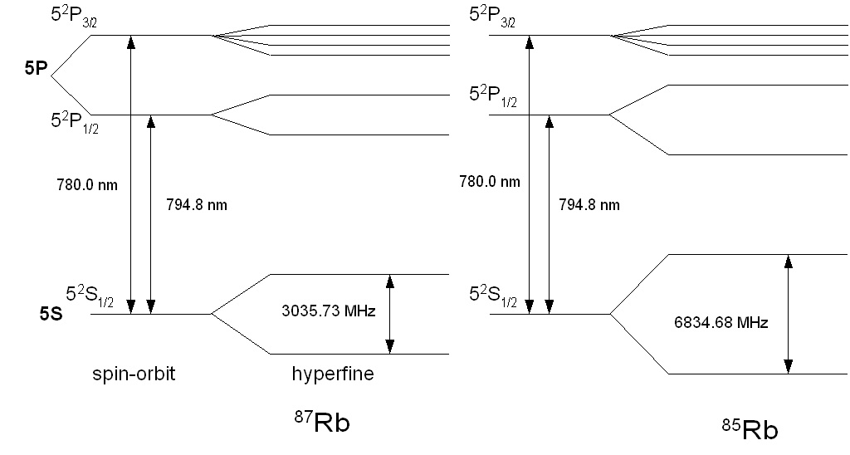
Figure V-1: Hyperfine structure of the two isotopes of Rubidium.

In this lab, you will study the transition from the 5S_{1/2} state to the 5P_{3/2} state (the D₂ line at 780 nm) and observe the splitting of the 5S_{1/2} state. You will see four absorption dips corresponding to resonant transitions from either of the two ground states of the two isotopes to allowed 5P_{3/2} excited states. The widths of these dips can be related to the temperature, and thus the velocity distribution of the atoms. (This is nicely described in the lab manual at the University of Colorado, in the references above, and we repeat much of it here.)

The probability that an atom has a velocity between v and v +dv is given by the Maxwell distribution:
$P(v)\text{dv}={\left(\frac{M}{2π\text{kT}}\right)}^{1/2}\text{exp}\left(−\frac{\text{Mv}}{2\text{kT}}\right)\text{dv}$ V-6

where M is the mass of the atom, k is Boltzmann’s constant, and T is the absolute temperature. By rearranging V-5 to express v in terms of the frequencies, and substituting in V-6, one can write the the probability for light absorption to occur at a frequency between f_{L} and f_{L} +df as:
$P(f_{L}){\text{df}}_{L}=\frac{2}{δ\sqrt{π}}\text{exp}\left(−4\frac{{\left(f_{L}−f_{0}\right)}^{2}}{δ^{2}}\right){\text{df}}_{L}$ V-7
where δ is called the “line-width” parameter:

$δ=σ\sqrt{8}≡2\frac{f_{0}}{c}\sqrt{\frac{2\text{kT}}{M}}$, V-8

where σ can be determined by fitting each absorption peak to a Gaussian distribution. The lineshift parameter can be used to determine T.

Procedure Outline
The basic experimental arrangement is shown in figure V-2. A diode laser is inside a mount connected to both a temperature controller and a second controller for the injection current of the diode. Light from the diode laser is collimated and attenuated before exiting the laser safety box. The laser light then passes through a cell filled with natural rubidium and is detected by a photodiode. If the light is at precisely the frequency corresponding to the atomic transition from the 5S_{1/2} ground state to the 5P_{3/2} excited state, the laser light will be absorbed as the rubidium atoms are excited out of their ground state, and consequently a drop in the photodiode signal occurs. Since for each rubidium isotope the ground state has two hyperfine levels (with quantum numbers F=1 and F=2) from which transitions to the excited states are possible, we expect to observe a total of four dips in the photodiode signal. Light resonant with this D₂ transition has a wavelength of about 780 nm. (Light at 795 nm, not achievable in this experiment will cause a 5S_{1/2} → 5P_{1/2} transition, the rubidium D₁ line.) To record an absorption spectrum, the frequency of the laser light is tuned across the optical transitions by changing the temperature or the current injected through the diode.

Interestingly, the excited rubidium atoms, produced by absorption of the laser light, will de-excite back to the ground state and emit light at the same frequency. When the experiment is tuned properly, this light can easily be seen with an infrared camera.

The Laser

Diode lasers are a relatively recent development in the history of lasers, and are used throughout the optical communications industry. The basic principle of the laser, based on stimulated emission, can be found in many textbooks. In semiconductor lasers, current injected into the diode stimulates the creation of electron-hole pairs, which recombine to form light. The most common semiconductor material used to produce light in the 780-900 nm region is a layered material of AlGaAs. For a given type of diode laser, each individual diode can have different characteristics resulting from the manufacturing process of the substrate. A more detailed description of diode lasers and their practical use in modern atomic physics can be found in the article by Weiman and Hollberg listed in the references.

Our laser is a 120 mW Sharp GH0781JA2C diode, hand-picked to lase at 780±1 nm not too far from room temperature. The mount has a “thermoelectric” cooler and a temperature sensor to monitor the temperature of the laser. Actually, the sensor is monitoring the temperature of the mount itself, so the controller tends to be rather slow to respond to changes because of the relatively large thermal mass of the mount.

The laser has a very divergent beam, so the light must be focused as close to the diode as possible. A collimating lens (focal length = 5 mm) is mounted in a microscope objective housing just at the exit of the diode. The laser is also much more powerful than required for the experiment, so a neutral density filter reduces the laser intensity down to less than 1 mW. For safety and temperature stability, the laser mount and the neutral density filter (ND3, which reduces the light intensity by 1000 or 10³) are enclosed in a box. DO NOT ATTEMPT TO OPEN THE BOX.

The frequency (and thus wavelength) of the emitted light depends on both temperature and the supplied current. In principle it is necessary to fully characterize the properties of the laser diode in order to know approximately where to set the temperature so that it will lase at the desired frequency. A precision spectrometer is presently not available to us in Physics 405, so this has been performed in one of the Atomic Physics laboratories here on campus prior to setting up the experiment. Our desired 780 nm light can be achieved at a temperature of 8.6° C and an injection current of about 90 mA. Away from this temperature, the laser operates at a very different frequency or jumps between multiple frequencies.

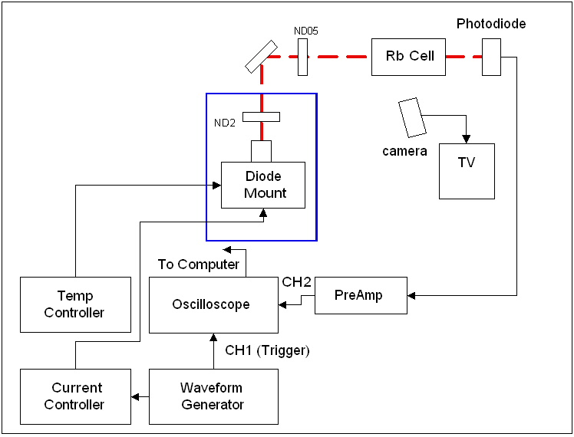
.
Figure V-2: Schematic of the apparatus

The Thorlabs TEC2000 temperature controller operates by a process called thermoelectric cooling. Energy in the form of heat is absorbed or released when a current passes through a junction of two dissimilar materials, such as a bimetallic strip or a p-n junction in a semiconductor. By controlling the direction and magnitude of the current across the junction, thermal energy can flow in either direction, providing either cooling or heating. The TEC2000 is designed to operate with a variety of different thermal loads, and thus one can tune the proportional, integral and derivative feedback parameters to suit the load. (For a concise discussion of the principles behind PID feedback loops, consult “Building Scientific Apparatus”, by Moore, Davis, and Coplan, p 519.) These parameters have been properly adjusted for the experiment to maintain a constant temperature of 8.62° C. If you find that the measured temperature is not stable to 0.05° C, consult with your instructor. NOTE: THE TEMPERATURE CONTROLLER SHOULD BE ON AT ALL TIMES AND NOT ADJUSTED. In the event of a power outage, contact one of the instructors or labporatory technical staff.

The Thorlabs LDC 500 current controller allows the current delivered to the diode to be adjusted either by hand or to be modulated with an input signal. The maximum current delivered to the diode can be set from the front panel, and should be kept at the preset value of 110 mA in order to protect the diode. You should have the front display set to injection current (I_{LD}) as you will typically want to monitor the injection current. In the back of the current controller is also a modulating input. In this experiment a saw-tooth signal from a function generator will provide such a modulating signal that will add a (small) periodic variation to the preset current. When the modulation is turned on you can observe the corresponding current changes on the LED display of the controller. The modulation amplitude should always be kept much lower than the average current that is injected into the diode. In the present experiment, the current, which corresponds to emission of light resonant with the rubidium D₂ line, is approximately 90 mA, whereas the modulation is about 3 mA above and below this value.

IMPORTANT SAFETY NOTE: The wavelength of this laser is infrared, so it is barely visible on a piece of white paper, so you’ll need to use an infrared card to see the beam. Nonetheless it can do damage to your eyes if the direct beam reaches you. While precautions have been taken to avoid this, use caution whenever the laser is turned on. Laser goggles are available: these will filter out the laser light but pass through visible light so you can still see the laser on the IR card. Avoid putting your head in the vicinity of beam height or looking directly into the laser beam at any time.

The Rubidium Cell
The cell used in this experiment contains natural Rubidium, which is approximately 72% ⁸⁵Rb and 28% ⁸⁷Rb. Rubidium is an alkali metal that has a high vapor pressure at room temperature. The cell is constructed of a Pyrex tube with windows fused onto the ends. The cell is evacuated, and a few grams of rubidium are deposited in the cell. Some small fraction of the metal vaporizes, so the cell will contain a small sample of rubidium gas in addition to the metal on the glass walls. Do not handle or adjust the cell, as it is very fragile and costly to replace.

The Photodiode
After passing through the rubidium cell, the laser light is incident on a photodiode. The photodiode is connected to a transimpedance amplifier that converts the output current signal to a voltage. The gain of the amplifier should be set to 10⁴ Volts/Amp. The photodiode signal is then sent to CH2 of the oscilloscope.

The Infra-Red Camera
If the light incident on the atoms is resonant with an atomic transition the atoms will cycle between the corresponding ground and excited states while absorbing and reemitting light. A CCD camera sensitive to infrared light used in conjunction with a TV monitor is set up to enable observation of the fluorescent light emitted by the atoms. As the laser is periodically swept through the atomic transitions light flashes can be easily observed on the TV screen.

Procedure Detail
As mentioned above, the temperature controller should be on when you enter the lab, the laser diode controller should be on, but at zero current on the display, and all other equipment should be off. Check that the temperature controller’s set point T_{set} is 8.62° C, and that the actual temperature, T_{act}, is close to this value (to the last significant digit). Do not adjust the temperature set point or the PID Gain parameters. Turn on the transimpedance amplifier and set gain to 10⁴ Volts/Amp and verify that the amplified signal is connected to CH1 on the oscilloscope. Turn on the TV monitor, you should see an image of the Rb cell and part of the set-up appear on the screen.

Mapping the output of the laser:
Before enabling the laser diode controller, check that the current adjustment knob is fully counterclockwise (e.g., set to 0). Verify that the maximum current, I_{lim} , is set to no more than 110 mA. Disconnect the waveform generator from the current controller, so that you can start with no modulation of the current. (It is advisable that you disconnect the cable at the front of the wave generator, rather than at the back of the laser diode controller.) Click on the ENABLE button and slowly increase the injection current. The laser diode has a threshold current of about 40 mA. At currents above that value you should begin to see a clear signal from the photodiode. You should also easily see a bright red spot when you hold the IR-card in the path of the light beam. In steps of 5 mA between 30 and 90 mA, record the photodiode output (you can just read the value from the scope) and the injection current. The laser power will continue to increase with increasing current and this will be reflected in the photodiode output. Make a graph of the photodiode signal vs. I_{act}. While it’s tricky to estimate the laser output power from the photodiode signal, this will give you a feeling for how the laser behaves. Note the threshold and slope.

Note that although the diode is lasing, it is likely not lasing at the right wavelength to cause the transitions in Rb. This will only happen at a very specific injection current, near 90 mA. The best approach is to raise the current to above this value (about 100 mA), and then very slowly, in steps of 0.1 mA, reduce the current to the region of 85-95 mA. You should be able to see flourescence in the cell coming from excited Rb atoms that have been stimulated by the laser when you have achieved the correct wavelength. . If you are lucky enough to see this, note the injection current at which it occurs and set the controller there.

Setup of the waveform generator:
Before connecting the waveform generator to the current controller, observe the waveform output on CH2 of the oscilloscope. You should adjust the waveform as shown in figure V-3: most useful is an asymmetric sawtooth ramp with a full period of about 180 msec and a full (peak-to-peak) amplitude of no more than about 200 mV. The output of the waveform generator is then connected to the modulation input at the back of the laser diode controller. On the display you will notice that the current varies periodically between a minimum value of approximately 88 mA and a maximum value of 96 mA. On CH1 of the oscilloscope you can also now observe how the photodiode signal increases and decreases synchronously with the applied saw-tooth modulation signal.
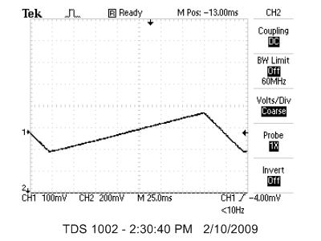
Figure V-3: Setup of the waveform generator ramp signal

Tuning to the absorption signal:
With the current modulation on, raise the current manually until the maximum current reading is approximately 100 mA. (Be careful not to exceed the value of I_{LIM} -- the controller will start to beep.) Then reduce the current in very small steps of 0.1 mA while observing the photodiode signal on the oscilloscope (at this point you should have the scope triggering on CH1). As you start sweeping across the atomic resonances the corresponding dips in the photodiode signal will enter the oscilloscope display one by one from the left hand side. Keep reducing the current slowly until you have all four peaks on the display. If your maximum current value is below 85 mA and you have not seen the desired signal, repeat the procedure a few times, likely you have turned down the current too fast or in steps that were too big. Once you have observed all four dips, record your trace on the computer. The OpenChoice software on the computer will capture the display and allow you to save either a picture or a .CSV file that can be transferred to Excel or some other analysis program.

Data analysis:
For the conditions that give you the best spectrum, identify the four hyperfine peaks, two from ⁸⁵Rb and two from ⁸⁷Rb. Taking care to align the signal amplitudes at the beginning and at the end of the sweep, you should be able to subtract the baseline, and invert the spectrum so that you have 4 upward pointing peaks, as shown in figure V-4. Identify the atomic transition (and the Rb isotope) that corresponds to each peak, and verify that the splitting in ⁸⁵Rb is about half that of ⁸⁷Rb. Use the spacing between the peaks as cited in the literature to calibrate your x-axis in frequency units and determine the widths of the peaks in MHz from these values. How do the widths of the different peaks compare? From the widths of the peaks you can determine the mean temperature of the Rb atoms. You’ll need to look up the mass of the Rb atoms.

Discussion Questions
A. Do you expect the peaks that you see to be Gaussian? Explain.

B. What feature of the laser gives rise to high resolution spectroscopy? In your experiment, the diode laser has a spectral linewidth of approximately 20 MHz. Why then were you unable to resolve the hyperfine structure of the excited P-states? How might you go about getting around this (this is a technique called “Doppler-free” saturated absorption spectroscopy)?

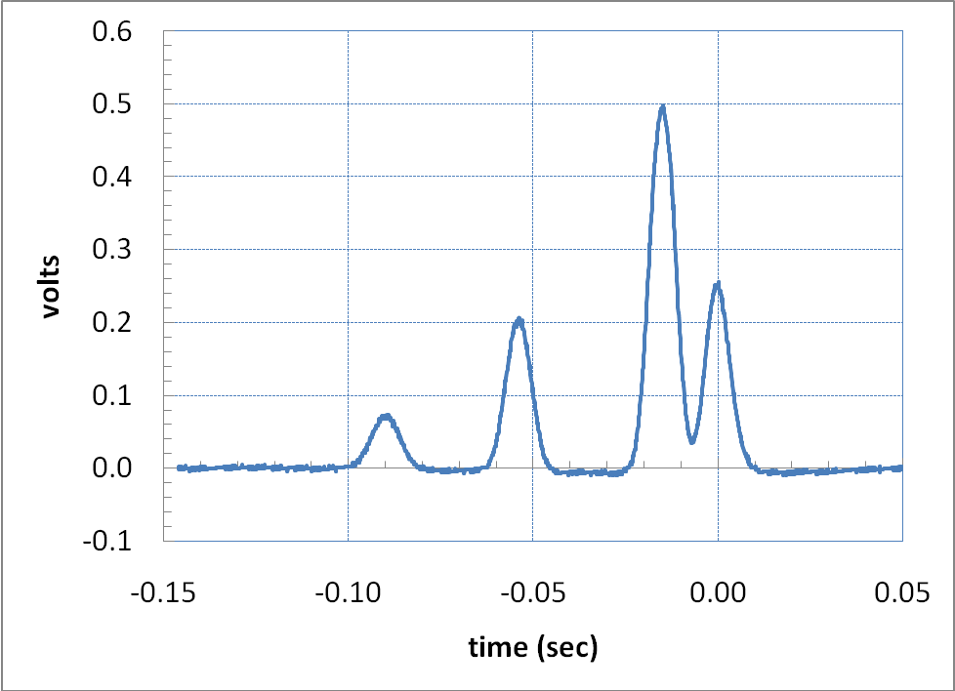

Figure V-4: Background subtracted hyperfine spectrum of rubidium. This spectrum was acquired with the diode laser at 8.6° C.

