IV: Determining Planck’s Constant from the Photoelectric Effect

References
A.B. Arons and M.B. Peppard, American Journal of Physics 33, 367 (1965). (Translation of Einstein’s original 1905 paper ).

R.A. Millikan, Phys. Rev. 7, 355 (1916).

H. J. Round, Electr. World, 49, 308 (1907). There is also a short summary of the history of the LED in an April 2007 edition of Nature Photonics.

Preparatory Questions
(must be answered in lab book before experiment is started and signed by instructor or TA)
- Make a sketch of current vs. voltage for the LED. Show clearly the region in which you will be taking data. Sketch how you expect to get the diffusion potential V_{D}.
- Describe how you will determine the central emission wavelength of each LED. What factors influence the shape of the spectrum of the light detected by the Luxmeter at the output of the monochromator?

Overview
Shining a light upon a metal surface can induce the emission of electrons. It was known from experimentation this process takes place on a time scale of 10⁻⁸ seconds, but the classical radiation theory would predict a much slower timescale, on the order of 100 seconds. In one of his famous 1905 papers, Einstein postulated a particle theory of light as the explanation, relating the energy of the emitted electrons to the quanta of light postulated by Planck 5 years earlier in order to explain blackbody radiation. The quantized nature of the emission was eventually shown experimentally by Millikan in 1916. Planck’s constant, the ratio between the energy of the emitted electrons and the frequency of the incident photons, is what will be measured in this experiment. These extraordinary results were recognized by Nobel Prizes in Physics for Planck in 1918, Einstein in 1921, and Millikan in 1923.
Here we will use the reverse process, emission of photons from a light emitting diode. The phenomenon of light emission by electrical excitation of a solid was first observed in 1907 by H. J. Round using silicon carbide (SiC). O. V. Lossev investigated these electro-luminescence effects in more detail between 1927 and 1942, and correctly assumed that they represent the inverse of Einstein's photoelectric effect.

Theory
LEDs are based on the injection luminescence principle. They consist of a simple p-n junction diode. Without an externally applied voltage, a diffusion potential $V_{D}$ is generated in the depletion layer between the n- and p-type material. The diffusion potential prevents electrons and holes from leaving the n- and p-regions respectively and entering the opposite regions
When an external voltage $V$ is applied in the forward bias direction, the barrier is reduced to e($V_{D}$-$V$). When $V»V_{D}$ the barrier is nearly zero and electrons can flow from the n-side to the p-side. As electrons are injected, some will radiatively recombine with holes from the p region and emit a photon of energy $hν»E_{g}$, the band gap energy.
This means that to a very good approximation
${\text{eV}}_{D}»E_{g}$ IV-1
If we assume that, of those electrons injected into the depletion region, all of their energy supplied by the electric field is converted into light, then the frequency of that light is approximately,
$hν»E_{g}$ IV-2
Combining Eqs. IV-1 and IV-2 gives,
$hν»{\text{eV}}_{D}$ IV-3
Equation IV-3 therefore provides us a way of measuring Planck's constant. If we know the frequency of the light emitted from the LED and we can measure the diffusion potential, then $h/e$ is given by Eq. IV-3. However you will be finding the wavelength of the light, not its frequency. Since you know that $\text{νλ}=c$, Eq. IV-3 can be rewritten: $V_{D}=\left(\frac{\text{hc}}{e}\right)\frac{1}{λ}$ IV-4
The next section below describes how to find $\left(\frac{\text{hc}}{e}\right)$ and since $c$ is a defined quantity and $e$ is known with high precision, it is possible to extract$h$.

Procedure Outline
To determine h in this experiment you will basically be looking for the voltage at which the diode begins to emit light, for diodes of differing wavelengths. The circuit board containing the diodes is shown in Fig. IV-1.
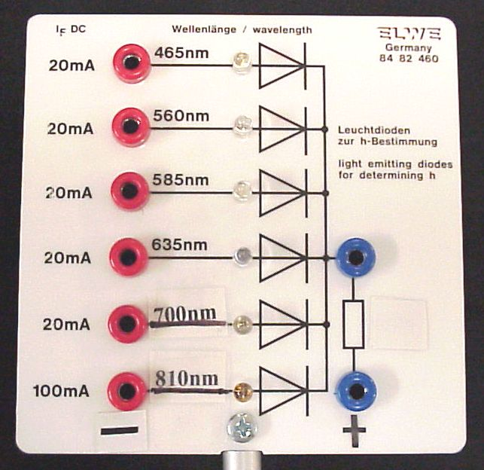

Figure IV-1
The spectrum of light coming out of an LED is relatively narrow compared with, for example, a light bulb, but broad compared with a laser. You will be measuring the central value of the emission wavelength with a monochromator. The light intensity and the current are a function of the diffusion potential, $V_{D}$. There is a "knee" in the curves where the intensity/current begins to increase rapidly. The applied voltage at the "knee" is proportional to the minimum voltage for light to be emitted from the diode. The applied voltage at the "knee" must be approximately $V_{D}$. Since we need $V_{D}$ to apply Eq. (4), data below the turn on potential will not be used in the analysis.
The LED (in the visible region) will begin to emit light when the voltage is above the knee. Again, this is because at this voltage you are injecting a significant number of electrons into the depletion region where they recombine with holes and emit light. This observation indicates that the two physical phenomena (light emission and conduction) are causally linked. You can demonstrate this relationship by plotting graphs of light intensity (Lux) versus current. What you will need for your data analysis are the intensity-V curves for each working diode.
After you have collected your intensity vs. voltage data, use the grating spectrometer and photodetector to measure the emission spectrum from each working diode. Mount the emitting diode at the entrance slit of the spectrometer and the photodetector at the exit slit (remove the aluminum slit cap from the photodetector). Set the applied voltage difference around 3.8 volts (follow the more detailed instructions below). Rotate the grating of the spectrometer until you see the maximum output from the photodetector. Note that wavelength and voltage. Then, on each side of the maximum in steps of 5 nm measure the output value of the light sensor. You should go far enough away from the central value that you see the Lux value drop to a baseline.

Procedure Detail
A monochromator (Jarrell-Ash 82-410) is used to determine the actual wavelength of each of the LEDs. This device uses a movable diffraction grating to separate the light and selects the desired component with the exit slit. The construction is as indicated in Fig. IV-2. This arrangement, known as the Ebert mounting, allows a given optical length to be placed in a box half that long. When using the monochromator with the 6000 Å grating, the indicator on top will show the approximate wavelength of the first order spectra in nanometers. Note that this reading is approximate, since harsh treatment of the device can cause slippage of the indicator shaft. You may need to pay attention to backlash effects as well.

Figure IV-2

Setting Maximum Voltage Applied to Diodes:
Connect positive and negative terminals of the ramping power supply to the Keithley 177 Microvolt meter. Set ramp/reset switch to ramp position and observe voltage. Adjust output voltage of power supply so that the power supply ramps voltage from 0 (zero) to approximately 3.8 volts. Never go above 4 volts on the supply voltage when attached to a diode!
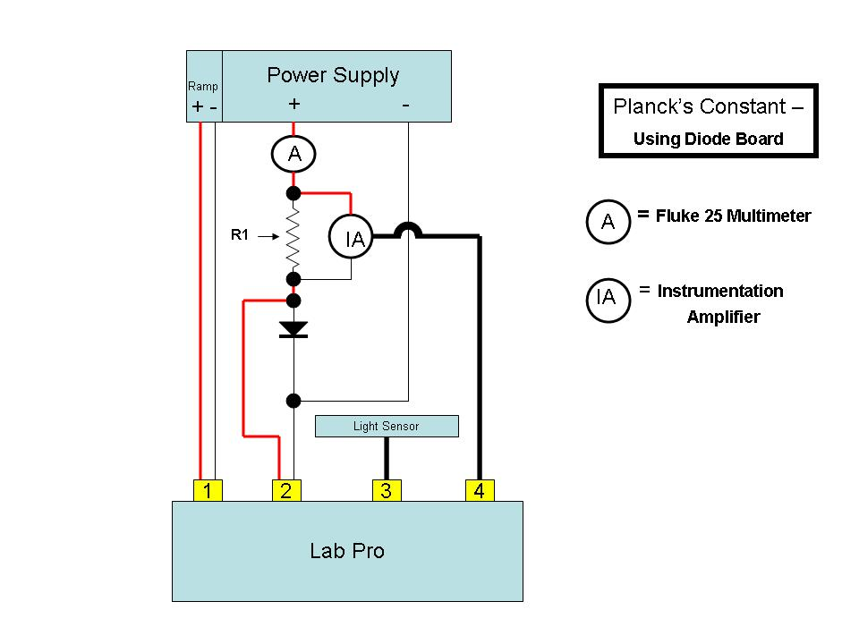

Figure IV-3 Circuit diagram for connecting the LED board and the photodetector

Connections to record the LED lumens vs applied current:
- Put the ramp/reset switch on the ramp power supply in the reset position and disconnect from the voltmeter.
- Connect the ramp power supply positive and negative terminals to the diode apparatus as shown in Figure IV-3. Be sure to include connecting the Fluke 25 DMM so that the current can be monitored accurately.
- Connect the CH 1 signal terminals of the Lab Pro to the trigger output of the ramp power supply.
- Connect the CH 2 signal terminals of the Lab Pro to measure the voltage applied to the diodes. Note: the positive connection should be made after the R1 resister so that you are measuring only the voltage applied to the diode.
- Connect the light sensor to the CH 3 signal terminals of the Lab Pro.
- Connect the CH 4 signal terminals of the Lab Pro to the Instrumentation Amplifier so that you can measure the voltage drop across the resister in the diode apparatus. For this experiment you will be using the 0-1 volt setting of the Instrumentation Amplifier.

Current Limit
- Turn the current limit control of the ramping power supply to zero.
- Put the ramp/reset switch on the ramp power supply in the ramp position and wait approximately 10 seconds.
- Slowly increase the current limit of the power supply to set the current applied to the diode circuit to approximately 12 - 15 mA (observed with the Fluke 25 current meter). Do not exceed 20 mA as damage to the diodes could occur.

Diode alignment.
1. Install slit onto end of light sensor.
2. Align the light sensor and the diode to assure light from diode is collected with light sensor.
3. Put the ramp/reset switch on the ramp power supply in the reset position.

Computer acquisition of the diode and light sensor signal:
You are now ready to run the computer program “LoggerPro” which will permit you to record the output of the diode signal.
- Go to the Logger Pro Templates folder on the desktop and select the Plancks Constant - Diode Experiment template. This should start the Logger Pro program with the appropriate settings selected.
- In this experiment, the trigger that initiates the taking of data will be provided by the ramp power supply to CH 1 on the Lab Pro as the reset/ramp switch is set to the ramp position.
- Make sure the ramp switch on the power supply is set to reset. From the tool bar in Logger Pro press the “Zero” button and select “OK” to zero all sensors. This zeros, or aligns, Logger Pro and the Lab Pro with the sensors.
- Set the reset/ramp switch on the ramp power supply to the ramp position. This will initiate the ramping of the voltage of the power supply and the taking of the data by the computer. (It is a good idea to put the reset/ramp switch to the reset position as soon as the data sampling is completed to insure a proper zero start for the next data sampling.)
Note that the Instrumentation Amplifier has several range settings. It is important that if a different range setting is selected (default +/- 1 Volt) that the calibration for the amplifier must be changed to reflect this change. From the Logger Pro toolbar menu, select “Experiment”. From the list displayed move the curser to calibrate and the sensors used in this experiment will be displayed. Select the Instrumentation Amplifier and in the “Current Calibration” box select the range setting that you have chosen. Once the range of the amplifier has been changed and the calibration set, it is important to zero the Instrumentation Amplifier.

Recording the diode characteristics:
The following will allow you to record the wavelength characteristics of the diodes used in this experiment.
- Leave the LabPro and power supply connected to the diode apparatus as used in the previous section.
- Remove the slit from the light sensor and position sensor at exit slit of spectrometer.
- Put the ramp/reset switch on the ramp power supply in the ramp position. This will allow the ramping power supply to ramp to the full setting of 3.8 volts as done in the Preliminary section.
- Position diode board so that light from the illuminated diode enters the entrance slit of the spectrometer.
- Move dial of spectrometer to prescribed wavelength of illuminated diode.
- While observing the illumination scale Lux reading on the Logger Pro display, adjust light sensor, diode, and wavelength dial of spectrometer to maximize the Lux reading
- You must record the emission spectrum of each diode by reading the Lux intensity for a variety of wavelengths around the center peak maximum.

Data Analysis

Determining $V_{D}$:
For each of the diode Intensity versus Voltage curves make a linear fit to the linear portion of the curve above the knee. An approximate value for $V_{D}$ can be obtained from the intercept of the fitted line with the voltage axis. The intercept occurs at $−\frac{a_{0}}{a_{1}}$, where $a_{0}$ and $a_{1}$ are the intercept and slope of the fitted line. In your analysis you should look at how sensitive your value of $V_{D}$ is to the range or number of points used in your fit. Find the uncertainty, from the fit, for your value of $V_{D}$. For your report plot all six curves and show the best fit line, extrapolated to below the voltage axis.

Determining the Emission Spectra of the LEDs:
Perform a fit to each set of emission data to get the central wavelength and its uncertainty. The shape of the luxmeter data depends on both the emission spectrum of the LED, the acceptance of the monochromator, and the response function of the luxmeter, so the shape will not be perfectly Gaussian, but the “sigma” of the Gaussian will be a reasonable representation of the uncertainty. Plot the spectrum for each diode with its fitted function.

Determining hc/e and h:
For each diode, plot your values of $V_{D}$ versus $1/λ$, the reciprocal of the wavelength of the light emitted from the diode. The wavelength of the light from each diode is found from the central wavelength in your emission spectrum fit. The uncertainty in the wavelength is given by the half width of your fit to the emission spectrum data. Fit a line to the data points. From Eq. (4) the slope of the fitted line to the data is $\left(\frac{\text{hc}}{e}\right)$. Once you know $\left(\frac{\text{hc}}{e}\right)$, as c is a defined constant and e can be obtained from tables of physical constants, you can easily find your experimental value for h and its uncertainty.

Errors and other considerations:
Your report should also include some discussion of the physics of light emitting diodes. In particular you should consider the errors associated with the approximation given in Eq. (4). There is usually a spectral spread in the light emitted by the diode. Why is there a spread and how does it influence the error in your determination of h/e?
Another source of error comes from the fact that the diffusion potential is a function of temperature. Investigation of the temperature dependence of $V_{D}$ and comparison with reference data shows that $V_{D}$ rises with falling temperature:
$\frac{{ΔV}_{D}/ΔT}{V_{D0}}=−5\text{.}7x{\text{10}}^{−4}K^{−1}$ IV-5
Where $DT$ and ${DV}_{D}$ are the changes in temperature and diffusion potential, respectively, relative to their $T_{0}$ values, i.e. $DT=T−T_{0}$ and $DV=V_{D}−V_{D_{0}}$. $V_{D_{0}}$is the diffusion potential at $T_{0}=0K$. This increase can possibly explain the systematic error found in measurements at room temperature. Check this out by using Eq. (5) to estimate $V_{D_{0}}$ and plotting $V_{D_{0}}$vs. $1/λ$. Compare the values of ${\text{hc}}/e$ found from this plot to the one determined earlier.

