III: The Franck-Hertz Experiment

References
Melissinos and Napolitano, Experiments in Modern Physics, 2nd edition, 2003, pp. 10-20

Eisberg, Fundamentals of Modern Physics, 1961, p. 124-8

James Franck, Gustav Hertz, Nobel Prize, 1925.

Preparatory Questions
(must be answered in lab book before experiment is started and signed by instructor or TA)
- Why is the collecting anode made negative with respect to the grid?
- Why must the Franck-Hertz tube be operated at an elevated temperature? What is the consequence of going to a temperature even higher than recommended?
- Do you expect the heights of the voltage peaks to increase or decrease with increasing filament voltage? Why?
- Why are voltage maxima used to determine the energy of the excited state?

Overview
Bohr’s quantum theory of the atom was supported for emission of photons by the regular structure seen in atomic line spectra. The experiment by J. Franck and G. Hertz in 1914 confirmed the quantization of energy absorption for atoms excited by collisions with electrons. Mercury atoms, bombarded with electrons of known energy, only absorbed discrete amounts of energy during the electron atom collisions. This strengthened the acceptance of Bohr’s postulates as it implied that the energy levels were intrinsic to the atoms and not due to some special properties of photons.

Theory
Two basic postulates of Bohr’s quantum theory of the atom were the existence of discrete energy levels and the proposition that atoms can only absorb or emit by amounts corresponding to the difference between two such energy levels. Bohr’s theory was based on the regular characteristics of atomic line spectra (as are observed in Experiment II), but evidence was needed that the discrete energy levels were intrinsic to the atomic systems. One of the most direct experimental confirmations of the quantization of the energy absorbed by the atom was the experiment of J. Franck and G. Hertz. Mercury atoms were bombarded by electrons of known energy. The electrons lost only discrete amounts of energy, corresponding to differences in atomic states.
The Franck-Hertz tube is designed to be plano-parallel so that the accelerating fields are nearly uniform. In order for the electron beam to be approximately monoenergetic, the hot cathode sits behind a non-emitting diaphragm held at the same potential. The length of the interaction region is chosen to be several mean-free-paths for electron-atom collisions, so that electrons crossing this gap will collide with several mercury atoms. (The decelerating region between the grid and the collector electrode is small so that few collisions can occur.)
When an electron collides with an atom, several outcomes are possible:
An “elastic” collision. As the mercury atom is much more massive than the electron, little energy can be transferred from the electron to the atom, and the scattered electron continues with almost the same energy but on a different trajectory.
An “inelastic” collision. If the bombarding electron has sufficient energy it can raise the outermost bound electron of the mercury atom to a higher energy state. In this experiment 99.9997% of the mercury atoms will be in their ground state, and almost all of these collisions will result in the mercury electron being raised to its first excited state, which is about 4.9 eV above the ground state, and which is the amount of energy normally transferred from bombarding electron to atom.
A “superelastic” collision. Extremely rarely will an electron encounter an already excited atom, de-excite the atom to its ground state, and thereby gain kinetic energy. This process is too rare to be considered as an explanation for any effect observed by the experimenter.
The net effect of all the possible interactions is that the initially monoenergetic electron beam will have a variety of energies after passing through the tube.

Procedure
The apparatus is shown in Fig. III-1. The picoammeter, A₂, will measure the current of electrons, which start with energy corresponding to accelerating voltage, V₂, and pass through the interaction region to end up with more than the energy corresponding to voltage V₃. That is, it will not be reading the total electron current, but just that current of electrons which still possess some of their original energy when they finish traversing the tube. You will be measuring this current while changing the accelerating voltage.
As the potential difference between the positive grid and the cathode is first increased from zero, no current is collected until the electrons have enough energy to overcome the slight retarding voltage. Then the current “increases” (it is a current of negatively charged electrons so that it is actually a negative current) as the accelerating voltage is raised.
Once the accelerating potential reaches 4.9 volts, inelastic collisions become possible. Those electrons which suffer such a collision will not have sufficient energy to overcome the retarding potential between grid and collector. The current to the collector electrode will suddenly decrease. As the accelerating potential is further increased, even those electrons that have suffered inelastic collisions will again have energy to reach the collector and the current will continue to rise. Each time the accelerating potential reaches a multiple of the first excited state energy of the mercury atom, the current will decrease suddenly. This gives rise to a trace as in Fig. III-2.
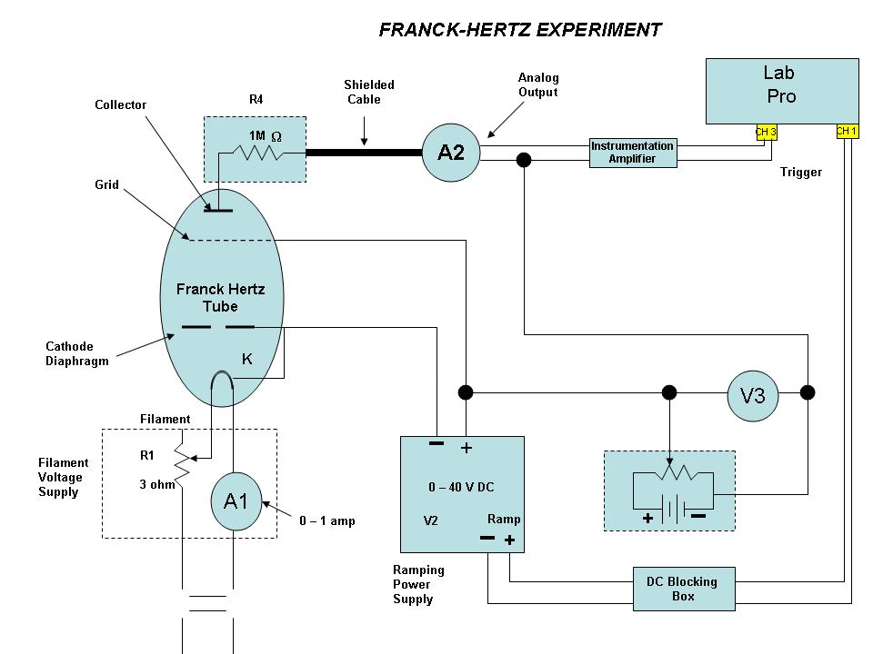
Figure III-1
A₁ 0-400 DC Milliameter
A₂ Picoammeter
V₂ Voltmeter on Power Supply
V₃ Voltmeter

Procedure Detail
The mercury vapor pressure is very sensitive to temperature. Consequently, the temperature should be kept stable, near 180°C. The oven temperature is set on the controller. Press the button on the controller face to view the set temperature. The oven should be switched on early enough to allow it to warm up and obtain equilibrium. Do not operate the tube above 200°C. Continue to monitor the oven temperature throughout the data-taking. Unfortunately, the Thermologic controller uses 60 Hz ac current to heat the oven and this can produce an unwanted 60 Hz modulation of the measured collector current. If you find too much 60 Hz noise on your data, it is recommended to turn the temperature controller off just prior to starting a data acquisition run. Remember to turn the temperature controller back on after the trace is finished so that the oven temperature can return to the initial value. You should note in your lab book the starting and final temperature of the oven and take any temperature drift problems into consideration when analyzing your data.
The filament is powered by a 6.3 VAC STEP-DOWN transformer. Make sure that the resistance R₁ is set at maximum (fully ccw) before turning on the transformer, to avoid a large current surge to the cold filament. With the accelerating voltage, V₂, set at maximum, the current through the Franck-Hertz tube should be about 0.1-1 nA as read from A₂ (the picoammeter) – this is set by R₁. Note that the anode current is a very sensitive function of the filament current, and should be monitored occasionally.

Figure III-2

In this experiment, a computer and a Lab Pro will be used to sample the voltage output of a picoammeter. The picoammeter is used to amplify the current generated by a Franck-Hertz tube. A variable acceleration voltage is applied to the tube by a ramping power supply. The values of the voltage at points where the current decreases due to inelastic collisions of electrons with mercury atoms are used to deduce the energy of the first excited state.
The computer will permit you to first display a linear graph of the tube current output vs. time (proportional to acceleration voltage) and then a linear graph of the ramping (acceleration) voltage as a function of time for purposes of calibration. These graphs will be used for qualitative and quantitative analysis. It will be possible to save the data to a file for further analysis, or to print out graphs or numerical values.

Connections to record the Franck-Hertz output:
The following connections will permit you to record the tube output as a function of time and to determine for which times the tube current begins to decrease (current peaks). The connections are made from the tube to the pico-ammeter and to the Lab Pro as shown in Fig. III-1 and in the following way:
- Connect the ramp power supply positive and negative terminals to the grid and the cathode of the Franck-Hertz tube. The cathode connection is actually the low voltage side of the filament connection.
- Connect the Franck-Hertz collector terminal to the picoammeter using a BNC cable.
- Connect the analog output of the picoammeter (at the rear of the instrument) to the input of the Instrumentation Amplifier. The Instrumentation Amplifier should then be connected to CH 3 input of the Lab Pro.
- Connect the box labeled “Adjustable V3” to the circuit. This applies the retarding voltage to the circuit and tube. The positive terminal connects to the positive terminal of the power supply and the negative terminal to the negative input of the instrumentation amplifier. Also connect the voltmeter to monitor and adjust the retarding voltage. These connections are shown in figure III-1.
- Connect the trigger output of the ramping power supply to the DC blocking interface box. The output of that box is connected to CH 1 input of the Lab Pro.

Preliminaries:
- Put the ramp/reset switch on the ramp power supply to the RESET position. In this position, the voltage output is zero. One voltage ramp is generated by putting the switch in the ramp position.
- Adjust the maximum voltage produced by the supply to its maximum. (This is approximately 40 volts.)
- Ramp the power supply and adjust the ramp speed for the ramping time to be approximately 20 seconds.

Computer acquisition of the signal using the program Logger Pro:
You are now ready to run the computer program “Logger Pro” which will permit you to record the output of the pico-ammeter.
- Select the folder on the computer desktop labeled Lab_Pro_Templates. This folder contains Logger Pro templates designed for the Phys 405 lab experiments. Selecting one of these templates starts the program Logger Pro and loads the setup information for the experiment selected.

The following information is stored in the Logger Pro template.
- The Lab Pro will collect data from 3 analog channels.
- Channel 3 (Instrumentation Amplifier with Gain setting +/- 1volt) is set to collect data from the Pico Ammeter and display this data in the table and on the graph.
- Channel 2 is set to collect data from the output of the voltage divider and display this data in a table and as a graph.
- Channel 1 is set to trigger the data collection. The trigger that initiates the taking of data will be provided by the ramp power supply as the reset/ramp switch is set to the ramp position. The trigger data is not displayed.
- The Data Collection sampling rate is set to 50 samples (measurements) per second.
- The Data Collection Length has been set to 20 seconds.
- Make sure the ramp switch on the power supply is set to reset and press the “zero check” button on the Pico Ammeter (the reading on the meter should now be zero). From the tool bar in Logger Pro press the “Zero” button and select “OK” to zero all sensors. This zeros, or aligns, Logger Pro and the Lab Pro with the sensors. Press the “Zero Check” button again on the Pico Ammeter to turn off this feature.
- Click on the Collect button and the screen should tell you it is “Waiting for trigger”.
- Set the reset/ramp switch on the ramp power supply to the ramp position. This will initiate the ramping of the voltage of the power supply and the taking of the data by the computer. (It is a good idea to put the reset/ramp switch to the reset position as soon as the data sampling is completed to insure a proper zero start for the next data sampling.)

You cannot collect both the current from the Franck-Hertz tube and the applied ramping voltage at the same time, due to grounding issues.
Measuring small currents always calls for care. The picoammeter is delicate and should always be kept on scale. Keep it on its least sensitive scale when not using it. You must minimize movement near the circuit when measuring as you can induce currents even in shielded cable. Note that the Thermologic temperature controller may radiate noise into the system.
If there appears to be too much 60 Hz noise on your data, try turning off the Thermologic controller while you acquire data. If further noise reduction is needed, the variable resistance and capacitance boxes supplied can be used to construct a low-pass RC filter.

Note that the Instrumentation Amplifier has several range settings. It is important that if a different range setting is selected (default +/- 1 Volt) that the calibration for the amplifier must be changed to reflect this change. From the Logger Pro toolbar menu, select “Experiment”. From the list displayed move the curser to calibrate and the three sensors used in this experiment will be displayed. Select the Instrumentation Amplifier and in the “Current Calibration” box select the range setting that you have chosen. Once the range of the amplifier has been changed and the calibration set, it is important to zero the Instrumentation Amplifier.

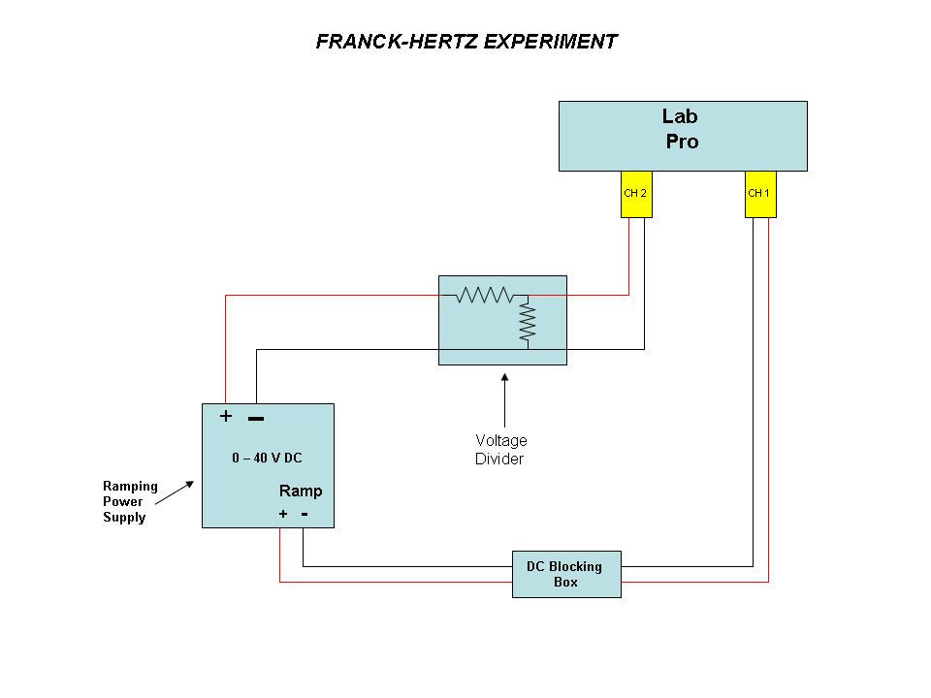
Figure III-3

Connections to record the ramp voltage (for calibrations)
The following connections will permit you to record the voltage output of the voltage divider as a function of time and to convert the time dependence of the current to the accelerating voltage difference at the beginning of the decrease in the current due to inelastic collisions of the electrons. See figure III-3.
1. Using the same settings on the ramp power supply as used to measure the Frank Hertz output, disconnect the output of the ramping power supply from the Franck-Hertz tube and connect it to the input of the 0.1X voltage divider. You should note that this voltage divider output voltage is approximately 10 times smaller than the input voltage. You must measure the total resistance and the output resistance of the voltage divider and calculate the factor by which the divider divides the input voltage difference.
2. The output of that divider is connected to the CH 2 input of the Lab Pro. If you connect the ramping power supply directly to the Lab Pro, the Lab Pro will be destroyed!
3. If you used an RC filter in your circuit, it is also important to understand the effect of the RC filter on your data because that circuit could introduce a time delay which alters the voltage-versus time in the measurement of the tube output.

The procedure to make a graph of the voltage of the power supply as a function of the computer sample number will be the same. It is important to use the same number of samples per second and total number of samples. If you used an RC filter in your circuit, it is also important to understand the effect of the RC filter on your data because that circuit could introduce a time delay which alters the voltage-versus time in the measurement of the tube output. Also, depending upon the choice of R, the RC filter, together with the input impedance of the A-D converter can actually behave as an unwanted voltage divider. You need to know what your measuring circuit is doing to your data and include these effects in your data analysis. You will reduce the ramping voltage by approximately a factor of ten with a voltage divider so that the 40 volt ramping voltage range can be accommodated by the computer (10 volt maximum). Multiply the recorded value by your measured value of the attenuation factor to obtain the correct ramp-voltage verses time conversion.
Determine if the shape of the curve depends upon the value of V3. Make an enlarged plot covering two successive maxima for two rather different values of V3.
Determine the energy of the first excited state of mercury. Successive maxima of the collector current, A2 should occur at voltages:
.
Since the background current rises, in order to find the peak positions one should first fit the background with a low order polynomial, and then fit individual peaks to a Gaussian. The center of the gaussian fit obtained from the fit statistics will give the position of the peaks.
The form of this equation should suggest how to determine V_{x} from your measured values of V_{max}. What is the physical significance of b ?

Discussion Questions (to be answered in lab report)
A. What is the maximum fraction of its energy that an electron can give to a stationary mercury atom in an elastic collision?
B. What is an electron-volt and what is its value in ergs?
C. What happens to the excited mercury atoms? If radiation is involved, what is its wavelength and how could it be detected?
D. The width of the first excited state in mercury is quite small (0.001 eV). What causes the much larger observed widths of the current minima?

