XII: Earth’s Field Nuclear Magnetic Resonance

References
“Resonance absorption by Nuclear Magnetic Moments in a solid”, Physical Review 69, 37-38 (1946).
“The Nuclear Induction Experiments”, F. Block, W. W. Hansen and M. Puckard, Phys Rev 70, 474 (1946).
“Nuclear Magnetism”, A. Abragam (Oxford at the Clarendon Press, 1961).
“Introduction to Solid State Physics”, C. Kittel.
“Optimizing Sudden Passage in the Earth’s-Field NMR Technique”, Journal of Magnetic Resonance, Series A, 122, 42-49 (1996).
(note: elements of the text of this lab manual are taken from the Teachspin Manual provided with the apparatus.)

Preparatory Questions
(must be answered in lab book before experiment is started and signed by instructor or TA)
- The measured value of the gyromagnetic ratio for a proton is $γ$ = 2.675x10⁸ C/kg (rad/sec-Tesla). Consider a classical particle of mass m and charge +q rotating at constant angular velocity ω in a circular orbit of radius r. Associated with the moving charge is an average current I=qf and a magnetic moment of $μ=Iπ r^{2}$. Calculate the classically predicted gyromagnetic ratio for a proton and compare it to its measured value. Why the difference?
- What is the meaning of T₁, T₂ and T₂*? From equation XII-9, what is the functional form of the decay of the free induction signal?
- What does it mean and why is it important to place the NMR detection coils properly?

Overview
On a snowy December 15, in 1945, a group of three young Harvard physicists, fresh from working on a secret radar system at the MIT Radiation Laboratory that greatly helped the allies win World War II, adjusted the controls on a crude electromagnet borrowed from Professor Curry Street's comic ray experiments. They became excited when they observed a repeatable deflection on the detector output meter. It was the first measurement of nuclear magnetic resonance in condensed matter. The material used for these first experiments was paraffin wax. The experimenters were Edward Purcell, Robert Pound and Henry Torrey. Ed Purcell, who led the group, received the Nobel Prize for this discovery. On the west coast, Felix Bloch at Stanford University had devised an apparatus to observe “nuclear induction” from magnetic nuclei in condensed matter systems. His work with W. W. Hansen and M. Packard published shortly after Purcell’s, is in many ways close to the experiments you will be doing in this laboratory. Neither of these two giants of twentieth century physics had any idea that their discoveries would change physics, chemistry, biology, and medicine in truly profound ways. NMR is one of the tools used for the identification and the structure determination of complex molecules. A major medical application, which we are all aware of, is magnetic resonance imaging (MRI), which allows three-dimensional resolution of abnormal growths, configurations, and reactions in the whole body.

Theory
Magnetic resonance signals can only be observed from materials whose atomic constituency has two properties: magnetic moment and angular momentum. Both are required and both act along a common axis, either parallel or anti-parallel. Nature has provided us with many examples, such as a single electron, certain collections of electrons, protons, neutrons, the nuclei of He³, Li⁷, Be⁹, C¹³, N¹⁴, 0¹⁷, F¹⁹, Na²³, Al²⁷, P³¹, and many, many more. Magnetic resonance refers to the characteristic precession of these particles in the presence of an external magnetic field.

There is a fundamental relationship between the magnetic moment of a nucleus and its angular momentum. This is written as:
$\vec{μ}=γℏ\vec{I}$, XII-1
where I is the nuclear spin, $μ$ is the magnetic moment, $ℏ$ is Planck’s constant divided by 2$π$, and $γ$ is the gyromagnetic ratio. The product $ℏ$I=L is the angular momentum of the nucleus. In an externally applied magnetic field B (assume it is along the z axis), the energy U of interaction of the nuclear spin with B is $U=−\vec{μ}⋅\vec{B}=−γℏB_{Z}I_{Z}$. The allowed values of I_{Z} are m_{I}=I,I−1,…−I and U=$−m_{I}γℏB$. In a magnetic field, a nucleus with I=1/2 has only two energy levels corresponding to m_{I}=± ½. If $ℏω_{0}$ denotes the energy difference between the two levels then $ℏω_{0}=γℏB$. By applying electromagnetic radiation at the frequency ${ω_{0}}/2π$ we can, under certain conditions, induce an absorption of energy.

Figure XII-1 shows a positively charged nucleus with its magnetic moment oriented at an angle $θ$ with respect to the magnetic field B pointing along the +z axis. The spin angular momentum vector L is not shown but it points in the same direction as $\vec{μ}$. You may recall from Newton’s 2nd law, the expression for torque $\vec{τ}=d{\vec{L}}/{\text{dt}}$, and that the magnetic torque tending to align $\vec{μ}$ with $\vec{B}$ is given by $\vec{τ}=\vec{μ}×\vec{B}$. By using equation XII-1 we can arrive at
$\frac{d\vec{μ}}{\text{dt}}=γ\vec{μ}×\vec{B}$ XII-2
The solution is that $\vec{μ}$ precesses around B at an angular frequency, independent of$θ$;
$ω_{0}=γB$. XII-3
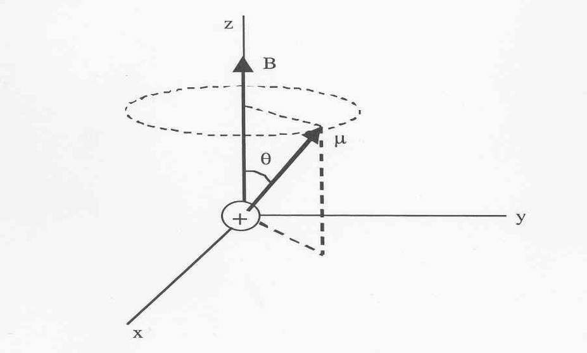

Figure XII-‎0-1
The angular frequency $ω_{0}$ is frequently called the Larmor precession frequency because a spinning charged sphere will execute precessional motion when placed in a uniform magnetic field. Both protons and electrons have charge and angular momentum and their magnetic moments will precess about an applied magnetic field.

Since it is almost impossible to detect the precession of a single proton or electron, we will be studying the collective precession of about 10²⁵ hydrogen nuclei (protons). If all those protons were aligned with their magnetic moments pointing in the same direction and they were all to precess and remain aligned, then our signal would be 10²⁵ times as large as from a single proton. But unfortunately not all the spins will point in the same direction because of interactions with the environment (temperature). The degree of alignment in a sample is formally referred to as the polarization or as the magnetization, M. The nuclear magnetization is the sum $\sum{{\vec{μ}}_{i}}$ over all the nuclei in a unit volume. There are only two possible magnetic states for the proton (spin=1/2) to reside in, spin along B (spin up) and spin opposed to B (spin down). The magnitude of the magnetization is proportional to the difference between spin up and spin down.

$M∝N_{↑}μ_{↑}−N_{↓}μ_{↓}$ XII-4

In thermal equilibrium, and in the presence of a not too large static magnetic field B, magnetization vector is given by
M_{x}=0 , M_{y}=0 , $M_{z}=M_{0}=χ_{0}B={\text{CB}}/T$ , XII-5
where T is the temperature, C is the Curie constant C=${{Nμ}^{2}}/3k_{B}$, $χ_{0}$ is the spin susceptibility, and k_{B} is the Boltzmann constant. The population ratio in thermal equilibrium is given by the Boltzmann factor for the energy difference $2μB$: $({N_{↓}}/{N_{↑}})_{0}=\text{exp}(−2{μB}/{k_{B}}T)$. For all fields, Eq. XII-5 for the equilibrium magnetization becomes
M₀=$Nμ$$\text{tanh}({μB}/{k_{B}}T)$. XII-6
As shown in Figure XII-2, if B=0 at t=0, and if we suddenly increase the magnetic field, the magnetization approaches its new equilibrium value M₀ according to
$\frac{{\text{dM}}_{z}}{\text{dt}}=\frac{M_{0}−M_{z}}{T_{1}}$ or $M_{z}(t)=M_{0}\left[1−\text{exp}(−t/{T_{1}})\right]$ , XII-7
where T₁ is called the longitudinal relaxation time or the spin lattice relaxation time.

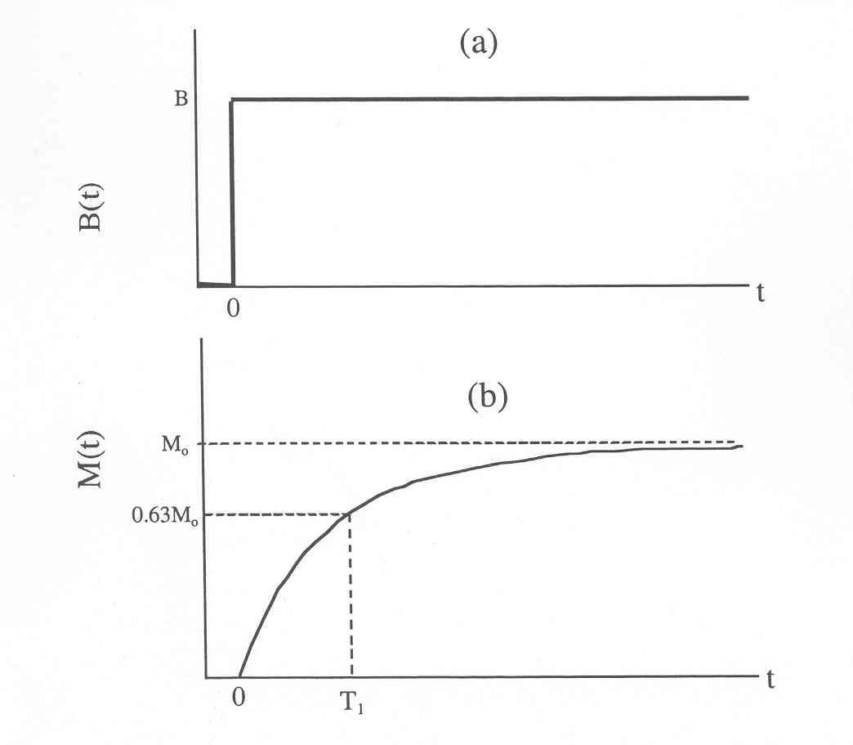
Figure XII-2
Combining Eqs. XII-2 and XII-7 for N spins, the rate of change of M_{z} becomes
$\frac{{\text{dM}}_{z}}{\text{dt}}=γ(\vec{M}×\vec{B})_{z}+\frac{M_{0}−M_{z}}{T_{1}}$ , XII-8
which shows that in addition to precessing about B, M will relax to an equilibrium value M₀. If the transverse magnetization components (M_{x} and M_{y}) are not zero, they must decay to zero in equilibrium but not necessarily at the same rate as T₁. We can describe this relaxation by
$\frac{{\text{dM}}_{x}}{\text{dt}}=γ(\vec{M}×\vec{B})_{x}−\frac{M_{x}}{T_{2}}$ and $\frac{{\text{dM}}_{y}}{\text{dt}}=γ(\vec{M}×\vec{B})_{y}−\frac{M_{y}}{T_{2}}$ , XII-9
where T₂ is called the transverse relaxation time. Sometimes T₁ and T₂ are nearly equal but generally T₁ > T₂ because T₂ is a measure of the time during which the individual moments that contribute to M_{x} or M_{y} remain in phase with each other. Placing your sample in a region where gradient magnetic fields exist, or studying samples with internal local magnetic fields will cause some of the spins to precess at different frequencies. If initially the spins have a common phase, the phases will become random over time and M_{x} and M_{y} will become zero. We generally think of T₂ as a dephasing time, but it is not necessarily a fundamental property of the system under investigation.

In order to detect the NMR signal, a sample is generally surrounded by a tightly coupled RF coil whose axis must be perpendicular to the applied static magnetic field. The RF coil provides an RF magnetic field of amplitude B₁ and frequency ω and is part of a circuit for measuring the inductance and loss of the coil. Such a system will show a resonant absorption of energy from the driving field. As the frequency is varied, the power absorbed P will be of the form
$P(ω)∝\frac{\text{ωγ}M_{z}T_{2}}{1+(ω_{0}−ω)^{2}T_{2}^{2}}B_{1}^{2}$ , XII-10
where $ω_{0}=γB$ with the half-width of the resonance at half-maximum power given by $(Δω)_{1/2}=1/{T_{2}}$.

Apparatus
In this experiment we will use the earth’s magnetic field as one of our externally applied fields as shown in Figure XII-3. The polarization power supply will supply a DC current to the coil surrounding the sample for a selectable amount of time. The current produces a polarizing magnetic field B_{P,} perpendicular to the earth’s magnetic field, that is several hundred times larger than the earth’s field. The nuclear magnetization M builds up with time constant T_{l} toward the equilibrium value in the resultant field B, which is the vector sum of B_{P} and B_{E}. The angle between B and the earth's field is $α$, and the initial value of this angle is usually very close to 90° if the polarizing field is large and is left on for a sufficiently long time.
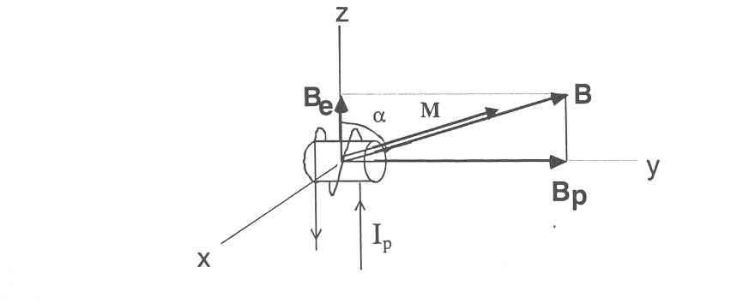
Figure XII-3
After the sample is polarized, the current in the coil is suddenly reduced to zero, and the tuned amplifier is automatically connected to the sample coil (after a delay of 100 ms needed to allow the transient response of the circuit to die down). The output of the tuned amplifier is viewed on an oscilloscope and the free precession of the spins can be directly observed, stored and transferred to a computer if necessary.

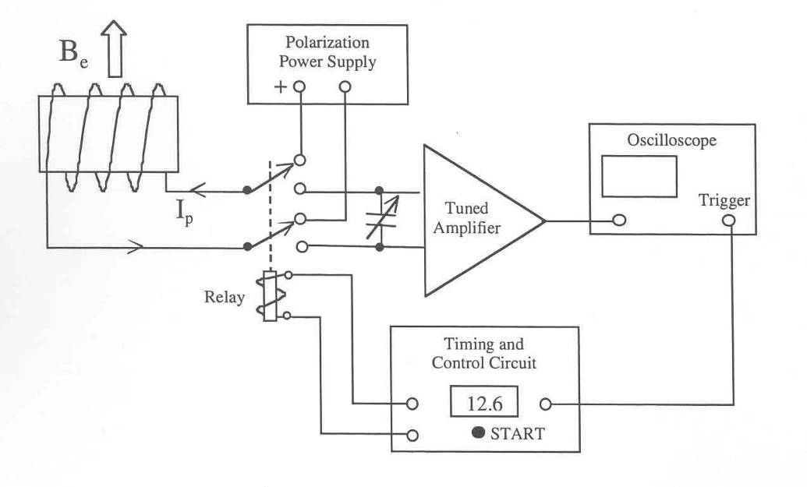
FigureXII-4
When the coil current is reduced to zero, the resultant field B shrinks in magnitude and rotates through angle $α$. If the polarizing field is reduced quickly (sudden passage), the magnetization is “left behind” and ends up precessing about B_{E} at frequency $ω$ = $γ$B_{E} in a cone with an opening angle of ~90°. The precessing magnetization produces a changing magnetic field in the coil, which induces a signal in the coil, with signal amplitude proportional to the component of M perpendicular to B_{E}. For maximum signal, the polarizing field must be reduced to zero quickly in order to flip M to be perpendicular to B_{E}. A simplified block diagram of the apparatus required for detecting the free precession signal is shown in Figure XII-4. A switching circuit (represented by a relay) connects the coil to a DC power supply for polarizing the sample, or to a high-gain, narrow-bandwidth, tuned amplifier for detecting the free precession signal. When the user presses the START button, the switching circuit connects the coil to the power supply, and turns the polarizing current on in the coil. Magnetization M grows exponentially with time constant T_{l} toward the equilibrium value in the polarizing field. A schematic picture Bp and M versus time are shown in Figure XII-5. When the polarizing field is switched off suddenly at the end of the polarizing time t_{p}, the magnetization begins precessing about the earth’s magnetic field at frequency f=$ω/2π=(γ/2π)B_{E}$. The precession frequency is typically in the range 2.0-2.5 kHz.

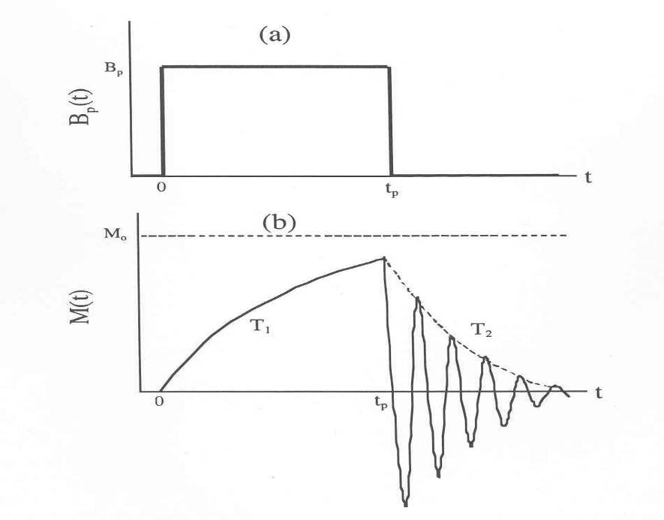
Figure XII-5
A more detailed block diagram of the apparatus required for the earth’s-field free precession technique is shown in Figure XII-6. It consists of four major elements:
- Sample and Bucking Coils,
- Digital Timing and Control Circuit,
- Current-Switching and Relay Circuits,
- Preamplifier, Bandpass Amplifier, and Amplitude Detector.

The sample coil and bucking coils are included to compensate for any stray signals that may be picked up by the sample coil, due to fluorescent lights and other sources of electrical noise. During signal detection, the Sample and Bucking Coils are connected in series. The Bucking Coils together have the same total number of area-turns as the Sample Coil but the turns on the Bucking Coils are wound in the opposite direction. Therefore, the majority of the pickup noise in the Sample Coil is cancelled by an equal and opposite emf induced in the Bucking Coils. You can rotate the bucking coils with respect to the sample coil slightly to improve your signal to noise.

The Signal and Current Relays in Figure XII-6 are both double-pole. They are shown in their quiescent (unenergized) states, with the current relay open, which disconnects the coils from the polarization power supply and current-switching circuit. In the quiescent state, the signal relay connects the sample and bucking coils to the preamplifier for signal detection.

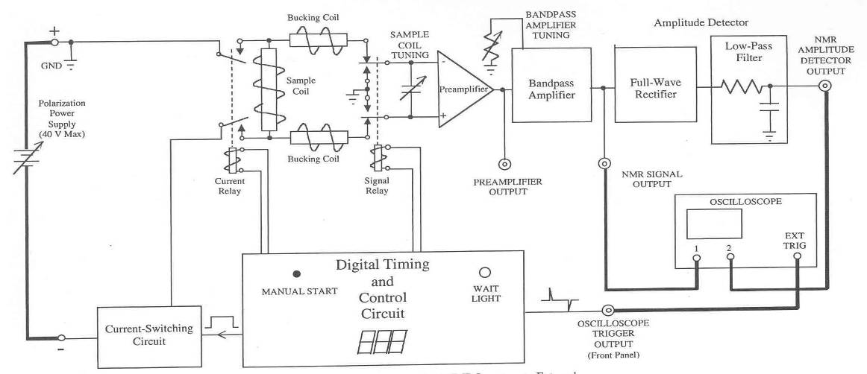

Figure XII-6
Pressing the MANUAL START switch initiates the following ordered sequence of events:
- The Signal Relay is energized, which disconnects the coils from the Preamplifier and grounds the Preamplifier input.
- The Current Relay is energized, which connects the Sample Coil to the Current- Switching Circuit and Polarization Power Supply.
- The Digital Timing and Control Circuit sends a pulse to the Current-Switching Circuit, which turns current on in the coil. A counter begins counting from the preset polarizing time down to zero.
- On the count of zero, counting stops, and the Current-Switching Circuit turns off the current in the Sample Coil within a few milliseconds, which is sufficiently fast to meet the condition for sudden passage.
- After a 20 ms delay, to insure that the current has been reduced to zero, the Current Relay is de-energized, which opens the relay and disconnects the Sample Coil from the Current-Switching Circuit and Polarization Power Supply.
- After another 80 ms delay, to insure that the Current Relay has opened, the Signal Relay is de-energized, which connects the Sample and Bucking Coils to the Preamplifier. At the same time, the control circuit provides a pulse to trigger the oscilloscope sweep for signal detection. On the count of zero, the WAIT light comes on. The digital counter remains on the count of zero for 5.0 s, and then counts back up to the original polarizing time. These two time delays are included to prevent rapid cycling of the instrument that might cause overheating of the Sample Coil and Current-Switching Circuit.

The free precession signal is normally viewed by connecting an oscilloscope to the NMR SIGNAL OUTPUT. The PREAMPLIFIER OUTPUT is provided as an aid in adjusting the input capacitors to tune the series LC resonant circuit to the precession frequency. The NMR AMPLITUDE DETECTOR OUTPUT is useful for samples for which the signal is small; multiple signals can be collected and averaged to improve signal-to-noise.

Front Panel Controls and Connectors

THUMB WHEEL SWITCHES and DIGITAL DISPLAY
Users set the polarizing time in the range 0.1 to 99.9 seconds by means of thumbwheel switches on the front panel. Switch settings are automatically loaded into the count register of an internal presettable down counter. Contents of the count register are continuously displayed on the seven-segment digital displays during both loading and counting operations.
MANUAL START
Pressing the MANUAL START button initiates the automatic sequence necessary for acquiring a free precession signal. The polarization time t_{p} is the time set via the thumbwheel switches and displayed on the seven-segment displays.
EXTernal START INPUT
A contact closure to ground on this input (or a negative TTL pulse) performs the same function as pressing the MANUAL START button.
WAIT light
To prevent rapid cycling of the apparatus that would lead to overheating the Sample Coil and Current-Switching Circuit, the apparatus automatically delays 5.0 s on the count of zero. There is an additional delay (equal to the polarization time) as the counter counts from zero back up to the time that was set on the thumbwheel switches when the MANUAL START button was pressed. The WAIT light is turned on during both of these delays.
SAMPLE COIL TUNING (COARSE and FINE)
The input to the Preamplifier (see Fig. 12-6) is the voltage across a capacitor that is connected in series with the Sample and Bucking Coils. The resonant frequency of this series circuit, $ω_{0}$ = (LC)^{-1/2}, can be adjusted to coincide with the Larmor precession frequency by rotating the COARSE and FINE switches to vary the capacitance. Rotating either switch counterclockwise decreases the capacitance and increases the resonant frequency of the detection coil.
PREAMPLIFIER OUTPUT
This output is provided for monitoring the output of the Preamplifier while adjusting the COARSE and FINE controls to tune the resonant frequency of the input circuit to the Larmor precession frequency. When the input circuit is properly tuned to the frequency of the free precession signal, the amplitude of the signal at the output of the Preamplifier will be a maximum.
BANDPASS AMPLIFIER TUNING
The Preamplifier is followed by a Bandpass Amplifier that is included to block high and low frequency noise from the Preamplifier. The center frequency of this Amplifier must be adjusted to maximize the NMR SIGNAL OUTPUT by means of the ten-turn potentiometer.
NMR SIGNAL OUTPUT
The output of the Bandpass Amplifier is connected to the NMR SIGNAL OUTPUT, which is normally connected to an oscilloscope for observing the free precession signal.
SOUND VOLUME
The NMR SIGNAL OUTPUT is connected internally to an audio power amplifier that drives an internal speaker. This allows users to hear the free precession signal, as well as view it on an oscilloscope.
NMR AMPLITUDE DETECTOR OUTPUT
The signal available at the NMR SIGNAL OUTPUT is also connected internally to an Amplitude Detector, which consists of a Full-Wave Rectifier followed by a Low-Pass Filter. The output of the filter is the average value of the full-wave rectified free precession signal. For a full-wave rectified sinusoidal signal, the average value is 2/$π$ of the peak value. Thus, the output of the NMR AMPLITUDE DETECTOR has essentially the same shape as the envelope of the free-precession signal, but the amplitude is about 2/3 as large.

OSCILLOSCOPE TRIGGER OUTPUT
When using an oscilloscope to view the free precession signal at anyone of the three outputs on the front panel (PREAMPLIFIER OUTPUT, NMR SIGNAL OUTPUT, OR NMR AMPLITUDE DETECTOR OUTPUT) connect the OSCILLOSCOPE TRIGGER OUTPUT on the front panel to the EXTernal TRIGger input on the oscilloscope. The signal at the OSCILLOSCOPE TRIGGER OUTPUT is two narrow pulses. The leading (positive) pulse occurs at the instant the Signal Relay is deactivated, which connects the amplifier to the Sample and Bucking Coils. The trailing (negative) pulse occurs after a fixed delay of 80 ms, which is sufficient time to allow switching transients to die away before triggering the scope to view the precession signal. Set the trigger level on the oscilloscope to –1.2V.

Back Panel

POLARIZATION POWER INPUT (MAX 40 VOLTS)
The external power supply for providing polarizing current is connected to these two banana plug sockets. In order to obtain maximum signal, the power supply should be capable of providing 3.0 A at 36 volts. Both terminals of the power supply should be floating, i.e., neither terminal should be connected to ground. The positive terminal is connected to ground inside the Earth's-Field NMR instrument.
SAMPLE COIL
The four-wire shielded cable that connects to the Sample and Bucking Coils plugs into this socket.
DC INPUT POWER
This is the dc regulated power supply that provides ±15 volts and +5 volts to operate the electronics. The supply plugs directly into the ac power line and the dc outputs are connected by a cable to the rear panel of the control box. It is best to leave the dc line plugged into the rear panel and remove the supply from the power line when you have completed the experiments. There is no on-off power switch.
COIL CURRENT MONITOR
This is a connection for measuring the dc current (voltage across a 0.10$Ω$ resistor) into the sample coil. Do not ground either side of this connection.
The remainder of the connections (EXTERNAL DAMPING RESISTOR, COIL VOLTAGE MONITOR, and OSCILLOSCOPE TRIGGER OUTPUT) are provided for testing and for special applications. You will not be using these.

External Power Supply
This power supply provides the direct current for the polarizing magnetic field. This supply should be CURRENT REGULATED with a current range between 0.5 and 3 amperes and with a maximum voltage of about 38 volts. If the polarization power supply has both variable voltage and current limiting, wait until the current switches on. Then turn the current limit knob counterclockwise until the polarizing current drops to 3.0 A. Note the power supply voltage. You will find that the current-limiting power supply has automatically reduced the output voltage in order to provide the desired current of 3.0 A. At 3.0 A the power dissipated in the Sample Coil is roughly 100 watts. As time goes by, the Sample Coil will get warm; its resistance will increase. But the power supply will automatically increase the voltage as necessary in order to maintain the current fixed at 3.0 A. Ideally, the initial power supply voltage, which was set before the current was switched on, should be about 2 to 3 volts greater than the voltage actually required to provide the desired current. A difference of 2 to 3 volts is sufficient to allow the power supply to compensate for the coil's rise in temperature. If the voltage difference is too large, there may be problems associated with voltage transients that are invariably produced when the power supply current is suddenly switched from zero to 3.0 A. You should monitor the current in the coil by measuring the voltage across the 0.1 Ohm via the coil current monitor output.

Do not run the experiment with less than 0.5 amperes or more than 3.5 amperes.
DO NOT GROUND EITHER SIDE OF THE EXTERNAL POWER SUPPLY. This supply must be floating!

DO NOT TURN THE POLARIZING CURRENT ON UNTIL THE INSTRUMENT ITSELF HAS BEEN POWERED BY THE DC INPUT POWER.

Oscilloscope
A digital scope is provided for these measurements. However, "aliasing" can be a major problem. Some digital scopes are particularly bad and the signals they present can be extremely confusing. If you are not familiar with this inherent problem with digitizing data, you should carefully read the appendix to this chapter. One simple test for incorrect data presentation due to aliasing is to change the sweep time to a faster sweep by one unit and observe the same signal. If the signal changes appropriately, it is not aliasing, but if the scope presents significantly different data, then you may have an aliasing problem.

You will want to trigger the scope with the NMR trigger output and set the scope for single sweep mode. Your signal is digitized with about 2,500 points and aliasing should not be a problem at 10 ms/div or faster. You can transfer all the data to a computer file which is loaded on the PC next to your apparatus.

Tuning the NMR Instrument and Making Measurements
If the sample is located in a region where the earth's magnetic field is perfectly homogeneous, the free precession signal decays with time constant T₂ that is characteristic of the sample. For water at low fields, T₂ is equal to T_{l} and both are about 2.5 sec. In practice, however, one finds that the earth's magnetic field is not perfectly homogeneous, and even over relatively small sample volumes of 100 ml. Because of the earth's-field inhomogeneity, spins in different parts of the sample precess at slightly different frequencies $ω_{e}={γB}_{E}$. As the spins precess, they gradually lose phase coherence with each other, which causes the signal to decay toward zero with time constant T₂* that is less than T₂. If there are magnets or magnetic materials nearby that significantly distort the earth's magnetic field, T₂* can be so short that the signal dies away before the switching transient, which persists for times on the order of 50 ms. It is therefore desirable to position the coils in an area where the earth's magnetic field is as homogeneous as possible. That usually means near the open center of a room, about four or five feet above the floor. Near concrete floors the earth’s field is distorted by steel reinforcing rods. Typical ceilings have metal light fixtures and metal grids holding the ceiling tile. It is difficult to predict with certainty exactly where in the room the earth’s field is most homogeneous.

Noticeable variations in the direction of the field indicate the presence of nearby magnetic materials. Ideally, the coils should also be placed in an area as far away as possible from sources of radiated electrical noise. The coils have been prepositioned for the best possible location within the Physics 405 lab room. And they are surrounded by an additional set of gradient coils that can be tuned to make the field in the cell as homogeneous as possible. Fluorescent lights in the same room as the coils should be turned off, and be sure to check for sources of RF signals (cell phones, wireless antennas, etc.). Now you are ready to tune the instrument in order to detect a free precession signal.

Tuning the Instrument to Obtain Maximum Signal

- Use the 125-ml plastic bottle filled with distilled water, and place it in the center of the Sample Coil.
- Make sure the power supply you intend to use for providing the polarizing current does not exceed 38 volts. Also, make certain that both outputs are floating, i.e., neither terminal is connected to ground. With the power supply turned off, connect the + and − terminals on the power supply to the corresponding terminals on the back panel. The + terminal of the power supply is connected to ground inside the instrument. DON'T TURN THE POLARIZING POWER SUPPLY ON JUST YET. WAIT UNTIL INSTRUCTED TO DO SO.
- Connect the low-voltage power supply to the DC INPUT POWER connector on the back panel. The instrument should now be on, and the seven-segment displays on the front panel should display whatever polarizing time happens to be set on the thumbwheel switches.
- In order to detect a free precession signal, connect the PREAMPLIFIER OUTPUT to one of the input channels of an oscilloscope. Superimposed on the signal is a DC offset of up to ±500 mV. To eliminate the offset, set the oscilloscope COUPLING to AC. Set the vertical sensitivity to 50 m V /Div, and the sweep speed to 2 ms/Div.
- Connect the OSCILLOSCOPE TRIGGER OUTPUT on the front panel to the EXTernal TRIGger input on the oscilloscope. Set the oscilloscope to trigger on EXTernal, DC COUPLING with HF (High Frequency) REJECT, +SLOPE, and LEVEL (-1.2 V). This will insert an 80-ms delay between the time the Signal Relay is de-energized (which connects the coils to the Preamplifier) and the time the oscilloscope begins its sweep. Thus, the switching transient will not be visible since it will have died away before the oscilloscope sweep begins.
- Set the COARSE and FINE SAMPLE COIL TUNING switches to the middle of their ranges. Turn on the Polarization Power Supply; set the voltage at about 34 volts. If it is a current-limiting supply; set the current limit at maximum. Set the polarizing time to about two times T₁ (about 5.0 s for water); then press the MANUAL START button. Observe the current output of the power supply and adjust it to be limited at about 3.0 Amps. Adjust the voltage out of the supply such that it is about 2 to 3 volts higher than is necessary to drive 3 Amps through the coil. This should be sufficient to allow the power supply to compensate for the coil's rise in temperature. Press manual start again and observe the free precession signal. If the precession frequency is near the resonant frequency of the tuned circuit, you will see a free precession signal.
- Turn the COARSE SAMPLE COIL TUNING switch clockwise one position (this changes the capacitance by approximately 5,000 pF), and try again. If the signal is larger than before, you are searching in the right direction. Turn the COARSE switch clockwise one additional position, and repeat the process. If the signal is smaller than before, you have gone in the wrong direction. Rotate the COARSE switch counterclockwise two positions, and try again. If you still haven't seen any signal at all it may be because the resonant frequency of the tuned circuit is still too far away from the precession frequency. Turn the COARSE switch clockwise one additional notch, and try again. Keep rotating the switch clockwise until you detect the signal or come to the end of the range. If you come to the end of the range and still haven't detected the signal, set the COARSE switch back to the center of its range, and begin searching for the signal as you rotate the COARSE switch counterclockwise one step a time.
- Once you have found the setting of the COARSE switch that gives maximum signal, begin adjusting the FINE switch ($ΔC≈$500 pF for each position) to obtain the largest signal possible. When you have finished, the resonant frequency of the tuned circuit coincides with the free precession frequency. An example of what you should see is shown in Figure XII-7.

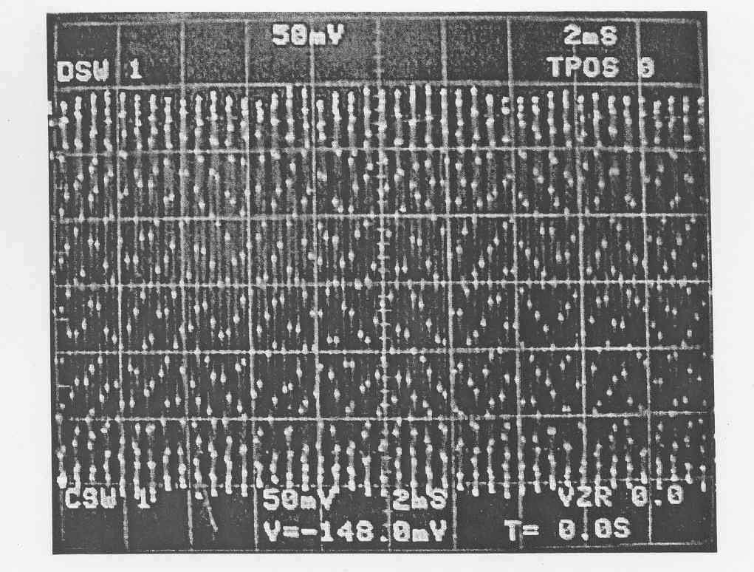
Figure XII-7

Adjusting the Center (Resonant) frequency of the Bandpass filter

In addition to supplying more signal amplification, the Bandpass Amplifier prevents electrical noise at frequencies far above and below the free precession frequency from reaching the NMR SIGNAL OUTPUT. By adjusting the ten-turn BANDPASS AMPLIFIER TUNING potentiometer, it is possible to adjust the center frequency of the Bandpass Amplifier to coincide with the frequency of the free precession signal. When that occurs, the amplitude of the free precession signal at the NMR SIGNAL OUTPUT will be a maximum. You will accomplish that in the steps that follow:
- Leaving the PREAMPLIFIER OUTPUT connected to the oscilloscope, connect the NMR SIGNAL OUTPUT to the unused oscilloscope input channel. Adjust the controls on the oscilloscope to view only the channel connected to the NMR SIGNAL OUTPUT. (Since the NMR SIGNAL OUTPUT has no DC offset, you may set the oscilloscope COUPLING to either AC or DC.) Set the vertical sensitivity to 1 Volt/Div. As a first approximation, set the ten-turn BANDPASS AMPLIFIER TUNING potentiometer to the center of its range. Without changing the settings of the COARSE and FINE SAMPLE COIL TUNING switches, cycle the instrument; as you do so, adjust the potentiometer to obtain a signal of maximum amplitude at the NMR SIGNAL OUTPUT. (Adjusting the potentiometer should have little or no effect on the amplitude of the signal at the PREAMPLIFIER OUTPUT.) As you adjust the potentiometer you can start by making relatively coarse adjustments in one- or one-half-turn increments. As the center bandpass frequency gets nearer the free precession frequency, you will need to make finer adjustments. Figure XII-8 displays the NMR signal you should obtain from a pure water sample over the first 20 ms of decay (after the 100 ms delay built in delay).

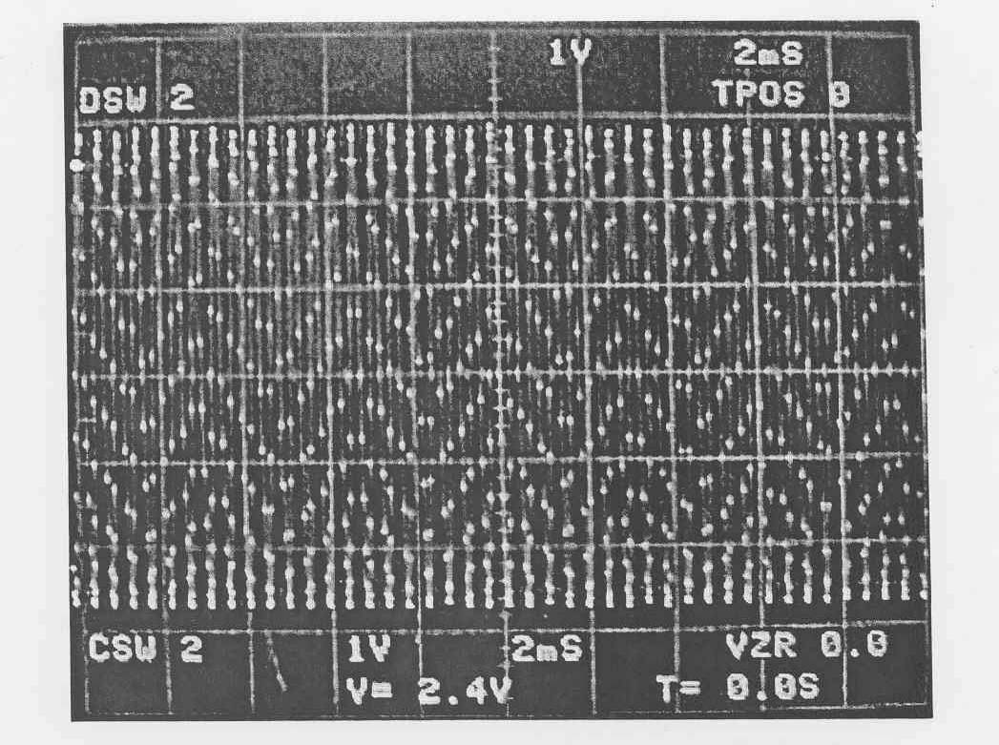
Figure XII-8

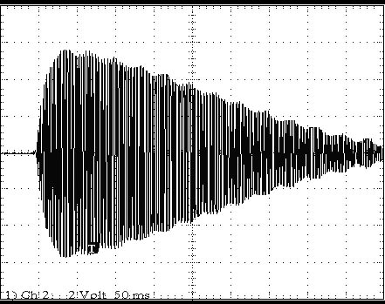

FigureXII-9
Figure XII-9 displays a NMR signal one student obtained on the 2nd floor roof from a pure water sample over the first 500 ms of decay in a slightly inhomogeneous earth’s magnetic field. These data were taken with the apparatus outside and without the gradient coils. The functional form of the decay is not a great exponential.

Data Collection

- Once you have your NMR system tuned, increase the time base to 20-100 ms/div and observe the full free precession decay signal (similar to Figure XII-9) from your distilled water sample, make sure that the sample coil axis is perpendicular to the earth’s field and note the change in shape and amplitude of this signal as you move the coil axis relative to the earth’s field. Make sure the data is fairly reproducible. You can now attempt to minimize the noise by rotating the bucking coils (leaving the sample coil direction unchanged) and observing and minimizing the magnitude of the base line signal at long times. Record and transfer your best free precession signal to a computer file. What is the frequency of the signal and what magnetic field does it correspond to? Fit the appropriate part of the data to determine the functional form of the decay time and the magnitude of the characteristic T₂* decay time. Does the oscillation frequency and shape agree with your expectations? Comment on possible systematic sources of error and what you did to minimize them.

- You are now ready to measure the relaxation time T₁ of protons in water by measuring the amplitude of the free-precession signal as a function of polarizing time. The amplified free precession signal is available on the NMR SIGNAL OUTPUT. The output of the NMR AMPLITUDE DETECTOR is the NMR SIGNAL after it has been full-wave rectified and filtered. It has the same shape as the envelope of the free precession signal, but its amplitude is 2/$π$, or about 2/3, as large. Pick a convenient reference point on the oscilloscope screen, say 1.0 division (which corresponds to 2.0 ms) after start of the sweep. Measure the zero-to-peak amplitude of the free-precession signal. Also measure the amplitude of the signal at the NMR AMPLITUDE DETECTOR OUTPUT. Do this for polarizing times of 18, 13, 10, 8, 5.0, 4.0, 3.0, 2.0, 1.0, and 0.5 seconds. You can do this by either transferring each data set to the computer or simply using the cursor function (much faster) on the oscilloscope. Periodically check that the power supply is still delivering 3.0 amps to the coil. As a general rule, for maximum accuracy in measuring signal amplitudes, the oscilloscope vertical sensitivity should always be adjusted so that waveforms fill as much of the screen as possible. For low-level signals, you will need to increase the vertical sensitivity of both channels to 500 or 200 mV/Div.

Analyze both sets of data to determine T₁ using Eq. XII-7 along with complete error analysis. Are they the same? Does T₁ depend upon the time at which you chose to measure the free induction decay signal? How do they compare to your T₂ measurement above?

- Check that the power supply is still delivering 3.0 amps to the coil. Set the polarizing time to about 10-15 seconds (4-6 T₁ time constants). Repeat the measurements in (2) above but change the current out of the power supply instead of the polarizing time. Measure the voltage out of the Coil Current Monitor with a hand-held multimeter to determine the actual current in the coils. Try using currents between 3.0 and 0.5 A in steps of 0.5 A. Once again at the start, the current output of the power supply should be limited at about 3.0 A and the voltage adjusted such that it is about 2 to 3 volts higher than is necessary to drive 3 A through the coil. The dc resistance of the Sample Coil and connecting cable is on the order of 10-11 ohms. Therefore, reducing the current in 0.5-A steps will require reducing the power supply voltage in steps on the order of 5.0-5.5 volts. If you are using a current-limiting power supply, be sure to heed the warning given in the next paragraph. As the polarizing current is reduced, the amplitude of the free precession signal drops as well.

CAUTION: When using a variable voltage supply with current limiting, don't reduce the current limit without simultaneously reducing the power supply voltage limit as well. Ideally, the voltage limit should be set no more than 2-3 volts higher than that required to deliver the desired current. Otherwise, unacceptably large power supply voltage transients may result. If, for example, the current limit is reduced to 0.5 A while the voltage limit is left at or near the maximum of 36 V, when the current is switched on, the output voltage from the current- limiting power supply will drop suddenly from 36 V toward a steady-state value of 6 V or less, depending on the resistance of the Sample Coil and cable. During switching, the output voltage of a typical current-limiting power supply is an underdamped transient that oscillates as it decays with a time constant on the order of 20 ms or even longer. During large amplitude transients, the power supply output voltage can undershoot so far that it reverses polarity. If that occurs, the switching circuit will turn the current off in the coil until the power supply voltage assumes its normal polarity.

Analyze both sets of data and determine if the signal height is described by Eqs. XII-5 or XII-6. Now attempt to determine the magnetization. Here you must assume that B is linearly proportional to current, the gain of the preamplifer is 1000, and that the gain of the BANDPASS AMPLIFER is between 15 and 20. Estimate N for protons in your water sample and assume that B/I for your detection/polarization coil is 154 gauss/amp. (This is at the center of the coil but near the end it falls to ~100 gauss/amp). Calculate the expected value of M₀ and compare to your data. Discuss any reasons you can intelligently think of for the discrepancies. This experiment serves as a sensitive test of both the Curie law and for proper operation of the instrument.

- Fill an empty 125 ml bottle with ordinary tap water and observe the free precession signal. Report any differences you might observe from your earlier distilled water experiments.

- Next study the free precession in at least one of the supplied samples containing fluorine. Use the bottles labeled HT-110, HT-70, and PFS-2. You will have to retune both the PREAMPLIFIER and the BANDPASS AMPLIFER because the $γ$ value for ₉F¹⁹ is 5.9% smaller than the $γ$ value for ₁H¹. Measure T₂ for your fluorine sample and compare to your water samples. Measure T₁ for one of these samples and compare to your water results.

- If time permits, take a quick look at the sample labeled fluorbenzene. This sample will exhibit a beat frequency in the fluorine free induction decay. The inequivalent sites of the fluorine atom attached to the benzene molecule cause this beat. Due to the spin-spin coupling, some fluorine atoms see a slightly different field than the others. You should attempt to estimate the difference in field at the two sites from your measurement of the beat frequency.

- If it is available, you might want to look at the proton signal from a sample of chloroform (CHCl₃). Due to very weak coupling to the lattice, T₁ in this liquid is dominated by the dipole-dipole coupling and is on the order of 80 seconds. This weak coupling is in part due to the fact that chloroform has only one hydrogen atom per molecule and the nearest hydrogen atoms are relatively far away from one another. (Tune the instrument with water first because you will have to wait more than two minutes between polarization cycles.) Report a value for T₁.

Discussion Questions (to be answered in lab report)

- For protons in water at room temperature, approximately how large of a magnetic field would you need to apply to see a 5% deviation in the linear behavior of M₀ vs B? Is this a constraint in this experiment?

- This instrument can only access NMR signals from ₁H¹ (protons) and ₉F¹⁹ (the abundant isotope of fluorine). What do you think would happen to your free precession signals if you used tap water that had been heavily fluornated? The gyromagnetic ratio for fluorine is 2.517x10⁸ rad/sec-Tesla.

- From your data on the polarization of water, is there any evidence for relationship between the degree of polarization and the rate of polarization? (Does the rate of polarization depend on B?).
Appendix: Digitial Aliasing

A typical digital oscilloscope samples the input waveform at fixed time intervals, and then displays the digitized samples on the oscilloscope screen. These samples are normally connected by straight line segments in order to give, at least roughly, the appearance of a smooth waveform. Figure XII-10 shows a 2200 Hz sinusoidal waveform and, for comparison, the sampled approximation. The samples are shown as squares, and the squares are shown connected by straight line segments. In constructing Figure A1 the time between samples was assumed to be 0.1 ms, which corresponds to a sampling frequency of 10 kHz, which is only 4.5 times the frequency of the input signal. Thus, on average, each cycle of the input signal is approximated by only about 5 points. Furthermore, the points are joined by straight line segments rather than a smooth curve. The distortion is obvious. Some of the cycles appear to have "missing peaks" since the oscilloscope digitizer did not happen to sample the input waveform when it was at a maximum.

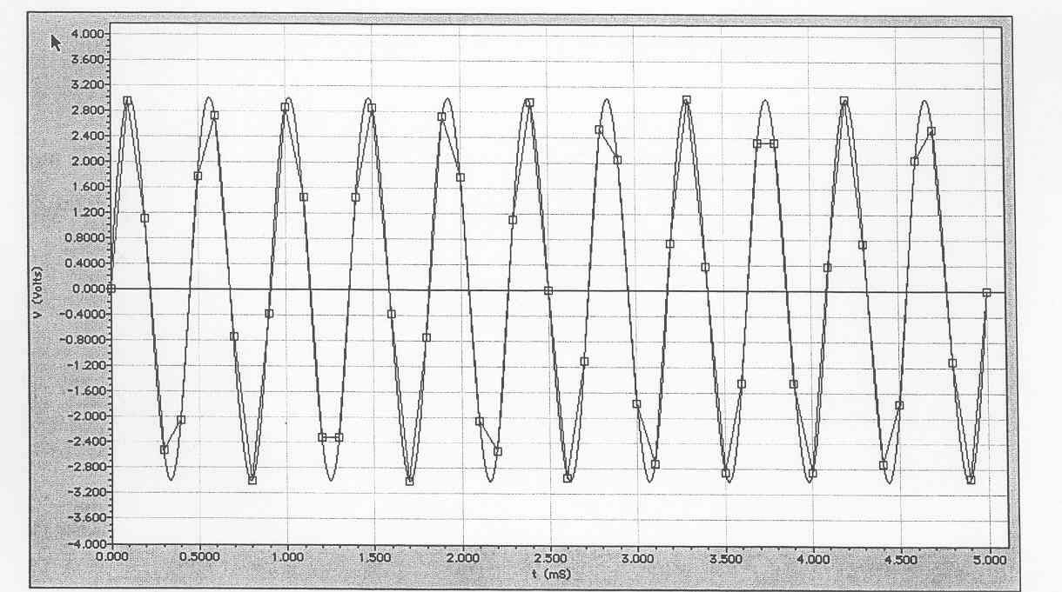
Figure XII-10 An example of the digitization of a 2.2 kHz sinusoidal signal when the waveform is sampled a 10 kHz.

A similar graph is shown in Figure XII-11, but in this case the sampling frequency has been increased to 20 kHz, which is almost ten times the frequency of the input waveform. The digitized approximation now appears to have about the same shape as the input waveform. Now each cycle is approximated by ten straight line segments, rather than just five as before. However, there are still some obvious distortions. Note, for example, the 4th peak from the left, which occurs near time t = 1.5 ms. The oscilloscope happened to sample the waveform on either side of the peak, but not at the peak itself. Therefore, when viewed on the oscilloscope screen, the peak will appear to be "flattened off' and slightly reduced in size relative to other peaks of the waveform.

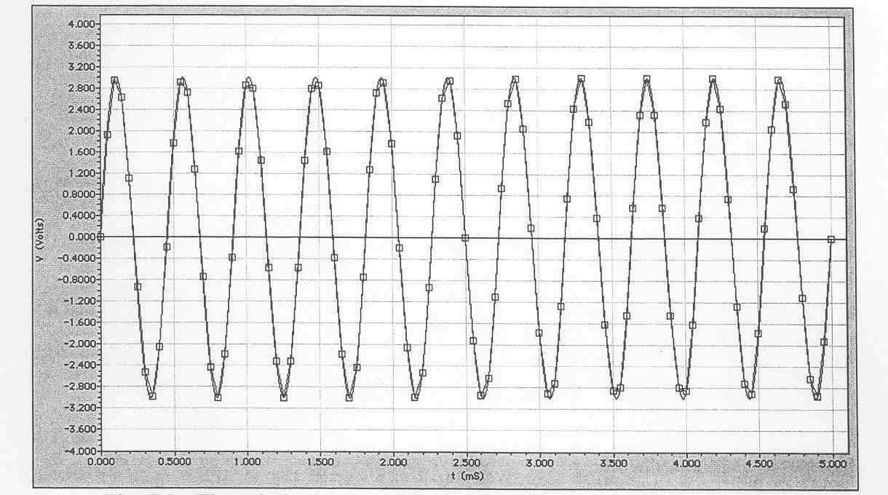
Figure XII-11 The relatively smooth waveform that results when a 2.2 kHz sinusoidal waveform is sampled at 20 kHz.
Thus, in order to obtain a waveform that is displayed smoothly on the screen, it is necessary to have an oscilloscope sampling frequency that is more than ten times the frequency of the signal. At low sampling frequencies it is easy to be completely misled by the digitized waveform displayed on the oscilloscope screen. Figure XII-12 shows the same 2200 Hz signal as before, but the sampling frequency has been reduced to 2 kHz.

Note that the input waveform is sampled only about once each cycle, and the digitized waveform appears to be, at least approximately, a sinusoidal signal of much lower frequency than the input waveform! To avoid these kinds of errors, the sampling frequency must meet the requirement of the Nyquist theorem, which states that the sampling frequency must be at least twice the signal frequency. For comparison, Figure XII-13 shows the 2200 Hz input waveform sampled at 5 kHz (time between samples is 0.2 ms). This sampling frequency meets the Nyquist criterion, which effectively means that the sampled waveform has no "missing cycles." However, it still looks greatly distorted. Based on the appearance of the sampled waveform in Figure XII-13 one might be tempted to conclude, quite incorrectly, that the input waveform exhibits beats.

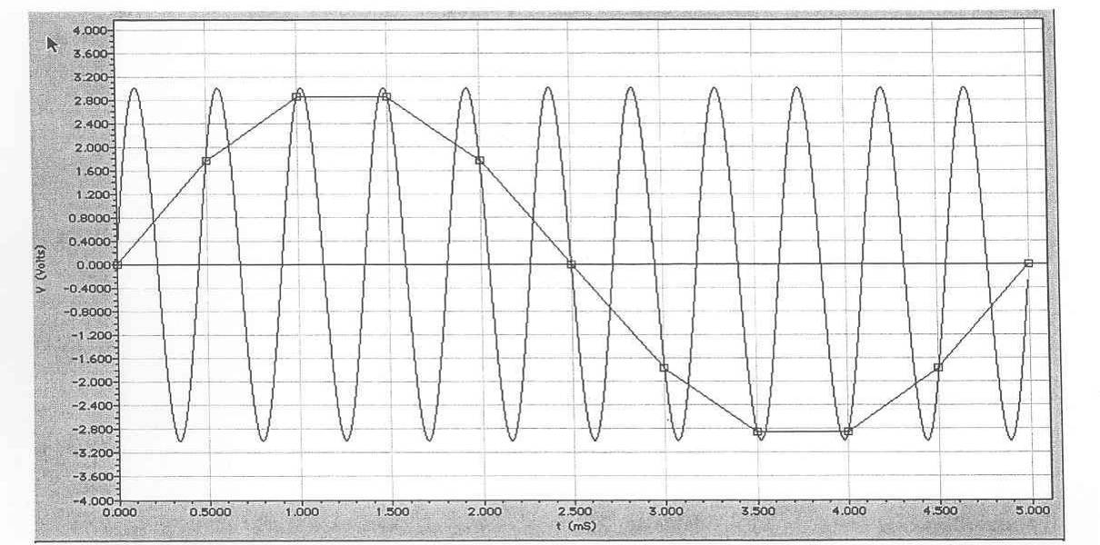
Figure XII-12 : Missing cycles that result when a 2.2 kHz signal is sampled at 2 kHz.
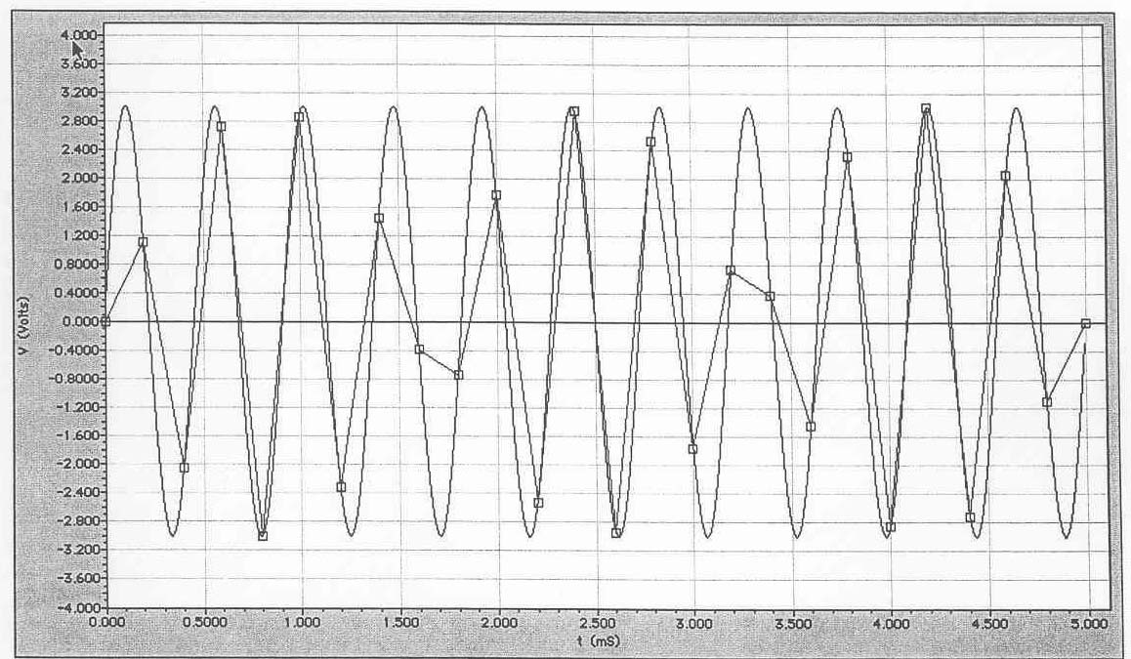

Figure XII-13 : A 2.2 kHz signal sampled at 5 kHz. Note the distortion even though the sampling frequency meets the Nyquist criterion.
So, what does all this mean with regard to using digital storage oscilloscopes for capturing free precession signals? First of all, it is obviously desirable to have a sampling frequency that is at least ten times the frequency of the free precession signal. For signals at 2.1 kHz, corresponding to an earth's field of 0.05 mT, the sample frequency should be of the order of 20 kHz or more. Digital oscilloscopes vary, but, for your oscilloscope, the oscilloscope takes 2500 samples during one horizontal sweep or 250 samples per division. At a sweep speed of 50 ms/Div, 250 samples per division corresponds to a time interval of 0.2 ms between each sample, which is equivalent to a sample frequency of only 5 kHz, not really sufficient to produce a smooth digitized waveform but still meets the Nyquist criterion. At 250 samples per division and a sweep speed of 10 ms/Div the corresponding sample frequency is 25 kHz which is more than sufficient to give a good estimate of the signal. Therefore, severe sampling errors like that shown in Fig. A3 can be expected when the oscilloscope sweep speed is 50 ms/Div or slower.

