I: Measurement of the Speed of Light

References
Griffiths, Introduction to Electrodynamics, (Prentice-Hall, 1999) Chapter 9.
Serway, Physics for Scientists and Engineers, Vol II, (Harcourt Brace, 1996) Chapter 36.
Hecht, Optics (Addison-Wesley, 1998) p 158 ff.

Preparatory Questions
(must be answered in lab book before experiment is started and signed by instructor or TA)
- Show that for a simple convex lens of focal length f, the minimum distance between a real object and a real image is 4 f .
- You will now investigate the impact of this constraint on this experiment. The lens being used has f ~5 m, which means that the rotating mirror must be at least 20 m away from M₁. The room, however, is only around 7 m in length and around 3 m high. Using the rule of combining multiple optical elements, demonstrate that the 7 m length of the room is not a problem. Do this by drawing a ray diagram assuming S and R are at the same vertical level and a 7 m horizontal separation, M₁ and M₂ are at the same vertical distance of 0.5 m directly above S and R respectively, and that L₁ is centered horizontally and vertically.
- Using equation I-20, find the expression for the relative variance in u , (σ_{u}/u)² . Treat RL₁M₁M₂ as a single quantity. Note that when doing the lab, f/EE' is determined from fitting a line.
- Assume some reasonable uncertainties for RS ~7 m, RL₁~3.5 m, L₁M₁ ~3.5 m, M₁ M₂ ~7 m, EE' ~0.15 cm, f ~200 Hz, and the angle EBB' ~45 degrees. Which of these quantities produces the largest uncertainty in u?

Introduction
If light is an electromagnetic wave it can be represented by periodically varying electric and magnetic fields. Thus
$E_{x}=E_{0}\text{sin}2π\left(\text{ft}−\frac{z}{λ}\right)$ I-1
$H_{y}=H_{0}\text{sin}2π\left(\text{ft}−\frac{z}{λ}\right)$ I-2
may represent a monochromatic beam travelling in the positive z direction. The radiation has a unique frequency f and wavelength λ, where f is the number of wave amplitude maxima passing a fixed point per second and λ is the instantaneous separation of successive wave amplitude maxima. The velocity with which any phase angle φ travels is just ν = f λ and is known as the phase velocity. In a vacuum all frequencies travel with the same phase velocity c, while in a medium of refractive index n(f) the phase velocity is
$v(f)=\frac{c}{n(f)}$ . I-3
In practice no beam is monochromatic but contains radiation with a certain spread of frequencies Δf about the frequency f₀. Thus the electric field associated with a real beam becomes
$E_{x}=\int_{(f_{0}−Δf)}^{(f_{0}+Δf)}{E_{0}}\text{sin}2π\left[\text{ft}−\frac{\text{fn}(f)z}{c}\right]\text{df}$ . I-4
For any spectroscopic line source the limits ±Δf over which the amplitude$E_{0}(f)$ has non-zero values is very small; i.e.,
$\frac{Δf}{f_{0}}$<<1 . I-5
The general form of E_{x} associated with any real beam can readily be seen by considering a beam consisting of only two frequencies f₀ + Δf and f₀ - Δf with equal amplitude, then
$E_{x}=2E_{0}\text{cos}\frac{2π}{T}\left[t−\frac{z}{cΔf}(nΔf−fΔn)\right]\text{sin}2π\left(f_{0}t−\frac{z}{λ_{0}}\right)$ , I-6
or $E_{x}=2E_{0}\text{cos}\frac{2π}{T}\left(t−\frac{z}{u}\right)\text{sin}\frac{2π}{τ}\left(t−\frac{z}{v}\right)$ , I-7
where v is the phase velocity: v = f₀ $λ_{0}$ =$\frac{c}{n}$ , I-8
and where u is the group velocity: $u=\frac{c}{\frac{d}{\text{df}}(\text{nf})}$ . I-9
Thus in any real light beam there is a term $\text{sin}2π(f_{0}t−\frac{z}{λ_{0}})$ which represents variations at the carrier frequency f₀ and a term $E_{0}\text{cos}\frac{2π}{T}\left(t−\frac{z}{u}\right)$ which represents amplitude modulation. $τ=\frac{1}{f_{0}}$ is the period of the carrier frequency oscillation;
T =$\frac{1}{Δf}$ is the period of amplitude modulation and shows the spread of frequencies in the beam. The energy density in the beam is proportional to the amplitude squared
$I={\left|E_{x}\right|}^{2}$ , I-10
and the velocity with which energy is transported is the velocity with which E_{x}(max) travels, therefore T>>$τ$, and the velocity with which energy is transported is the group velocity u.
In vacuum u =v =c, while in most common substances, for frequencies in the visible spectrum, uvc_{n} , where c_{n} = c/n and n is the index of refraction of the medium.. In certain cases either u or v or both may be greater than c_{n}; however when u>c_{n}, it can no longer be interpreted as the velocity with which energy propagates, i.e., the simple analysis given above no longer holds.
Any experiment to measure the velocity of light must measure the group velocity u at which energy is transported over a given distance. There is no known method of measuring directly the phase velocity v.
Many methods have been developed for determining the group velocity of light; we shall use the method first successfully applied by Foucault and Fizeau in 1850 after being suggested to them by Arago. As with all other methods, this method consists essentially of timing the passage of energy from a light source to a distant mirror and back to the light source.

Apparatus
The layout for the apparatus is shown schematically in Fig. I-1. The plane of the diagram is the horizontal plane; in practice the apparatus is also displaced in the vertical plane so that M₁ and M₂ fall above the laser and R respectively. This allows the whole experiment to be mounted on one wall of the laboratory. M₁ and M₂ are plane mirrors. R is a 1-cm diameter flat mirror that can be rotated at high speed. It is supported by high speed ball bearings, mounted in a protective housing, and driven by a mylar belt connected to a pulley and a DC motor.
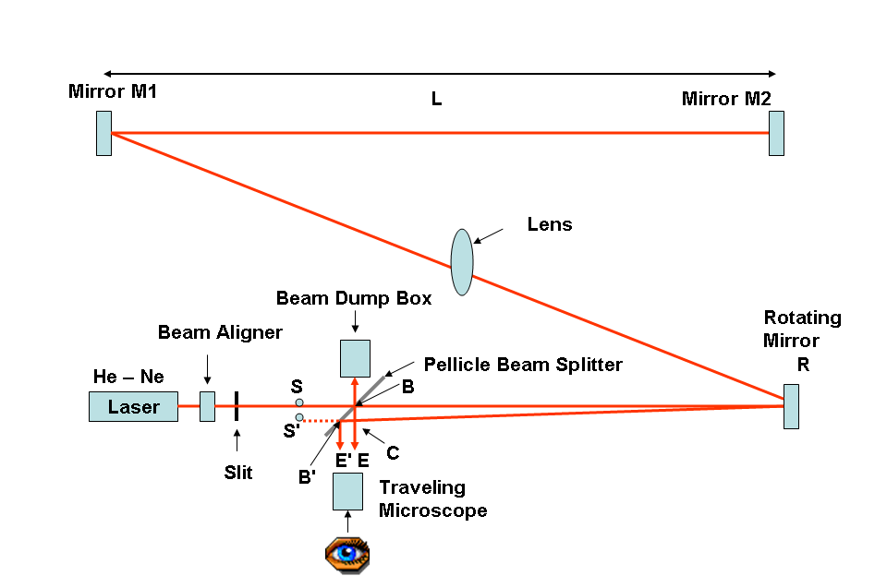
Figure I-1
Note that the mirror appears to have two flat sides but only one is shiny. The shiny side is the one you want to use for alignment. The rotational speed is set and read with the motor controller placed near the observation point. All alignment is done with R stationary and the motor controller off. In addition to the mirrors, there is a spherical lens with a focal length of approximately 5 m, and a pellicle beam splitter. This splitter is fragile and expensive. KEEP YOUR FINGERS OFF! S is an adjustable vertical slit, normally set to a width of approximately 0.2 mm. A 0.25 mW He-Ne laser is used as the light source. The wavelength of the red light is 632.8 nm. The position of the beam from the laser can be adjusted both vertically and horizontally with the alignment device in front of the laser.

Procedure for setting up
With the mirror R stationary and off, align the optical system so that light from S traverses the pellicle beam splitter, and after reflection from R is focused by the lens on mirror M₂ via mirror M₁. You should start with the slits in front of the laser wide open. Make sure the beam is going through the center of the slits and also through the beam splitter. The angle of reflection from R can be adjusted by slightly rotating the pulley which the mylar belt is attached to using your finger. Note that there is a lens directly in front of the mirror and you must make sure that the reflected light from this lens does not trace back to the beam splitter. Thus the first image of S appears on the surface of M₂. Since M₂ is a mirror, light from this image can be reflected back to M₁, and through the lens (we’ll call this location L₁) to R, so forming the second image of S, called S', coincident with the original S, when R is stationary. The image S' can be seen on the image plane in by making use of the pellicle beam splitter to reflect it to the location E, and then can be seen with a small magnification (10) through the microscope eyepiece. DON’T LOOK THROUGH THE EYEPIECE WHILE R IS STATIONARY, but you can hold a piece of paper in front of the eyepiece to see the image. Note that if R is moved slightly by hand, the first image moves across mirror M_{2,} but the image at E remains stationary. Before attempting to set up any of the optics, determine the approximate positions for each piece using the simple lens formula and the above statements regarding positions of focus. One further requirement must be met: because of the size of the laboratory, the distance L cannot be greater than 7 m. The beam splitter should make a 45° angle with the laser path in order for EE' to measure the beam splitting accurately. Why?
Knowing the approximate positions at which each component must be placed, adjust the system for optimum focus.
Accurately measure the distances SR, RL₁, L₁M₁ and M₁M₂.

The Pellicle Beam Splitter G
The pellicle beam splitter has a reflectivity R_{B} of approximately 50% and transmission T_{B} of approximately 50%. There is negligible absorption. Referring to Fig. I-2, if the intensity incident on the splitter from the source is I₀, the intensity going on to the optical system is I₁ and
I₁=I₀T_{B} . I-11
The optical system can be assumed to be a perfect reflector for that part of the revolution of R during which an image is formed at E; thus we assume that the intensity returning from the optical system is also I₁. The intensity reflected from the splitter to E is I₂ and
$I_{2}=I_{1}R_{B}=I_{0}R_{B}T_{B}$ or $I_{2}=I_{0}R_{B}(1−R_{B})$ . I-12
I₂ is a maximum when R_{B} ~ 50%, hence the choice of a half-silvered mirror or a pellicle beam splitter and not an uncoated piece of glass, as used by Foucault and Fizeau.
Figure I-2

Theory of the Experiment
Light from S is reflected from R to M₁ and M₂ then back to R and so back to its origin S. Because of the finite velocity of light u, the time taken to cover the return journey from R to M₂ and back to R is
$t=2\frac{({\text{RL}}_{1}M_{1}M_{2})}{u}$ (sec) , I-13
where $({\text{RM}}_{2})={\text{RL}}_{1}+L_{1}M_{1}+M_{1}M_{2}$ (cm) . I-14
If during this time the mirror R is turned through an angle θ (radians), the returning beam reflected from R towards S will be turned through an angle 2θ. Consequently the image of S at E will be displaced to the new position E', such that
$\text{EE}'=2θ\text{RS}$ (cm) . I-15
The distance EE' can be measured by using the travelling microscope eyepiece. The angle through which R turns in the time t depends on the angular velocity of R, ω radian/s,
$θ=ω t$ . I-16
Therefore $\text{EE}'=\frac{4ω({\text{RM}}_{2})\text{RS}}{u}$ , I-17
and the only unknowns in this equation are ω and u. The angular velocity ω of R can be determined from the measured frequency of rotation f since
$ω=2πf$ I-18
Therefore $\text{EE}'=\frac{8π({\text{RM}}_{2})\text{RS}}{u}f$ I-19
or $u=\frac{8π({\text{RM}}_{2})\text{RS}}{\text{EE}'}f$ . I-20
Let RS and RS' intersect the beam splitter at B and B', respectively. Since we do not see the points E, E' on a screen, it is not quite correct to say that
EE' = 2$θ$RS . I-21
If we assume that BS = BE, and if the line RS' intersects BE at the point C, then
BC = $2θ\text{RB}$ . I-22
But, in the eyepiece we notice EE', which is equal to CB'. (This is because we do not have the beams projected on a screen, in which case the separation between two points on the screen will depend on the position of the screen. In our case only the angular position of the eyepiece matters.) Hence
CB'/CB = tan(EBB ) ~ 1 I-23
CB' = tan(EBB')$2⋅θ⋅\text{RB}$ I-24
EE' = CB' = tan(EBB')$2⋅θ⋅\text{RB}$ I-25
Now using the expression for t, one can modify Eq. (I-20) to find u.

Optimizing the Experiment
Three criteria must be kept in mind to optimize this experiment:
A. The displacement EE' must be measurable to some desired accuracy, i.e., EE' must be larger than a few mm.
B. The system must be so designed that sufficient light intensity passes through the system so that the displaced image E' is visible to the observer. Try to minimize the diameter of the image spot for best measurement precision.
C. We notice that EE' is proportional to f and to the product (RM₂)RS. Since the intensity seen by the observer in the image at E' is independent of the velocity once the mirror rotates at greater than about 25 rev/sec, it is clearly profitable to make f as large as possible, but f is limited by the equipment. The rotation rate is reversible and continuously variable from 300 to 1000 rev/sec, and the maximum rate of 1200 rev/sec can be obtained by holding down the MAX REV/SEC button. The motor is not stable when operated at a frequency below 300 Hz. So while taking data, either the frequency range is to be limited to beyond 300 Hz or a larger uncertainty has to be associated with the frequency measurements below 300 Hz.

Safety Notes
The laser has a 0.25 mW output. As with many items, danger exists only when it is mishandled or misused. Read the laser safety information on the bulletin board in Room 3206 before starting.
A. When aligning the apparatus, keep the door of the room closed to avoid shining the laser light on those passing down the corridor.
B. Note that there is a small box attached by screws to the wall behind the travelling microscope. This box is used to dissipate the light projected against the wall by the half-silvered mirror and whose reflection from the wall will interfere with the viewing through the microscope.
C. Ear muffs are available to deaden the noise of the mirror motor at high speeds. Laser goggles are also available. (You will, however, be unable to see the light when wearing them).

Experimental Procedure
The distance between the mirrors can be measured accurately by using the plumb bob to locate a point on the floor under the mirrors, and then by measuring the distance between the points using the tape measure.
The digital readout and frequency controls are located on the front panel of the motor power supply and controller. The digital readout provides measurement of mirror speed to within 0.1% and 1 rev/sec. When the equipment has been aligned properly, turn on the rotating mirror to a frequency of 800 rev/sec. Take data for 10 to 15 different frequencies in the clockwise direction, allowing the motor to stabilize at each setting before recording the frequency. Do not allow the motor to run at very high or very low frequencies for very long because the motor driver may malfunction forcing you to turn off the power and wait until things cool down. Repeat the measurements in the counterclockwise direction. With the data of displacement versus frequency (plot ccw data as negative frequency), carry out a least squares fit to the data. The fitted slope of the line determines u and σ_{u} .
NOTE: When reversing the direction of the travelling microscope, there will always be some movement in the knob before the carriage responds (backlash). To avoid this source of error it is recommended that one adjust the initial position so that measurements are made always turning the carriage in the same direction.

Discussion Questions (to be answered in lab report)
- Calculate the object and image distances and give a ray diagram for a simple convex lens with f = 10 cm used as a magnifying glass with a magnification of 3 times.
- State the law of optics which tells us why as mirror R rotates slowly so that the first image traverses M₂, the image of S at E remains stationary.
- Is a monochromatic source necessary for the experiment? If yes, why? If no, why not? What other parameters should be modified for both the cases?

