V Hyperfine Structure of Rubidium

References
Griffiths, Introduction to Quantum Mechanics, (Prentice-Hall, 1995) pp. 235-252

C. Weiman and L. Hollberg, “Using Diode Lasers for Atomic Physics”, Review of Scientific Instruments 62 (1991) 1-20.

G.N. Rao, M.N. Reddy, and E. Hecht, “Atomic hyperfine structure studies using temperature/current tuning of diode lasers: An undergraduate experiment”, American Journal of Physics, 66 (1998) 702-712.

J. Moore, C. Davis and M. Coplan “Building Scientific Apparatus”, (Addison Wesley, 1989), pp 519-521.

For a nice description of lock-in amplifiers, phase-sensitive detection, and noise sources, see the application note on lock-in amplifiers at the Stanford Research Systems Web page,
http://www.srsys.com/html/analoglock-inamplifierstechnot.html

Preparatory Questions
(must be answered in lab book before experiment is started and signed by instructor or TA)
- Show, using equation V-5, that the hyperfine splitting of the ground state of ⁸⁵Rb is 3000 MHz. Calculate the corresponding expected wavelength shift.

Overview
The purpose of this laboratory is to serve as an introduction to the use of diode lasers in atomic spectroscopy. In this lab, it is possible to measure the hyperfine splitting of the ground states of two most common isotopes of rubidium, ⁸⁵Rb and ⁸⁷Rb, by observing the absorption of the laser light as it is tuned over wavelengths corresponding to the energy transition from the 5S_{1/2} ground state to the 5P_{3/2} excited state of the two isotopes.

Theory

Two basic postulates of Bohr’s quantum theory of the atom were the existence of discrete energy levels and the proposition that atoms can only absorb or emit energy by amounts corresponding to the difference between two such energy levels. Bohr’s theory was based on the regular characteristics of atomic line spectra (as are observed in Experiment II), but additional evidence was needed that the discrete energy levels were intrinsic to the atomic systems.

The quantization of energy levels in an atom was first postulated by Bohr in 1913, at which time it was possible to correctly predict the observed energy levels in hydrogen. In the years that followed, the theory of quantum mechanics was developed and it became clear that Bohr’s relatively simple model of the hydrogen atom was not sufficient to describe the fine details of atomic spectroscopy. As experiments became more precise, more energy levels were found, requiring the concept of electron spin and coupling between spin and angular momentum to describe the observed states. With the development of lasers, precision atomic spectroscopy became a valuable tool to study chemical properties of atoms and the basic quantum properties of nuclei. Diode laser technology has made it economically feasible for lasers to be used for many everyday applications.

In Bohr’s model of the hydrogen atom, the allowed energy states are given by
$E_{n}=\frac{−2π^{2}{\text{me}}^{4}}{n^{2}h^{2}}$ V-1
in which m is the mass of the electron, e the electron’s charge, and n is any positive integer, referred to as the principle quantum number. This model is application to any one-electron atom, such as the alkalis, which consist of an inert electron core (a set of filled subshells) plus one active electron that circulates outside the core. Bohr’s expression is slightly modified to account for the screening effect of the electron core: this is the subject of Experiment II. Bohr’s expression needs to be modified, however, for several other reasons, described below.

First, the electrons possess orbital angular momentum, which is also quantized (denoted by the quantum number L). In Experiment II, for example, you directly investigate the effect of the orbital angular momentum on energy levels by measuring quantum defects in sodium.

The electrons (and the nucleons in the nucleus) also posses a quantum number called spin, labeled S, and the spin-orbit interaction results in a splitting of all energy levels with L not equal to 0. As the electron orbits the nucleus, in its frame the nucleus is orbiting around it, apparently generating a magnetic field, and the magnitude of the field is proportional to L. The intrinsic spin of the electron, which is responsible for its magnetic moment, interacts with the resulting magnetic field, and the resulting difference in energy for the different possible spin orientations of the electron can be written as:

$ΔE=−\vec{μ}⋅\vec{B}=ζ_{\text{nl}}\vec{L}⋅\vec{S}$, where $ζ_{\text{nl}}=\frac{e^{2}}{2m^{2}c^{2}r^{3}}$ V-2

Here it is useful here to introduce the quantum number J, the total angular momentum of the electrons, which is the sum of the spin and orbital angular momentum: J=L+S. J can have the following values:
J = (L+S), (L+S-1), (L+S-2),...|L-S| V-3
and
L⋅S = J² – L² – S² =J(J+1) − L(L+1) – S(S+1). V-4
When S=1/2, as in the case of a typical “one-electron” atom, J can take on two possible values, J=L+1/2 and J=L−1/2. If you have carried out Experiment II, you have already investigated the fine structure of some of the L=1 excited states of sodium by identifying the doublet lines in S-P transitions. Spin orbit coupling is one of the two mechanisms responsible for atomic fine structure, the other arising from relativistic corrections.
Finally, of relevance to this lab, the orbiting electrons can also interact with the magnetic moment of the atomic nucleus. This is generally referred to as hyperfine structure. Because, even in the case of hydrogen, the nucleus is much heavier than the electron, its magnetic moment is several orders of magnitude smaller than the electron’s magnetic moment, so the resulting level splittings of the hyperfine interaction are much smaller than those due to fine structure. In an analogy with fine structure, the shift in energy due to the hyperfine interaction can be written as an interaction between the nuclear magnetic moment and the magnetic field due to the electron’s angular momentum: in this case it is the total angular momentum J.

${ΔE}_{\text{hf}}=−{\vec{μ}}_{I}⋅{\vec{H}}_{J}=\text{hA} \vec{I}⋅\vec{J}=\frac{1}{2}\text{hA} \left[F(F+1)−J(J+1)−I(I+1)\right]$ V-5

Thus, states with two different angular momentum values J will shift by different amounts. To complete the analogy, we have introduced two new quantum numbers: I, which is the angular momentum of the nucleus, and F=J+I, which is the total angular momentum of the atom when the nuclear spin is considered. In large atoms with many electrons, it is very difficult to calculate the energy splittings from first principles, because it depends strongly on the configuration of the electrons in the vicinity of the nucleus. Thus, the coefficient A is usually determined experimentally.

In our determination of the hyperfine splitting, we have neglected any higher order contributions that could arise as a result of the charge distribution of the nucleus. Typically, one also sees splittings due to the quadrupole moment. With the experimental setup of this lab, we will not have the resolution to see anything other than the magnetic dipole splittings of the ground states of the two naturally occurring isotopes of rubidium, ⁸⁵Rb and ⁸⁷Rb. The separation of the ground state lines is larger than the natural “Doppler broadened” line width of the states resulting from the fact that the atoms are in motion in room temperature rubidium vapor. To see splittings of excited states of rubidium, we would have to resort to a technique called “Doppler Free” (or saturated absorption) spectroscopy, where the motion of the atoms is effectively removed from the experimental arrangement.

Figure V-1 shows the hyperfine structure for the two isotopes of Rubidium that you will be studying in this lab. The ground state of rubidium has a spectroscopic configuration of 5S_{1/2}, meaning that L=0, J=1/2 and the principle quantum number n=5. The two isotopes have different nuclear spin, so the hyperfine splitting of the ground states is different in the two cases. In addition, the nuclear charge distributions are different, so the A coefficient differs. The relevant properties and the hyperfine splittings are listed in Table V-1.

Isotope | Nuclear Spin | A | Δν_{hf} of ground state
⁸⁵Rb | I=5/2 | 1011.91 MHz | 3036 MHz
⁸⁵Rb | I=3/2 | 3417.34 MHz | 6834.7 MHz

Table V-1: Splittings of the ground states of the two isotopes of Rb.

Note that it is common practice in laser spectroscopy to quote frequency difference rather than wavelength difference for line splittings. Using the relation c=νλ , the frequency splitting can be readily converted to a difference in wavelength:

$$\frac{Δλ}{λ}=\frac{Δν}{ν}=\frac{λ}{c}Δν$$

So, for example, the hyperfine splitting of ⁸⁵Rb in table V.1 corresponds to a wavelength shift of only 8 parts per million.

If the Rb atoms were at rest, photons of only a single energy should be absorbed or emitted in the transitions between the ground and excited states since the energy levels are quantized. However, the atoms are at a finite temperature and therefore have a range of velocities corresponding to a Boltzmann distribution. The photons seen by atoms moving towards the laser are apparently at shorter wavelength, or blue-shifted, so the photon wavelength required for resonant absorption must be longer. Equivalently, those seen by the atoms moving away from the laser are red-shifted. This results in a “Doppler broadening” of the resonant transition, which for rubidium is about 0.5 GHz (FWHM). If the laser lines are narrower than this, then the width of the absorption peaks will be limited by this Doppler broadening.

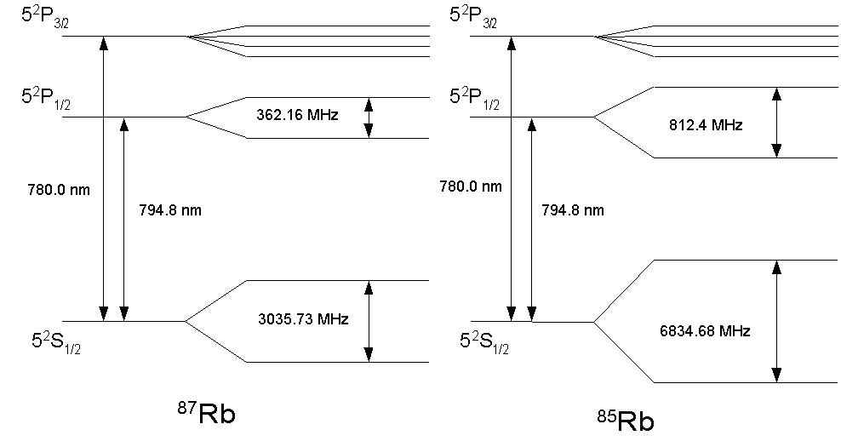

Figure V-1: Hyperfine structure of the two isotopes of Rubidium. In this lab, you will study the transition from the 5S_{1/2} state to the 5P_{3/2} state. The splitting of the 5S_{1/2} state should be apparent.

Procedure Outline
The basic experimental arrangement is shown in figure V-2. A 30 mW diode laser is inside a mount connected to both a temperature controller and a second controller for the injection current of the diode. Light from the diode laser is collimated, attenuated and chopped before impinging on a glass cell filled with rubidium. If the laser light is not at 780.0 nm, it will pass through the rubidium and be detected by a photodiode. If it is at precisely the correct wavelength, the laser light will be absorbed as the rubidium atoms are excited out of their ground state. Light at 780.0 nm will cause a transition from the 5S_{1/2} ground state to the 5P_{3/2} excited state. Light at 794.8 nm (not achievable in this experiment) will cause a 5S_{1/2} → 5P_{1/2} transition. Absorption of the light will cause a drop in the photodiode signal. The laser light can be tuned across this transition by changing its temperature or the current injected through the diode.

The Laser

The laser is a 30 mW Sharp LT024MD diode, hand-picked to lase at 780±1 nm close to room temperature. The mount has two “thermoelectric” coolers and two temperature sensors: either sensor can be used to monitor the temperature of the laser. Actually, the sensors are monitoring the temperature of the mount itself, so the controller tends to be rather slow to respond to changes because of the relatively large thermal mass of the mount.

The laser has a very divergent beam, so the light must be focused as close to the diode as possible. A collimating lens (focal length = 5 mm) is mounted in a microscope objective housing just at the exit of the diode. The laser is significantly more powerful than required for this experiment, so immediately following the microscope objective is a neutral density filter that cuts the laser intensity down by about a factor of 3.

Diode lasers are a relatively recent development in the history of lasers, and are used throughout the optical communications industry. The basic principle of the laser, based on stimulated emission, can be found in many textbooks. In semiconductor lasers, current injected into the diode stimulates the creation of electron-hole pairs, which recombine to form light. The most common semiconductor material used to produce light in the 780-900 nm region is a layered material of AlGaAs. For a given type of diode laser, each individual diode can have different characteristics resulting from the manufacturing process of the substrate. A more detailed description of diode lasers and their practical use in modern atomic physics can be found in the article by Weiman and Hollberg listed in the references.

The wavelength of the light emitted from the laser is depends on both temperature and the supplied current. In principle it is necessary to fully characterize the properties of the laser in order to know approximately where to set the temperature so that it will lase at the correct wavelength. A precision spectrometer is presently not available to us in Physics 405, so this has been performed at NIST prior to setting up the experiment. We are interested in the transition from the ground state of Rb to its 5P_{3/2} excited state, which corresponds to a wavelength of 780.0 nm. This wavelength can be achieved at various combinations of temperature and current, as shown in figure V-3. Typically, the laser is less stable at low injection current, but cooling the laser much below room temperature can cause problems with condensation. The injection current should never exceed 120 mA or the diode may be damaged. For the laser presently installed in the apparatus, a reasonable combination at which 780 nm is achieved with temperatures between 26.5° and 28.0° C. Outside of this range, the laser no longer operates at a single frequency and produces somewhat unstable results.

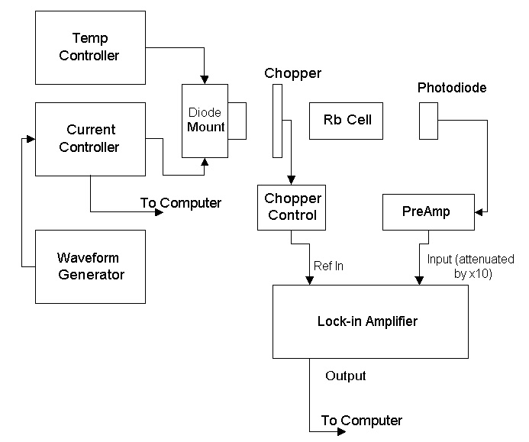
.
Figure V-2: Schematic of the apparatus

The Thorlabs TEC2000 temperature controller operates by a process called thermoelectric cooling. The basic principle behind thermoelectric cooling is that energy in the form of heat can be absorbed or released when a current passes through a junction of two dissimilar materials, such as a bimetallic strip or a p-n junction in a semiconductor. By controlling the direction and magnitude of the current across the junction, thermal energy can flow in either direction, providing either cooling or heating. The TEC2000 is designed to operate with a variety of different thermal loads, and thus one can tune the proportional, integral and derivative feedback parameters to suit the load. (For a concise discussion of the principles behind PID feedback loops, consult “Building Scientific Apparatus”, by Moore, Davis, and Coplan., p. 519. ) Typically, these parameters will not need adjustment. If you find that the measured temperature is not stable to 10 mK, consult with your instructor.

The Thorlabs LDC 500 current controller allows the current delivered to the diode to either be controlled by hand or to be modulated with an input signal. The controller has a fast response time, so it is possible to modulate the injection current at a rate of up to a few kHz. The maximum current delivered to the diode can be set from the front panel, and should be kept at 120 mA in order to protect the diode. Three additional signals can be monitored on the front panel display the laser current or power or the current through a photodiode inside the laser diode package, which we are not using. You will typically want to monitor either the laser power or current. There is an additional output on the back so the displayed signal can also be sent to a data acquisition system.

IMPORTANT SAFETY NOTE: At full current, the output power of the diode laser is 30 mW and its wavelength is infrared. It is barely visible on a piece of white paper, so you’ll need to use an infrared card to see the beam. It is also powerful enough to do serious damage to your eyes, or to someone else’s who might be passing by. So use caution whenever the laser is turned on. Use the laser goggles provided: these will filter out the laser light but pass through visible light so you can still see the laser on the IR card. Keep the curtain drawn to the cubicle in which the experiment is located. Avoid putting your head in the vicinity of beam height at all times.

The Rubidium Cell
The cell used in this experiment contains natural Rubidium, which is approximately 72% ⁸⁵Rb and 28% ⁸⁷Rb. Rubidium is an alkali metal that has a high vapor pressure at room temperature. Typically, the cell is constructed of a Pyrex tube with windows fused onto the ends. The cell is evacuated, and a few grams of rubidium are deposited in the cell. Some small fraction of the metal actually vaporizes, so the cell will contain a small sample of rubidium gas in addition to the metal on the glass walls. The gas density can be increased (resulting in more absorption) by warming the cell with a heating tape, although care must be taken not to heat it so much that the cell will break. Turning the VARIAC up to about 10-20% will likely be enough.

The Lock-in Amplifier

Background on the signal can be reduced by the use of lock-in detection. A nice description of the principles of lock-in detection (as well as a good overview of sources of experimental noise) can be found in an application note provided by Stanford Research Systems at their web page:
http://www.srsys.com/html/analoglock-inamplifierstechnot.html.
..
Here we will just cover the basic principles, since our requirements are not particularly stringent. Lock-in detection is essentially a very fine frequency filter. An external reference signal, usually a square wave, is sent to the lock-in, with which it generates a sine wave locked to the same phase and frequency of the reference. The reference signal in our case is the frequency of the chopper wheel. It is assumed that the experimental signal will oscillate at the same frequency as the reference, but that the input signal may contain noise that is broadband (i.e., it oscillates at many different frequencies) and it is sent to the input of the lock-in.
Ref = V_{L} sin(ω_{L}t+φ_{L} )
Sig = V_{s} sin(ω_{s}t+φ_{s} )

The lock-in first amplifies the experimental input signal and multiplies it by the reference, resulting in a new signal that oscillates at both the difference and sum of the input and reference signals.

Sum = V_{L}V_{s} sin(ω_{s}t+φ_{s} ) sin(ω_{L}t+φ_{L} )
= ½ V_{L}V_{s} cos[(ω_{L}+ω_{s})t+φ_{s}+φ_{L}] − ½ V_{L}V_{s} cos[(ω_{L}−ω_{s})t+φ_{s}−φ_{L}]

A low-pass filter then rejects the first portion of the signal at the higher sum frequency. If the reference and signal frequencies are identical, the resulting output is a DC voltage for which the magnitude depends on the relative phase between the input signal and reference.

Out = ½ V_{L}V_{s} cos[φ_{s}−φ_{L}]

The PAR 5101 lock-in amplifier used in this experiment has a control on the front panel to allow the user to adjust the relative phase of the input signal and reference in order to maximize the output DC voltage. More sophisticated models have two inputs that allow for detection of the signal independent of this relative phase.

The lock-in amplifier also has a prefilter with a variable time constant. One should keep in mind that this time constant should be long enough relative to the period of the reference signal to accurately detect the reference frequency.

Prior to passing through the rubidium cell, the laser light is mechanically chopped. The reference signal from the chopper is sent to the reference input of the lock-in amplifier. After passing through the rubidium cell, the laser light is incident on a photodiode. The photodiode is connected to an amplifier that also converts the signal to a voltage. The photodiode signal is then attenuated by a factor of 10 so that it is of the correct magnitude to go into the input to the lock-in amplifier. The lock-in amplifier has both an analog meter and a DC voltage output that can be recorded by the data acquisition system as either the injection current or the temperature of the laser is tuned.

Procedure Detail
A typical procedure for the experiment will be to stabilize the diode temperature at a specific value (it should be stable to 10 mK), then ramp the injection current over a specified range and look for a drop in the lock-in DC output voltage, indicating that some of the laser light is being absorbed by the rubidium. The injection current can be ramped by using a function generator to send a sawtooth or triangular pattern to the modulation input at the back of the current controller. If the experiment is working well, it should be possible to see a total of four peaks, such as in figure V-3: associated with the transition from the two hyperfine levels in the ground state to the 5P_{3/2} excited state of Rb, for each isotope.

To start the diode laser, first turn on the temperature controller. Set the controller up to monitor the AD590 sensor, which will give you a display in degrees. Choose a desired reference temperature and push the “ENABLE” button. This will engage the feedback system and you should see the temperature of the diode mount, T_{act} , approach T_{set} . Watch it for a bit to get a feeling for how much overshoot there is and how quickly the TEC mount responds to heating and/or cooling.

Turn on the chopper and the photodiode amplifier: the gain of the amplifier should be on its lowest possible setting. It is useful to monitor the chopper signal and the photodiode output on an oscilloscope at least during the initial tuning phase of the experiment. A reasonable chopping frequency is something around 0.5-1 kHz.

Before turning on the current controller, check that the current adjustment knob is fully counterclockwise. Turn the power on and be sure that the maximum current is set to no more than 120 mA. Start with no modulation of the current. Click on the ENABLE button and slowly increase the injection current. The laser diode has a threshold current of about 60 mA. At currents above that value you should begin to see a signal from the photodiode. The laser power will continue to increase with increasing current. At some value corresponding to a wavelength of 780 nm you should see a slight dip in the amplitude of the photodiode signal, or even a few dips, depending on how rapidly you are adjusting the current. This is due to resonant absorption of the laser light.

Send the chopper signal to the reference input of the lock-in amplifier and turn on the lock-in. After about 10 seconds, a light will come on, indicating that the frequency of the reference signal has been detected. Set the lock-in input voltage to its largest value (250 mV), and send the photodiode output to the input of the lock-in: it is likely that you will need to attenuate the photodiode signal by about a factor of 10 in order for it to be in range of the lock-in. Follow the “quick-start” directions in the manual to get the lock-in properly set up for use in the experiment. Once you have the lock-in properly set up, you should be able to change the injection current and watch the lock-in output decrease as you cross through the resonant absorption. Once you have an idea of where the signal is, you may wish to use a DC offset and adjust the lock-in phase so that you can use a more sensitive range. The DC output of the lock-in should be sent to the ACQUIRE trigger input box.

There are several time constants to keep in mind in setting up the lock-in, the current modulation and ACQUIRE. The lock-in prefilter should be set to a time constant that is long enough to accurately detect the frequency of the input signal, but short enough compared with the diode current modulation that the signal you are looking for does not get washed out. The sampling rate in ACQUIRE should be relatively fast compared with the current modulation rate, which, in turn, should be fast enough to be insensitive to drifts in the laser temperature. You will no doubt want to take scans with several different settings of each variable to find the optimum combination. You may wish to heat the Rb cell to improve your absorption signal.

For the conditions that give you the best spectrum, identify the four hyperfine peaks, two from ⁸⁵Rb and two from ⁸⁷Rb. Make an identical scan with no Rb cell to get measure of how the baseline changes with current. After subtracting the baseline, use the the spacing of the peaks todetermine the relationship between wavelength and current for the laser. If you are unable to identify which peaks are which, you can try a cell that contains only ⁸⁵Rb. Determine the widths of the peaks in MHz. How do the widths compare with the expected Doppler-broadening of 500 MHz?

Discussion Questions

Do you expect the peaks that you see to be Gaussian? Explain.

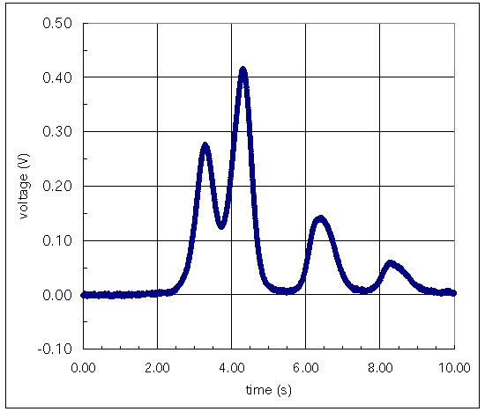

Figure V-3: Background subtracted hyperfine spectrum of rubidium. This spectrum was acquired with the diode laser at 27° C.

