Appendix A: Oscilloscopes

An oscilloscope is an instrument used to view signal amplitude, frequency, and shape at different points throughout a circuit. We will employ a dual trace digital oscilloscope, which uses fast analog-to-digital converters to convert two channels of input (CH1, CH2) into arrays (V1,t) and (V2,t) where V1 and V2 are voltages and t is time represented by 2500 points, equally spaced by a set time interval Δt. Since the data is digital, the oscilloscope can use a powerful microprocessor to process and display the data in many ways, although it is still most commonly used to display V1 and V2 versus time. Oscilloscopes come with a wide variety of features and functions, but the basic operational features are almost identical.

The Time Base: Some oscilloscopes contain circuits that produce a beam of light that is swept continually from the left to the right of the cathode-ray tube (CRT) screen. In the scopes that we use in this lab, the display is a Liquid Crystal Display (LCD) instead but the principle is similar. When no input signal is applied, this sweep will produce a straight horizontal line in the center of the screen. When an input signal is present, the horizontal sweep is influenced by the input signal, which moves it up and down to produce a pattern on the screen the same as the input pattern (sine, square, sawtooth, etc.). The sweep time/cm switch selects the speed of the sweep from left to right, and it can be either fast (0.2 μs/cm) or slow (0.5 s/cm). A low-frequency input signal (long cycle time or period) will require a long time setting (0.5 s/cm) so that the sweep can capture and display one or more cycles of the input.

Voltage measurement: The screen is divided into eight vertical and ten horizontal divisions. This 8x10 cm grid is called a graticule. Every vertical division has a value depending on the setting of the volts/cm control. Channel 1 and 2 Vertical Controls: Volts/div knobs set the number of volts to be displayed by each major division on the vertical scale of the screen. Position control moves the trace up or down for easy measurement or viewing.

Trigger controls: These provide the internal timing control between the sweep across the screen and the input waveform.

Trigger level control: This determines where the sweep starts.
Slope switch
(+): sweep is triggered on positive-going slope.
(−): sweep is triggered on negative-going slope.
Source switch:
CH1: The input arriving into channel-1 jack triggers the sweep.
CH2: The input arriving into channel-2 jack triggers the sweep.
EXT: The signal arriving at the external-trigger jack is used to trigger the sweep.

Coupling: This allows you to filter the trigger signal used to trigger an acquisition.
AC: A capacitor on the input will pass the AC component entering the input jack, but block any DC components.
DC: Both AC and DC components are allowed to pass and be displayed on the screen.

Digital oscilloscope TDS 210/220

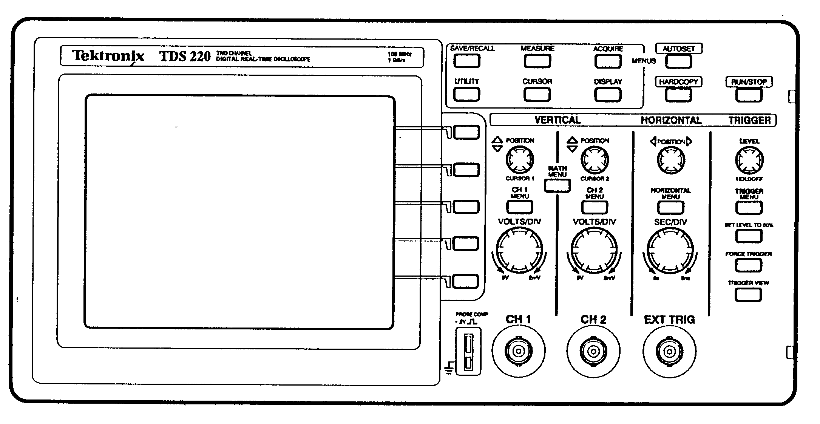

Figure A-1: Front panel layout of the TDS 210/220 oscilloscope

You should consult the user manual of the oscilloscope to understand its function in detail. Some highlights are summarized below.
Fig. A-2: Illustration of MEASURE MENU.
- MEASURE
Push the MEASURE button to access the automated measurement capabilities. There are five measurements (Peak to peak voltage, Mean voltage over a period, RMS measurement of a complete cycle of the wave form, Period, and Frequency) available, and up to four automated measurements can be displayed at a time. Highlight “Source” to select the channel number and highlight “type” to select measurement type.

CURSOR
Push the CURSOR button to display the measurement cursors. There are two types of cursors: (1) voltage cursors and (2) time cursors. Each has two cursors. Use the Vertical Position knobs to move cursors. The oscilloscope displays the location of the two cursors and the difference (delta) between the two cursors.

MATH: Push the MATH MENU button to display the waveform math operation:
CH1-CH2: The channel-2 waveform is subtracted from the channel-1 waveform.
CH2-CH1: The channel-1 waveform is subtracted from the channel-2 waveform.
CH1+CH2: Channels 1 and 2 are added together.
CH1 inverted: The channel 1 signal display is inverted.
CH2 inverted: The channel 2 signal display is inverted.

Push the same button again to turn off the math operation.

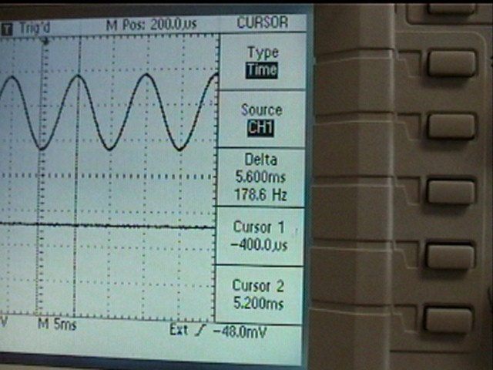

Fig. A-3: Illustration of horizontal and vertical cursors.

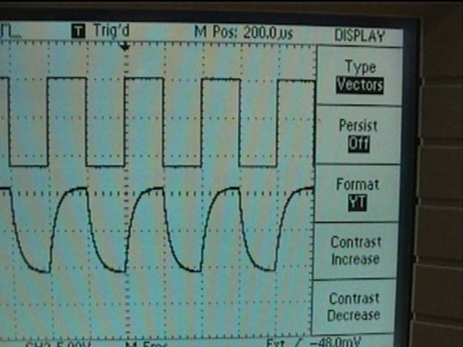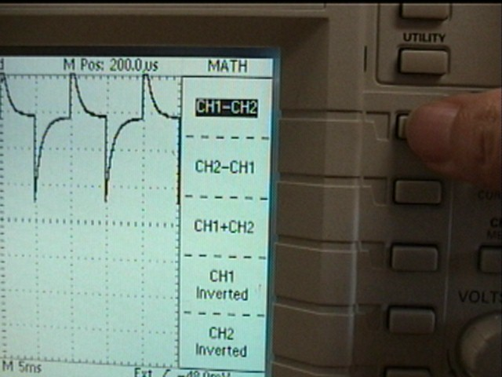

Fig. A-4: Illustration of waveforms for RC circuits. Left side is CH1-CH2.

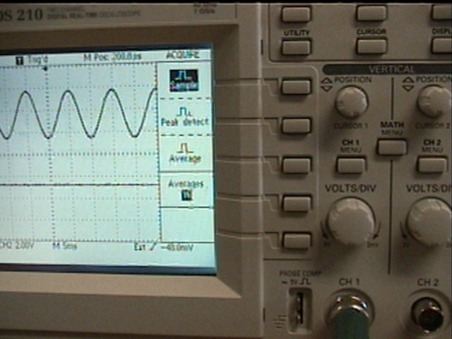

Fig. A-5: Illustration of the ACQUIRE MENU
- ACQUIRE
Push the ACQUIRE button to set the acquisition parameters.

Sample: This is the default mode.
Acquire 2500 points and display them at sec/div setting.
Peak Detect: To detect glitches as narrow as 10 ns.
Average: To reduce random noise. Select the number of acquisitions (4, 16, 64, or 128) to average the waveform.

DISPLAY

Push the DISPLAY button to choose the format (YT or XY) of the display, type (vectors or dots) of the display, or the length of time each displayed sample point remains. This button can also be used to control the display area contrast.

YT: This format displays the vertical voltage as a function of time (horizontal scale)
XY: This format displays channel 1 on the horizontal axis and channel 2 on the vertical axis.

- UTILITY:
Display the system status (lists parameters of the horizontal, vertical, and trigger system), perform calibration, or display a list of logged errors.

PRECISION AND ACCURACY OF THE SCOPE

The precision with which you can measure time and voltage on the oscilloscope can be estimated in a few different ways. To start with it helps to know the resolution with which the signals are digitized.

The oscilloscope collects 2500 sample measurements and displays them on the screen. In the time axis direction, since there are 10 big divisions, there are then 250 samples per division. The sampling interval is the ratio of the time base scale to the number of samples per division, or [(SEC/DIV] / [250 samples/division] in units of seconds. The resolution is about half the sampling interval. So, for a trace that is displayed on the 1 msec/div scale, the best resolution with which you could make a measurement in the time direction would be about 2 μsec.

The voltage (vertical) measurements are made with an 8-bit analog-to-digital converter, leading to a total of 256 possible voltage levels across the vertical axis. There are 8 big divisions, so the voltage step size is ([VOLTS/DIV]/[32 levels/div]) in units of Volts. If again one assumes that you can read the voltage to about half that, the resolution is [VOLTS/DIV] /64. These “digitization” errors will be particularly noticeable if you download a trace to EXCEL using WAVESTAR and look at the numerical values. In addition to the resolution, there is an overall inaccuracy of the voltage measurements of ±3%.

Sometimes, when using the cursors, it is not possible to achieve this level of precision, depending on the shape of the trace that you are looking at. You can get an additional estimate of the precision by moving the cursor slightly and deciding how well with your eye you can line the cursor up with your trace.

The MEASURE tools should be able to achieve the precision of the digitization, however, the MEASURE function will be sensitive to fluctuations in either the ground or in the input voltage signal.

Appendix B: AC Circuits and Oscilloscopes

In this appendix we will show how one can measure AC voltage levels using oscilloscopes. Imagine you have the following AC circuit with two loads, labeled R₁ and R₂, with the variable signal V_{IN} originating from the function generator. As seen in figure B.1, the output of the function generator is actually grounded at one end. In fact, this is true for any electronic device which uses the so-called BNC connectors that you see on generators, scopes, etc.

Figure B-1: A circuit with two resistors and varying input voltage from a waveform generator.

Now suppose that you wanted to look at the voltage as a function of time across the load R₁. You’d naturally hook a scope input across R₁. However, remember that the scope input is BNC, so one “side” is grounded. If you were to do this, as in figure B.2, you’d see that you’d have a connection to ground such that current will naturally flow from A to B, and not A to C:

Figure B-2: With a scope across resistor R₁, points A and B are at the same potential as point C, effectively removing R₂ from the circuit.

Clearly, this won’t work, in that it will change the circuit (current no longer flows through the load R₂). There are two possibilities:
Move the scope so that you look at R₂ but not R₁! If you insist on viewing the voltage across R₁, then rewire the circuit, switching R₁ and R₂ such that the negative side of R₁ is connected to ground at both ends (the function generator and the scope). The circuit would look like the following:

Figure B-3: Using the scope to measure the voltage across R₂ does not perturb the circuit.

Use the “Instrumentation Amplified” provided, and hook it up according to Figure B-4. This little box is really a x1 amplifier (no amplification), and works in such a way that the upper line (in the figure) is proportional to the difference between the two inputs, and the bottom line is grounded. Note, however, that this solution should only be used if you need to look at R₁ and R₂ at the same time (using two scope inputs).

Figure B-4: Proper measurement of the voltage across R₁ using an instrumentation amplifier.

Appendix C The Function Generator:

A function generator can produce a variety of AC waveforms, including a square wave, a sine wave for a triangle format. The picture below should help with the initial setup of the function generator for the various Physics 276 labs.

Figure C-1: Front panel display of the function generator.

Waveform type: The buttons in the upper right corner allow you to choose a sine wave, triangle wave or square wave.

Frequency Adjustment: The frequency is adjusted using the coarse adjust knob. The order of magnitude is set using the buttons across the top. Try setting it to ~100Hz. The Duty cycle, which is the space between pulses, can be used to make a pulse “mostly on”, “mostly off”, or, if it is disabled (fully counterclockwise) will make a symmetric waveform.

Zero Offset: The Offset Adjust knob should be pushed in for a waveform that is symmetric about zero. If it is pulled out, the waveform can be adjusted to anything between fully positive or fully negative. Check using the scope whether the DC offset is indeed zero using the scope.

Amplitude: The Amplitude knob changes the amplitude of the pulse. If the knob is pulled out, the amplitude will be attenuated by 20db. Normally we will use this knob in its pushed in state.

TTL Output: The TTL output knob should be pushed in to get a TTL output, which can be used to externally trigger the oscilloscope. A TTL pulse is a standard “logic” signal that has a well defined rise time and is 5V when it is “ON”, 0 V when it is “OFF”.

EXERCISES with the function Generator and Oscilloscope

1. NO SIGNAL: Start with no signal in CH1 or CH2. Set RUN/STOP to RUN. Set VOLTS/DIV on 200 mV on both channels. Select CH1 and CH2 to see the traces. Select the TRIGGER MENU, set it to EDGE, then set MODE: AUTO. Play with the COUPLING, RUN/STOP, VERTICAL POSITION and TRIGGER MODE.

2. DC CIRCUIT: Put a DC Voltage (Battery ~ 1.5 V) into CH1. Set the VOLTS/DIV on 500 mV for both CH1 and CH2. Compare the displays, and convince yourself that the scope is measuring the proper battery voltage. Change the COUPLING on CH1 from DC to AC then GND and note what happens to the display. With the COUPLING on DC and the triggering an AUTO, measure the battery voltage by a) counting squares, b) using the CURSOR function, and c) using the MEASURE function. Then play with the MATH mode to display –CH1, and CH1+CH2.

Note that the effective resistance of the oscilloscope is 1 M so by connecting the scope across the battery terminals you have made a simple circuit with a battery and a resistor.

3. SQUARE WAVE: Using the waveform generator, put a 1 kHz, symmetric square wave that has an amplitude of 1V and an offset of 0V into CH1. Set the VOLTS/DIV on 500 mV and convince yourself that the scope is properly reading the function generator output. Select the TRIGGER MENU, trigger on CH1, select EDGE, then switch the trigger between Rising and Falling and note what happens to the display. Observe trigger arrow across top of screen.

Take the TTL output from the waveform generator and put it into the EXTERNAL TRIGGER input on the scope. Change the Trigger mode to EXT and adjust the trigger until you see the trace on CH1 again. Play with TRIGGER LEVEL. Measure the frequency and amplitude of the trace on CH1 using the cursors and using the MEASURE functions.

Vary the time base (SEC/DIV) and vary the HORIZONTAL POSITION. Play with the ACQUIRE MENU.

4. SINE WAVE: Put a 1 kHz sine wave in CH1 and repeat Exercise 3, triggering first on CH1 and then on the external TTL signal. When triggering on CH1, vary the TRIGGER LEVEL and note the effect by monitoring arrow on the top screen. Measure the frequency and amplitude again using the cursors and MEASURE tools.

5. DUTY CYCLE AND ZERO OFFSET: Vary the output of the waveform generator by playing with the DUTY CYCLE knob, the amplitude, the frequency, and the ZERO offset to explore the range of functions on the waveform generator.

