Problem Set # 8
Solutions

6-4 The time development of Ψ is given by Equation 6.8 or

,

with for a free particle of mass m. As in Example 6.3, the integral may be reduced to a recognizable form by completing the square in the exponent. Since , we group this term together with by introducing to get

.

Then, changing variables to gives .
To interpret this result, we must recognize that β is complex and separate real and imaginary parts. Thus, and the exponent for Ψ is

then

.

We see that apart from a phase factor, is still a gaussian but with amplitude diminished by and a width where is the initial width.

6-9 , so
This is the gamma ray region of the electromagnetic spectrum.

6-21 It has n-1=3 nodes and is even meaning antisymmetric about the midpoint of the well.

Note that the wavefunction has three nodes and is antisymmetric about the midpoint of the well.

6.22 The Java applet for this problem is available from our companion website (http://info.brookscole.com/mp3e QMTools Simulations → Problem 6.22). The applet models a proton confined by a square well potential with height U = 26.0 MeV and width L = 10.0 fm (1 fm = 10⁻¹⁵ m = 10^{–6} nm). These values appear on the Formulas tab of the applet, along with the proton mass value m_{p} = 938.38 MeV/c². On the Coordinate 2D Graphics tab the potential functionis plotted for 1024 points over the interval [−10 fm, +20 fm]. The listing to the right of the graph includes placeholders for two stationary states of the proton in this well. Follow the applet instructions to display each state in turn and adjust its energy until no discernible mismatch results in the wavefunction. The final form of the applet should resemble the screenshot below:

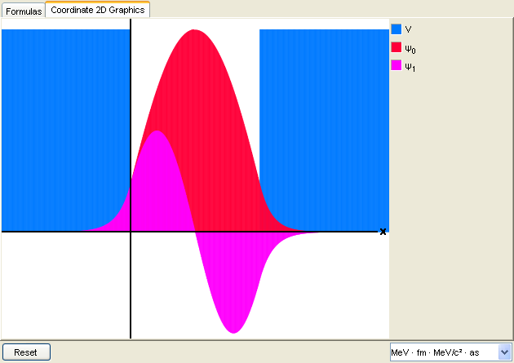

For this potential well, we find the ground and first excited state energies at and (waveforms with zero and one node, respectively). In a transition from to a photon is emitted with energy

Using, we calculate the corresponding wavelength as

For the infinite well model, we use to get

Then

6.28 A particle within the well is subject to no forces and, hence, moves with uniform speed, spending equal time in all parts of the well. Thus, for such a particle the probability density is uniform. That is, . The constant is fixed by requiring the integrated probability to be unity, that is, or . To find we weight the possible particle positions according to the probability density to get . Similarly, is found by weighting the possible values of with :

.

The classical and quantum results for agree exactly; for the quantum prediction is smaller by an amount which, however, goes to zero in the limit of large quantum numbers n, where classical and quantum results must coincide (correspondence principle).

6-32 The probability density for this case is with and . For the calculation of the average position we note that the integrand is an odd function, so that the integral over the negative half-axis exactly cancels that over the positive half-axis (), leaving . For the calculation of , however, the integrand is symmetric, and the two half-axes contribute equally, giving

.

Substituting for and a gives and .

